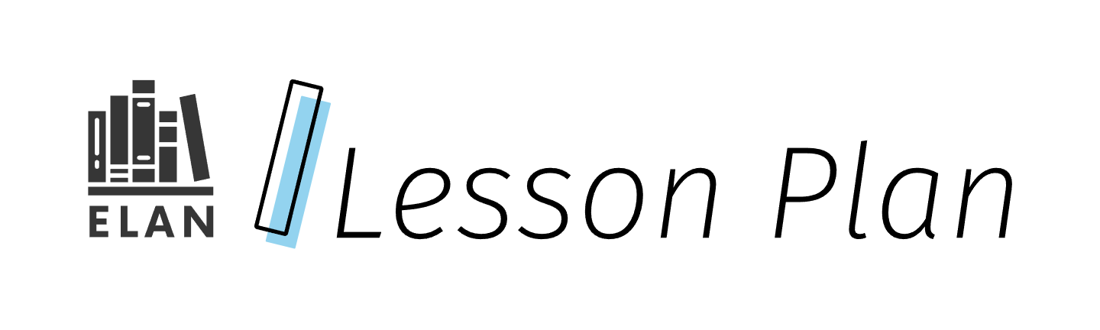

Verbal Reasoning: The Power of Comprehension

This lesson focuses on verbal reasoning and some of the different ways that students can show verbal reasoning as part of their comprehension as evidenced by their participation in guided, small group, and independent practice.

Verbal reasoning is defined in Scarborough’s Reading Rope as a reader’s ability to think about a text and infer meaning from what is explicitly and implicitly stated. To do so, readers must engage in cognitive and metacognitive processes such as: making logical inferences, integrating ideas within and across texts, and interpreting abstract language (Dieter & Washington, 2022).

Grade

7

Curriculum expectations

C1, C1.1, C2, C2.5, C2.6 (see Appendix E for full descriptions)

Strands

C. Comprehension: Understanding and Responding to Texts

# Contents

Grade 1

Curriculum expectations 1

Strands 1

Contents 2

Learning goals 4

Success criteria 4

Lesson path 5

Time 5

Materials and resources 5

Minds on 6

Introduction: 6

What’s the connection?: 6

Action 7

Modeling reasoning strategies 7

Leveraging guided practice 8

Supporting independent practice 9

Consolidation 10

Reflection 10

Possible extensions 10

Appendix A 11

Example text for modeling 11

Appendix B 12

Multimodal choice board 12

Verbal reasoning choice board 12

Appendix C 13

Single-point rubric 13

Verbal reasoning checkbric 14

Appendix D 14

Exit ticket 14

“3-2-1” 14

Appendix E 15

Curriculum expectations 15

C1. Knowledge about Texts 15

C2. Comprehension Strategies 15

References 16

Attribution license 18

Updates 18

# Learning goals



We are learning …

1. Demonstrate an understanding of verbal reasoning as a strategy to help with comprehending texts.

# Success criteria



I can …

* Identify key components of verbal reasoning including: identifying main ideas, making inferences, and understanding context.
* Name a variety of active reading strategies (e.g., predicting, questioning, and summarizing)
* Use active reading strategies
* Use language to analyze, interpret, and draw conclusions from information.
* Recognize patterns in texts and author’s style to help my understanding.

# Lesson path



## Time

Approximately 60 minutes

This is a suggested amount of time. This lesson may be implemented over a series of days. Educators will make the best judgement on how to implement.

## Materials and resources

* [Lesson slide deck: SLIDES Gr 7 Verbal Reasoning: The Power of Comprehension (Google slides)](https://docs.google.com/presentation/d/1v0dNH00rtoEDBBbiTOmsJEd8B0A_7u1qU-C8MT4QQjo/edit?usp=sharing)
* Text Resources:
  + **For the Action component** of the lesson: one excerpt from a novel, textbook, or selection of text from the school library/board approved digital resource or a newspaper article, taking into consideration CRRP and potential cross-curricular connections that are relevant to content being taught in your classroom.
  + **For the Guided Practice component** of the lesson: one excerpt per group of 3-4 students from a novel, textbook, or selection of text from your school library/board approved digital resource or a newspaper article, taking into consideration culturally responsive and relevant pedagogy and potential cross-curricular connections that connect to content being taught.
* Example text for modeling (Appendix A)
* Multimodal choice board (Appendix B)
* Single-point rubric (Appendix C)
* Exit ticket (Appendix D)

## Minds on

### Introduction:

1. Introduce the lesson and share the learning goals and success criteria (Slides 2-3). Explain the relevance of the lesson to improving reading comprehension and critical thinking skills.Highlight any key vocabulary, such as logic, reasoning, analysis and interpretation, that may be new or have new contexts for students.

### What’s the connection?:

1. Display three seemingly unrelated words on the board (e.g., “umbrella”, “smile”, and “sidewalk”) (Slide 4). An example connection might be Gene Kelly’s scene in the classic movie [“Singing in the Rain” (Full song / dance, YouTube video)](https://www.youtube.com/watch?v=swloMVFALXw).
2. Challenge students to use verbal reasoning to find a logical connection between the words. Discuss various student responses, making sure to emphasize that there is no single correct answer, but the reasoning provided must be logical and explained in a way that makes sense to your audience.

## Action

### Modeling reasoning strategies

1. Present a short, selection of text (Slide 5) and model a think-aloud process to demonstrate verbal reasoning. During the think aloud, demonstrate how to
   1. Identify the main and supporting details;
   2. Make inferences based on context clues and prior knowledge; and
   3. Analyze the author’s word choice and its potential impact on meaning, remembering to highlight that there is no single correct answer but one’s reasoning must be logical.
2. Introduce and explain some key verbal reasoning strategies (Slide 6). These may be included on an anchor chart to support students’ ongoing learning:
   1. Contextual analysis (a strategy for when students already know multiple meanings for a word (ex. tree bark vs. dog bark). Students can use the context to apply the correct meaning, but any unknown vocabulary should ideally be explicitly taught.)
   2. Inference-making (drawing a conclusion based on reasoning either from evidence, or from personal experience/understanding).
   3. Identifying text structure and organization (different text structures include narrative, sequential, cause and effect, problem/solution, compare and contrast, definition or description).
   4. Recognizing the author’s tone and purpose (the attitude the author conveys and the reason they’re writing the text).
3. It might be important to note that verbal reasoning is not only about knowledge of vocabulary. While vocabulary is always important, verbal reasoning involves additional skills of analysis and interpretation.

### Leveraging guided practice

1. Divide students into small heterogeneous groups and provide each group with a different short text excerpt.
2. Review or establish expectations for participation in small groups, for example:
   1. Everyone participates actively
   2. Listen respectfully to others’ ideas
   3. Be prepared to share your findings with the class
3. Guide students through a series of scaffolded questions (Slide 7) for each excerpt:
   1. What is the main idea of the passage?
   2. What can you infer about the author’s purpose? (The short video [Point of View and Author’s Purpose - Literary Analysis for Teens! (YouTube video)](https://www.youtube.com/watch?v=0ynmZAbdGdk) helps to explain the importance of an author’s purpose)
   3. How does the text structure support the message?
   4. What evidence supports your conclusions?

[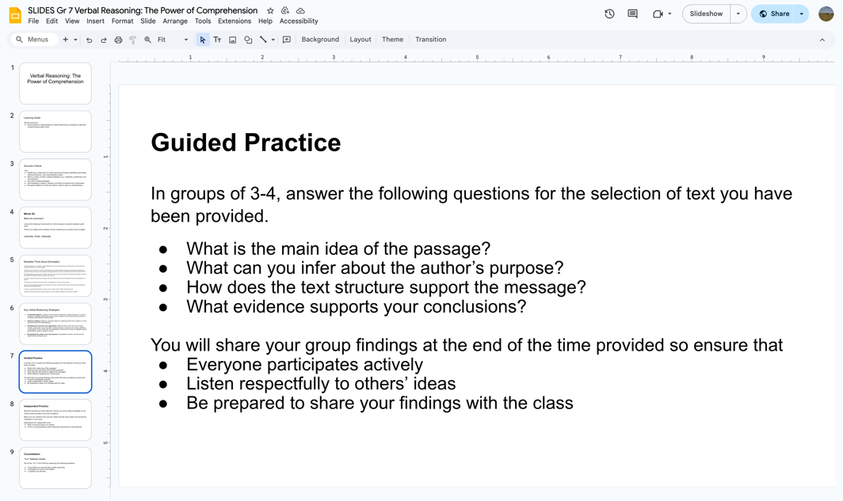](https://docs.google.com/presentation/d/1v0dNH00rtoEDBBbiTOmsJEd8B0A_7u1qU-C8MT4QQjo/edit#slide=id.g2f3569faded_0_20)

Slide 7 of the lesson slide deck includes scaffolds for small group guided practice.

#### Assessment opportunity

**During small group discussions,** provide support, feedback (assessment *for* learning) and clarification as needed. This may be a strategic time to sit with small groups and collect some observational and conversational data.

1. **As a whole group,** have groups share their findings, encouraging class discussion and comparison of different interpretations.

### Supporting independent practice

1. Introduce the multimodal choice board activity based on a student-selected text
2. Set expectations for independent work:
   1. Refer to text and lesson as needed
   2. Focus on demonstrating verbal reasoning using what you have learned
3. Distribute the text and choice board, explaining each option clearly.
4. Allow students to select and complete one option from the choice board.

#### Assessment opportunity

Encourage students to reference the success criteria, anchor chart and rubric before and during the completion of your work, and describe how students can use these to self-assess (assessment *as* learning). During independent practice, circulate the room to provide support, monitor progress and provide feedback. Conference with students who may need additional support (assessment *for* learning). Use the single-point rubric to provide further feedback.

## Consolidation

### Reflection

Have students reflect on the lesson and answer the following questions on the exit ticket provided in Appendix D:

* 3 new things they learned about verbal reasoning
* 2 strategies they found most helpful
* 1 question they still have

## Possible extensions

* Challenge students to create their own verbal reasoning puzzle (similar to the minds-on activity for this lesson) or question based on the text and have them share with a peer or the class.
* Students can be tasked with finding a news article or opinion piece and apply the verbal reasoning strategies learned in class. They can write a brief analysis (1-2 paragraphs) demonstrating their use of at least two verbal reasoning skills.
* Have students complete any of the other Choice Board options of interest.

# Appendix A

## Example text for modeling

**Title:** [“I’ve never been in such a hard battle”: How Paris 2024 was Noah Lyles’ Greatest Triumph and Hardest Challenge (website)](https://olympics.com/en/news/paris-2024-noah-lyles-greatest-triumph-hardest-challenge)

**Author:** Sean McAlister

“Goodness gracious, I’m incredible,” exclaimed Noah Lyles, as his name flashed up on the big screen to announce that he was the Paris 2024 men's 100m champion.

For 99 per cent of the race to crown the ‘world’s fastest man’ Lyles had trailed, seemingly out-gunned and out-sprinted by Jamaica’s Kishane Thompson who looked to be bringing gold back to the land of Usain Bolt for the first time since Rio 2016.

As the eight athletes vying for glory in athletics’ blue ribbon and men's race crossed the line seemingly inseparable, nobody in the 80,000-strong Stade de France crowd knew who had won.

Then, after a wait that seemed like an eternity, Lyles was declared the winner, the first past the line by five thousandths of a second.

This had been the closest 100m final in history. The greatest race in history, some had said.

It was a race that had been decided by the leaning torso of Lyles, whose dip for the finish line was the minuscule difference between gold and disappointment.

“I hope you guys like Noah because I’ve got a lot more coming,” the new 100m champ announced.

Little did he know that what was coming would prove to be the hardest challenge of his entire life in athletics.

# Appendix B

## Multimodal choice board

### Verbal reasoning choice board

#### Poetry response

Create a poem in a style that captures the main ideas of text and the author’s voice and purpose. (e.g. free verse, slam poem, etc.).

#### Oral presentation

Prepare a short oral presentation summarizing the text ensuring to include your inferences and personal insights to be presented to either your classmates or in a pre-recorded manner.

#### Mind map

Make a digital mind-map that visually represents the maid ideas and connections in the text.

#### Visual representation

Create a visual representation of the text’s main ideas in a style that speaks to you (e.g. comic strip, collage, etc.).

#### Written summary

Write a 1-2 paragraph summary of the main ideas from the text and use evidence from the text to support your claims.

#### Compare and contrast

Write a 1-2 paragraph summary and response comparing and contrasting elements within the text or with another text.

# Appendix C

## Single-point rubric

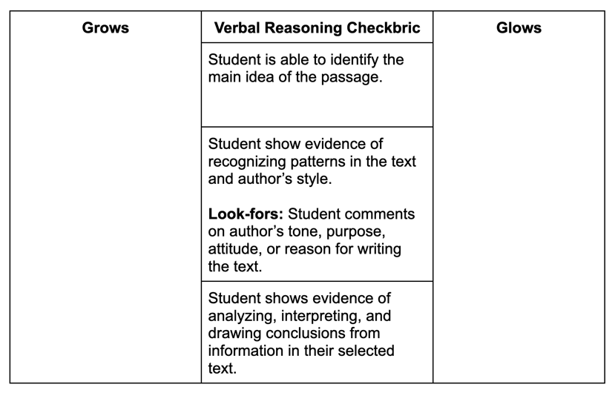

This example of a checkbric may work for someone who prefers paper format. Note: If you choose to create a digital checkbric the layout of the criteria and prompts may need to be adjusted to meet accessibility needs.

### Verbal reasoning checkbric

* Student is able to identify the main idea of the passage.
  + Grows
  + Glows
* Student show evidence of recognizing patterns in the text and author’s style. **Look-fors:** Student comments on author’s tone, purpose, attitude, or reason for writing the text.
  + Grows
  + Glows
* Student shows evidence of analyzing, interpreting, and drawing conclusions from information in their selected text.
  + Grows
  + Glows

# Appendix D

## Exit ticket

### “3-2-1”

Reflect on today’s lesson and answer the following questions below:

3 new things they learned about verbal reasoning are:

2 strategies found most helpful were:

1 question I still have is:

# Appendix E

## Curriculum expectations

### C1. Knowledge about Texts

apply foundational knowledge and skills to understand a variety of texts, including digital and media texts, by creators with diverse identities, perspectives, and experience, and demonstrate an understanding of the patterns, features, and elements of style associated with various text forms and genres

#### C1.1: Using Foundational Knowledge and Skills to Comprehend Texts:

read and comprehend various complex texts, using knowledge of words, grammar, cohesive ties, sentence structures, and background knowledge.

### C2. Comprehension Strategies

apply comprehension strategies before, during, and after reading, listening to, and viewing a variety of texts, including digital and media texts, by creators with diverse identities, perspectives, and experience, in order to understand and clarify the meaning of texts

#### C2.5: Monitoring of Understanding: Making Connections:

explain how the ideas expressed in texts connect to their knowledge and lived experiences, the ideas in other texts, and the world around them.

#### C2.6: Summarizing: Identify Relevant Information and Drawing Conclusions:

summarize and record the main idea and supporting details in various texts, and draw well-supported conclusions.

# References

Dieter, H. & Washington, T. (2022, September 13). *Examining Scarborough’s Rope: Verbal Reasoning*. <https://greatminds.org/english/blog/witwisdom/examining-scarboroughs-rope-verbal-reasoning>

McAlister, S. “‘I’ve Never Been in Such a Hard Battle’: How Paris 2024 Was Noah Lyles’ Greatest Triumph and Hardest Challenge.” *Olympics.Com*, 15 Aug. 2024, [olympics.com/en/news/paris-2024-noah-lyles-greatest-triumph-hardest-challenge](http://olympics.com/en/news/paris-2024-noah-lyles-greatest-triumph-hardest-challenge)

Miacademy Learning Channel. (2022, June 2). *Point of View and Author’s Purpose - Literary Analysis for Teens!* [Video]. YouTube. <https://www.youtube.com/watch?v=0ynmZAbdGdk>

Turner Classic Movies. (2018, June 20). *Singin’ in the Rain (Full Song/Dance - ’52) - Gene Kelly - Musical Romantic Comedies - 1950s Movies* [Video]. YouTube. <https://www.youtube.com/watch?v=swloMVFALXw>

# Attribution license

This lesson plan is published under a [CC BY-NC-SA](https://creativecommons.org/licenses/by-nc-sa/4.0/) license. Third-party resources are subject to their own copyright.



This license enables reusers to distribute, remix, adapt, and build upon the material in any medium or format for noncommercial purposes only, and only so long as attribution is given to the creator. If you remix, adapt, or build upon the material, you must license the modified material under identical terms. CC BY-NC-SA includes the following elements:

  BY: credit must be given to the creator.  
  NC: Only noncommercial uses of the work are permitted.  
  SA: Adaptations must be shared under the same terms.

# Updates

When updates are made to this document, they are tracked below with date and description of update.

* February 2025: initial release