

Multisensory Approaches to Language Foundations in Small Groups

This small group lesson structure explores various multisensory approaches to teaching letter-sound correspondence in conjunction with teacher-selected reading materials, including structured literacy resources. After teaching a whole group lesson on a particular phoneme and its associated grapheme(s), small group instruction may be used to continue practicing and consolidating the studied concept.

Grade

1

Curriculum expectations

B2, B2.3, B2.4, B2.5 (see Appendix D for full descriptions)

Strands

B. Foundations of Language

# Contents

Grade 1

Curriculum expectations 1

Strands 1

Contents 2

Learning goals 4

Success criteria 4

Lesson path 5

Time 5

Materials and resources 5

Minds on 6

Action 7

Working with tactile materials 7

Working with letters 7

Building knowledge through practice 8

Consolidation 9

Multisensory demonstration 9

Possible extensions 9

Appendix A 11

Map it/Write it blackline master 11

Appendix D 12

Curriculum expectations 12

B2. Language Foundations for Reading and Writing 12

Attribution license 13

Updates 13

# Learning goals



We are learning …

1. break (segment) words into sounds (phonemes) and identify the letters that make those sounds (graphemes).
   1. [segmenting definition (external resource)](https://www.dcp.edu.gov.on.ca/en/curriculum/elementary-language/glossary#s)
   2. [phoneme definition (external resource)](https://www.dcp.edu.gov.on.ca/en/curriculum/elementary-language/glossary#p)
   3. [grapheme definition (external resource)](https://www.dcp.edu.gov.on.ca/en/curriculum/elementary-language/glossary#g)
2. blend those sounds to read and spell words.

# Success criteria



I can …

* identify individual phonemes
* blend phonemes together to make a word.
* identify the letters that connect to each phoneme to help me read and spell.
* use different strategies to help me remember the phonemes and their letters.

# Lesson path

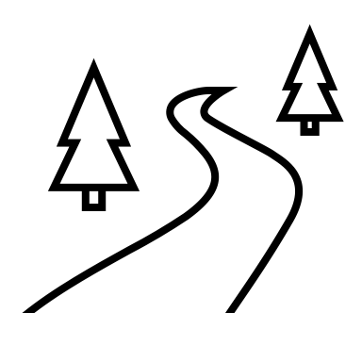

## Time

About 15-20 minutes per guided small group.

This is a suggested amount of time. This lesson may be implemented over a series of days. Educators will make the best judgement on how to implement.

## Materials and resources

* [Lesson Slide deck: Multisensory Approaches for Letter-Sound Correspondence (Google slides)](https://docs.google.com/presentation/d/1Wfssl5ouL1dEUUP0FRvytC43gr0GFUayx7L5DEXmM5Y/edit?usp=sharing) (optional)
* Teacher-selected texts for reading (e.g., stories containing words with targeted phonemes and blends)

The following materials are for guided small group learning and the number of items will depend on size of small groups (consider expanding modalities for the different materials. For example, a digital version of the Map It / Write It templates that are keyboard accessible):

* Handheld mirrors, one per student. If mirrors are not available, an alternative is to have students face a partner and study each other’s mouths as they say the phoneme out loud. “I say it, you watch…you say it, I watch.”
* Rectangular take-out containers or small plastic trays filled with uncooked rice or sand, one per student. Note: consider having a diversity of resources that will support different needs and preferences, including sensitivities to certain textures. For example, have rice, sand, or shaving foam (you can add food colouring) in large plastic Ziplock bags that can lay flat and be used as tactile boards.
* Sets of magnetic/foam letters AND/OR a set of “Pop It” ten frames or bracelets AND/OR counters
* Map It/Write It Blackline Master (Appendix A)
* Dry erase markers (for laminated materials)

## Minds on

1. Establish a small group while the rest of the class completes independent learning tasks (e.g., literacy centres).
2. Begin by having a set of handheld mirrors, one per each student, out on the table where your small group is gathered. Display the grapheme (for example, the digraph “ch“). Ask the students to look at your mouth while you model the sound that grapheme makes.
3. As students are trying out the phoneme, ask, “What shape does my mouth make when I say this sound?” Have students pick up the mirrors and invite them to look at their own mouths to see what shape it makes as they repeat the sound a few times.
4. Now ask, “Where was your tongue as you said this sound? Could you see it?“ Invite student responses. Guide students to be specific, for example, “my tongue is behind my teeth. I can't see it. My teeth are together and my lips are making an O shape.”
5. Point out to students that they will continue to work with this sound, and they will explore words that have this sound in them.

## Action

### Working with tactile materials

1. Provide small trays filled with rice/sand for each student. If this is the group’s first time using rice/sand trays, review expectations and procedures when using the trays. For example, being very clear about not picking up the rice/sand or throwing it, not eating the rice, and modelling how to use the tray properly.
2. Tell students, “Now we are going to practice spelling the letter(s) that make this sound. We are going to trace it in the rice. This is going to help our brains remember how to spell this sound.”
3. Have students practice tracing the grapheme that is the focus of the lesson with their index finger in the rice/sand while naming the letter(s) and saying the sound out loud a few times (for example, “c-h spells ch”).

### Working with letters

1. Next, provide students with magnetic letters (if there are not enough sets for each student in the group, the students can pair up). Say to students, “Now let’s map out and spell some words that have this sound together. First, we will do some finger tapping to tap out each sound in the word. Let’s notice how many sounds we hear in each word. Then we will spell the words with the magnetic letters on the word mapping sheet.”
2. Select 3 words from the lesson for the chosen phoneme/grapheme. Display images that illustrate the selected words and have students say each word out loud. Then, have students break the words down to the individual phonemes that they hear. Have students tap each of their fingers onto their thumb for each phoneme they hear (Note: The goal is to check how students are hearing each phoneme, and the activity may need to be modified based on students’ needs and preferences related to demonstrating this). For example, for the image of a chip, students will say out loud, “chip.” Then they will tap their index finger down to their thumb for “ch”, then touch the next finger down to their thumb for “i” and finally tap the next finger down to their thumb for “p”.

[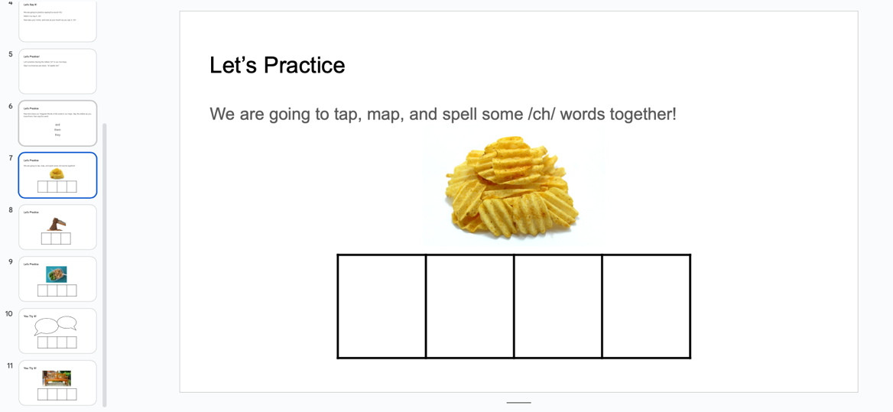](https://docs.google.com/presentation/d/1Wfssl5ouL1dEUUP0FRvytC43gr0GFUayx7L5DEXmM5Y/edit?slide=id.g27ff07d3973_0_0#slide=id.g27ff07d3973_0_0)

Slide 7 of the lesson slide deck is one of several practice rounds of the “working with letters” activity.

#### Assessment opportunity

Ask students, “how many fingers did we tap down to our thumb? These are the number of sounds we heard in the word. Each of these sounds is a phoneme. Now I would like you to select the magnetic letters that spell each of the phonemes, or sounds, that you tapped out.”

### Building knowledge through practice

1. Alternatively, students can use a “Pop It” bracelet or “Pop It” ten frame to push down the rubber circles for each phoneme they hear, or they may place a counter down for each phoneme. This will provide a visual for how many sounds they heard. Tell students, “These letters that represent the sounds are called graphemes.”
2. Allow some time for the students to place the magnetic letters on each sound box, guiding students to place the correct letters on each corresponding box (1 box per phoneme). When everyone has finished, ask students to slide each grapheme up as they say the phonemes individually. Then they will orally blend the phonemes together to say the whole word again.
3. Students can then use the dry erase markers to print the word again on the lines below the word mapping box, focusing on correct letter formation and printing neatly on the lines.

## Consolidation

### Multisensory demonstration

1. Provide an additional 3 images that illustrate words that follow the chosen phoneme/grapheme. This time, have students tap out the phonemes, map out the graphemes (with or without the magnetic letters), and print the word neatly.

## Possible extensions

* If the reading material or structured literacy resource being used provides “Heart Words” (high-frequency words that contain irregular spelling patterns or sounds, such as the word “said”), “High Frequency”, or “Irregular” words of the week, these can be displayed and students can trace them in the rice/sand trays or on the [sandpaper letter cards (YouTube video)](https://www.youtube.com/watch?v=LHF7bn_yGsk) before going onto the next part of the lesson.
* Provide lined writing paper and have students use each of the words they mapped and wrote out on the laminated Mapping/Writing template in a sentence.
* The multisensory approaches in this lesson can be adapted into literacy centres once students have learned how to use them appropriately and have had enough practice tapping/mapping/writing words in this way.

# Appendix A

## Map it/Write it blackline master

Use each ‘sound box’ for individual phonemes/graphemes, for example by putting magnetic letters for each grapheme so that students isolate and practice each letter/phoneme-sound connection. Once students blend phonemes to say the whole word together, have students write the word on the lines below.

Use the appropriate number of ‘sound boxes’ that match the phonemes in the word, for example, the word ‘chop’ (ch-o-p) needs three sound boxes, whereas the word ‘bench’ needs four sound boxes.

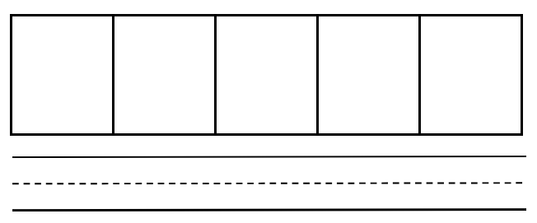

This example of a Blackline Master may work for learners who prefer paper format. Note: If you choose to create a digital Blackline Master the activity may need to be adjusted to meet accessibility needs.

# Appendix D

## Curriculum expectations

### B2. Language Foundations for Reading and Writing

demonstrate an understanding of foundational language knowledge and skills, and apply this understanding when reading and writing

#### B2.3 Phonics: Grapheme-Phoneme Correspondence

identify, read, and spell most common grapheme-phoneme correspondences of consonants and vowels, with automaticity

#### B2.4 Word-Level Reading and Spelling: Using Phonics Knowledge

use phonics knowledge and phonemic blending to read words, and phonemic segmentation to spell phonetically regular words, in isolation and various text contexts

#### B2.5 Word-Level Reading and Spelling: Using Orthographic Knowledge

use developing orthographic knowledge, including position-based tendencies, to make a spelling choice or accurately pronounce a word when reading

# Attribution license

This lesson plan is published under a [CC BY-NC-SA](https://creativecommons.org/licenses/by-nc-sa/4.0/) license. Third-party resources are subject to their own copyright.



This license enables reusers to distribute, remix, adapt, and build upon the material in any medium or format for noncommercial purposes only, and only so long as attribution is given to the creator. If you remix, adapt, or build upon the material, you must license the modified material under identical terms. CC BY-NC-SA includes the following elements:

  BY: credit must be given to the creator.  
  NC: Only noncommercial uses of the work are permitted.  
  SA: Adaptations must be shared under the same terms.

# Updates

When updates are made to this document, they are tracked below with date and description of update.

* February 2025: initial release