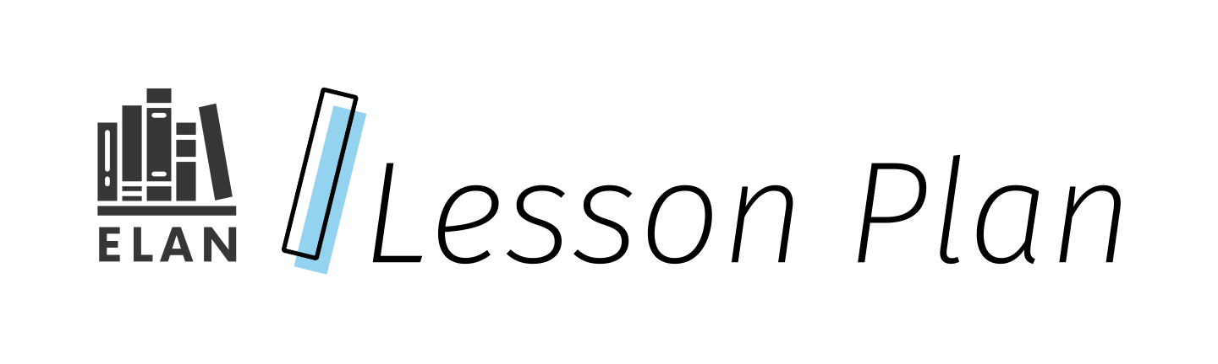

The Story of My Name

This lesson is an inquiry into the meaningful stories behind our students’ names, and encourages the sharing of these personal stories/histories with each other. Students will explore aspects of their names, as well as build community as learners. Note that not all students may have access to stories about their name, so offering a wide range of choices of questions related to their name will be important.

This lesson might be part of a larger inquiry, related to questions, such as Why does sharing personal stories matter? or How can we create a shared space where everyone’s name stories are respected?

Grade

1

Curriculum expectations

A3, A3.2, B3, B3.3, C2, C2.3, C2.5, D1, D1.2, D1.4 (see Appendix D for full descriptions)

Strands

A. Literacy Connections and Applications

B. Foundations of Language

C. Comprehension: Understanding and Responding to Texts

D. Composition: Expressing Ideas and Creating Texts

# Contents

Grade 1

Curriculum expectations 1

Strands 1

Contents 2

Learning goals 3

Success criteria 3

Lesson path 4

Time 4

Materials and resources 4

Minds on 5

Action 5

Exploring a mentor text 5

Creating name art 6

Consolidation 8

Sharing identity 8

Possible extensions 9

Appendix A 10

Gathering information and generating ideas template 10

Questions for students: 10

Appendix B 12

Sample Name art 12

Content on Sample Name art: 13

Appendix C 13

Optional gathering information and generating ideas template 13

Appendix D 15

Curriculum expectations 15

A3. Applications, Connections, and Contributions 15

B3. Language Conventions for Reading and Writing 15

C2. Comprehension Strategies 16

D1. Developing Ideas and Organizing Content 16

Attribution license 18

Updates 18

# Learning goals



We are learning …

* Share about our own identities and learn about the identities of others

# Success criteria



I can …

* Gather and generate ideas and information about my name
* Sort and sequence my information in a way that makes sense
* Describe what my name means to me and why it is special
* Share (e.g., through speaking) about my name(s) and personal stories that accompany them
* Share my information in an organized way, using transition words
* Use punctuation, especially capitalization, to make my information clear
* Respectfully listen to my peers when they share
* Describe what I’ve learned about my classmates’ names and personal stories

# Lesson path

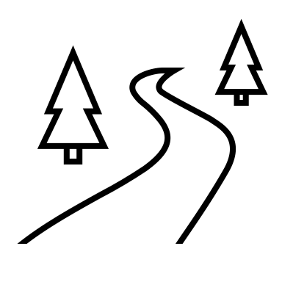

## Time

75 Minutes

This is a suggested amount of time. This lesson may be implemented over a series of days. Educators will make the best judgement on how to implement.

## Materials and resources

* *[Christopher Changes His Name](https://www.nfb.ca/film/christopher_changes_his_name/)* [by Cilia Sawadogo](https://www.nfb.ca/film/christopher_changes_his_name/)[(external resource)](https://www.nfb.ca/film/christopher_changes_his_name/)(National Film Board) (Alternatively, use the book *Christopher Changes His Name* by Itah Sadu, if it is available.)
* Appendix A: Gathering Information and Generating Ideas Template
* Drawing Supplies (e.g., crayons, markers, pencil crayons, etc.)
* Appendix B: Sample Name Art
* Appendix C: Optional Gathering Information and Generating Ideas Template

## Minds on

1. Gather students in a community circle and remind students of the agreed upon agreements (e.g., attentive listening, mutual respect, safety first)
2. Begin with a simple name game energizer, for example, “My Name is…” In the circle, the first student begins by saying “My name is … and I like to … (and adds an action). The rest of the circle then says the student’s name and hobby and copies the action. (e.g., “My name is Christopher and I like to play basketball (he pretends to shoot a ball into a hoop).” The class says, “Christopher likes basketball” (does the action). Let everyone in the circle who wants a turn, have a turn. Students are allowed to pass, if they do not want to participate today.

## Action

### Exploring a mentor text

1. Prior to viewing, listening to, and/or reading the mentor text, use pre-reading/pre-watching strategies to help prompt students to know what they should be looking for and understanding from this text. For example, record responses on anchor charts to the following prompts:
   1. What do you already know about the topic (liking or not liking your name) of this text? (to activate prior knowledge),
   2. What do you think this is about based on the front cover, title or title frame of this text? (to encourage predictions and set a purpose).
2. Show [*Christopher Changes His Name* by Cilia Sawadogo (external resource)](https://www.nfb.ca/film/christopher_changes_his_name/) (National Film Board of Canada) or read it aloud to students (if the book is available).

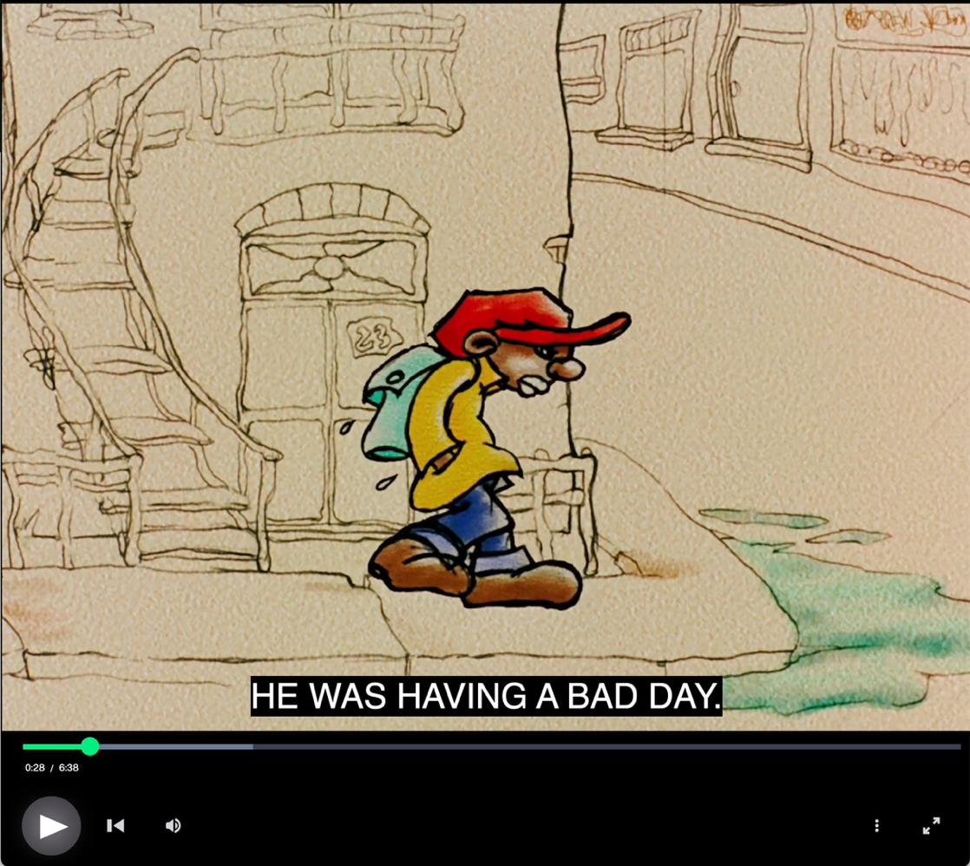

Christopher Changes His Name can be watched, listened to during class.

1. During viewing/reading, ask students to confirm predictions (e.g., Were your predictions correct? Do you have new predictions?)
2. After reading, encourage students to make connections (e.g., How does this text connect to your knowledge and lived experiences (e.g., do you wish you had a different name?)?) and invite students to reflect on key messages they take from the text (e.g., What did you learn from this text?)

### Creating name art

1. Post the following questions (e.g., on an anchor chart):
   1. What is your full name?
   2. How do you pronounce your name(s)?
   3. What is the meaning of your name(s)?
   4. Who named you?
   5. Why were you given your name?
   6. Do you like your name?
   7. Have you ever wanted to change your name? Why? Why not?
   8. Do you have a middle name? A religious name? A family name?
   9. Do you have any nicknames?
2. Invite students to choose at least one of the questions to be able to share information. Have students turn and talk (e.g., with a partner) to share answer(s) to the questions they chose. Reassure students that it is okay not to have answers to all of the questions. Be mindful that some students and their families might not have background to respond to some of the questions.
3. Students are given the *Name Art* template and asked to complete it individually. For answers they are not sure about, they can leave it blank and return to it after asking their families for details about their name, if this information is available. The template is only an example. Students can design their name art in any way that is relevant to the learning goal(s). This learning may be integrated with expectations from The Arts curriculum, and may involve additional learning goals and success criteria related to elements of design and use of techniques. Share work samples of other Name Art pieces, including the example provided (Appendix B).
4. Alternatively, students who do not want to create Name Art for their own name, may choose to complete the activity for a character from a book (e.g., Christopher Kwame, the character from the mentor text used above).
5. Using the example(s), co-create a success criteria with students for their Name Art, for example,
   1. Gather and generate ideas and information about my name
   2. Sort and sequence my information in a way that makes sense
   3. Describe what my name means to me and why it is special
   4. Share my information in an organized way
   5. Use punctuation, especially capitalization, to make my information clear

Note that these criteria are related to the Language expectations. If this learning is integrated with expectations from The Arts curriculum, additional success criteria may apply.

#### Assessment opportunity

As students are working on their Name Art, circulate and make observations and anecdotal notes on how students are gathering, organizing, sorting, and sequencing information. If students are using the Gathering Information Template (Appendix A) (optional), this can also provide assessment information.

## Consolidation

### Sharing identity

1. Gather students in a community circle where they share some of their learning from the lesson. This could also take the format of sharing in small groups, to the whole class, or visiting other classes to share.
2. Post name art in the classroom.

## Possible extensions

* Further explore the concept of names through companion texts (to have available for students to read or as additional read alouds throughout the larger unit this lesson is from):
  + *That’s Not My Name* by Anoosha Syed
  + *Chrysanthemum* by Kevin Henkes
  + *The Name Jar* by Yangsook Choi
  + *My Name is Saajin Singh* by Kulinger Kaur Brar
  + *Alma and How She Got Her Name* by Juana Martinez-Neal

# Appendix A

## Gathering information and generating ideas template

The following questions are intended to be a guide to help students recognize the relationship between the what, the how, and the why of texts to develop their own creativity and independence as text creators. Some of the questions in the framework may be more relevant to some texts than others.

### Questions for students:

How many letters are in your name?

How do you pronounce your name?

How many syllables are in your name?

What is your name?

What is your nickname?

What is the story of your name?

Who named you?

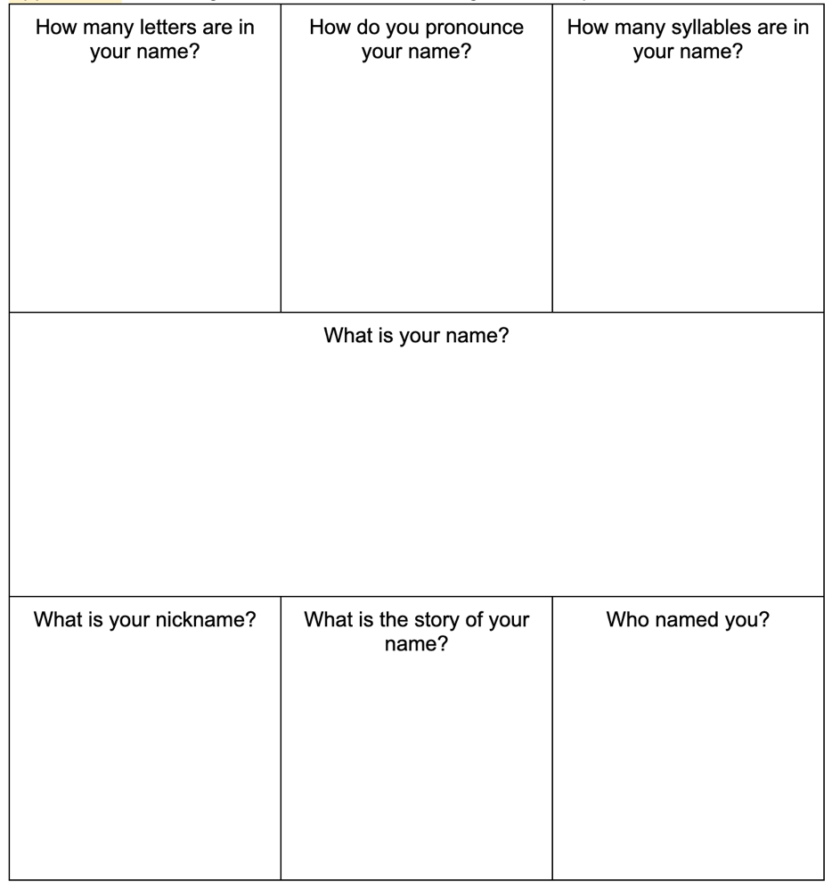

This is a layout example of a printed sheet for students who prefer handwriting. The questions in the sample sheet can be found listed above under Questions for student.

# Appendix B

## Sample Name art

Consider different ways for students to create art related to their name. Using digital platforms may mean clip art, colour, big fonts while using printout sheets may mean colouring pencils, stickers, collage. Here is one example using a printout sheet:

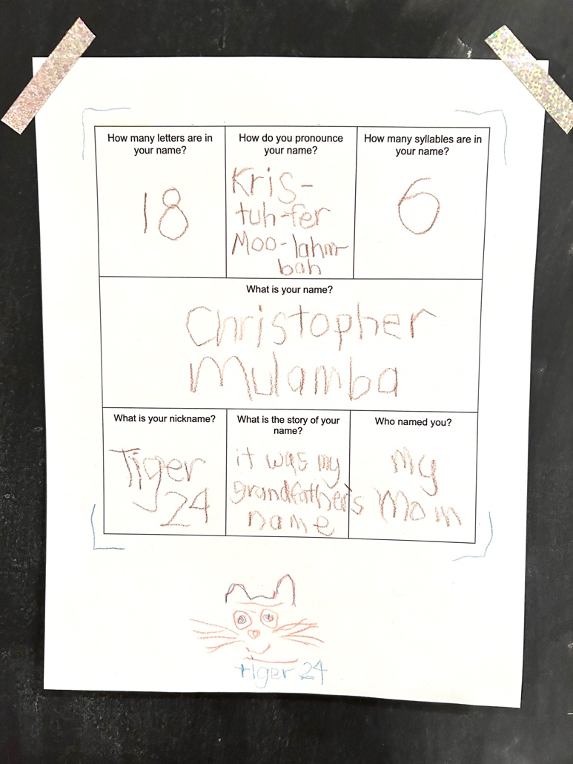

This layout is an example of Name art filled out by hand. Content found on this example is listed below under Content on Sample Name art.

### Content on Sample Name art:

* How many letters are in your name?
  + 18
* How do you pronounce your name?
  + Kris-tuh-fer Moo-lahm-bah
* How many syllables are in your name?
  + 6
* What is your name?
  + Christopher Mulamba
* What is your nickname?
  + Tiger 24
* What is the story of your name?
  + It was my grandfather’s name
* Who named you?
  + My Mom

# Appendix C

## Optional gathering information and generating ideas template

(Send home and collect responses prior to lesson)

What is the story of my name(s)?

Dear Caregivers:

As a class, we are interested in knowing more about the personal stories of how our students received their names. Please take a bit of time to share these stories of your child’s name(s) with them and together complete this task so your child can share what they learned with their class.

Thank you,

Your Teacher

What is your full name?

How do you pronounce your name(s) (e.g., how might you break your name into syllables or parts that show how your name sounds, for example, Kris-tuh-fer for Christopher)?

What is the meaning of your name(s)?

Who named you?

Why were you given your name?

Do you like your name?

Have you ever wanted to change your name? Why? Why not?

Do you have a middle name? A religious name? A family name?

Do you have any nicknames?

# Appendix D

## Curriculum expectations

### A3. Applications, Connections, and Contributions

apply language and literacy skills in cross-curricular and integrated learning, and demonstrate an understanding of, and make connections to, diverse voices, experiences, perspectives, histories, and contributions, including those of First Nations, Métis, and Inuit individuals, communities, groups, and nations

#### A3.2 Identity and Community

demonstrate an understanding of the contributions, lived experiences, and perspectives of a diversity of individuals and communities, including those in Canada, by exploring the concepts of identity, self, and sense of belonging in culturally responsive and relevant texts.

### B3. Language Conventions for Reading and Writing

demonstrate an understanding of sentence structure, grammar, cohesive ties, and capitalization and punctuation, and apply this knowledge when reading and writing sentences, paragraphs, and a variety of texts

#### B3.3 Capitalization and Punctuation

use their understanding of the meaning and function of capitalization and punctuation to communicate meaning clearly, including the use of a capital letter at the beginning of a sentence and the appropriate punctuation mark at the end

### C2. Comprehension Strategies

apply comprehension strategies before, during, and after reading, listening to, and viewing a variety of texts, including digital and media texts, by creators with diverse identities, perspectives, and experience, in order to understand and clarify the meaning of texts

#### C2.3 Monitoring of Understanding: Making and Confirming Predictions

make predictions using background knowledge, text features, and evidence from the text

#### C2.5 Monitoring of Understanding: Making Connections

identify connections between ideas expressed in simple texts and their knowledges and lived experiences, the ideas in other familiar texts, and the world around them

### D1. Developing Ideas and Organizing Content

plan, develop ideas, gather information, and organize content for creating texts of various forms, including digital and media texts, on a variety of topics

#### D1.2 Developing Ideas

generate ideas about given and chosen topics, using simple strategies and drawing on various resources, including their own lived experiences, and learning from other subject areas

#### D1.4 Organizing Content

sort and sequence ideas and information, taking into account the text form and genre to be used

# Attribution license

This lesson plan is published under a [CC BY-NC-SA](https://creativecommons.org/licenses/by-nc-sa/4.0/) license. Third-party resources are subject to their own copyright.



This license enables reusers to distribute, remix, adapt, and build upon the material in any medium or format for noncommercial purposes only, and only so long as attribution is given to the creator. If you remix, adapt, or build upon the material, you must license the modified material under identical terms. CC BY-NC-SA includes the following elements:

  BY: credit must be given to the creator.  
  NC: Only noncommercial uses of the work are permitted.  
  SA: Adaptations must be shared under the same terms.

# Updates

When updates are made to this document, they are tracked below with date and description of update.

* February 2025: initial release