

Allow Me to Introduce Myself

This multi-day day lesson weaves together a variety of expectations across the four strands of the Language curriculum. Students will explore and celebrate their unique characteristics by reflecting on their identity. They will write about what makes them special, including physical traits, talents, hobbies, cultural background, and personal values. Students will learn how to use similes and metaphors to creatively describe their identity. They will write sentences that compare aspects of themselves to other things, enhancing their descriptive language skills and deepening their understanding of identity. Finally, students will be empowered to use their voices and creativity to express their identities in a short poem, followed by a sharing session to reflect on how figurative language enriched their writing.

Grade

4

Curriculum expectations

A3, A3.2, B1, B1.5, C3, C3.1, D1, D1.2, D2, D2.3, D2.5 (see Appendix C for full descriptions)

Strands

A. Literacy Connections and Applications

B. Foundations of Language

C. Comprehension: Understanding and Responding to Texts

D. Composition: Expressing Ideas and Creating Texts

# Contents

Grade 1

Curriculum expectations 1

Strands 2

Contents 3

Learning goals 5

Success criteria 5

Lesson path 6

Time 6

Materials and resources 6

Minds on 7

Action 7

Describing traits 7

Using similes and metaphors 8

Using mentor texts 11

Generating content 12

Exploring spoken word 13

Consolidation 14

Creating spoken word 14

Possible extensions 15

Appendix A 15

Mentor text 1 15

Allow Me to Introduce Myself 15

Appendix B 16

Mentor text 2 16

Dion life 16

Appendix C 17

Curriculum expectations 17

A3. Applications, Connections, and Contributions 17

B1. Oral and Non-Verbal Communication 18

C3. Critical Thinking in Literacy 18

D1. Developing Ideas and Organizing Content 19

D2. Creating Texts 19

Attribution license 21

Updates 21

# Learning goals



We are learning …

* to express our identities through spoken word poetry in order to explore and celebrate who we are

# Success criteria



I can …

* generate ideas about what makes me special and unique
* use figurative language, including metaphors and similes, and other elements of style to describe myself
* select and use a variety of adjectives and “juicy words” that make my meaning clear for my audience
* name a variety of speaking strategies (e.g., voice, gesture, body language) that can be used to communicate ideas and emotions
* draft a spoken word poem using my generated ideas
* self-assess my drafts and make revisions that help to make my work effective for my purpose and audience
* plan the use of speaking strategies that best suit my spoken word poem and what I want to communicate
* deliver my spoken word poem using my planned speaking strategies

# Lesson path



## Time

180 Minutes

This is a suggested amount of time. This lesson may be implemented over a series of days. Educators will make the best judgement on how to implement.

## Materials and resources

* Cue cards (or any type of paper pre-cut into the size of cue cards)
* Chalkboard / Whiteboard / Chart paper
* [Lesson Slides](https://docs.google.com/presentation/d/1yWUjSJyOCYGkgHKV4TxfXpBhccIZXO2l-2TucvscWf8/edit?usp=sharing) (Google slides)
* Mentor text 1 (Appendix A)
* Mentor text 2 (Appendix B)

## Minds on

1. Ask students to think about one thing that makes them unique. Challenge them to try to choose something that no one else knows, but which they feel comfortable eventually sharing with the class. Instruct them not to tell anyone about their unique fact at this point.
2. Ask students to jot down (e.g., on a cue card) their unique quality (e.g., I can solve a Rubik’s cube in 1 minute; I have traveled to 5 countries).
3. Collect the cue cards. Let them know that you will be reading some of the cue cards out loud one at a time. Read one cue card and invite students to guess who in the class they think wrote it. Continue the process with a few more cards (or more as time allows).

## Action

### Describing traits

1. Choose 3 cue cards to use as examples of how to list character traits (e.g., adjectives). Record examples (e.g., on chart paper or using online classroom platforms) so that students can refer to them as inspiration later in the lesson. **Sample Responses:** If a child writes:
   * “I can solve a Rubik’s cube in 1 minute,” some traits they can write on their brainstorming page are: **problem solver, intelligent, speedy**
   * “I have traveled to 5 countries,” some traits they can write are: **adventurous, explorer**
2. Point out that with each example they have written, it tells a story about who they are and some of their unique character traits.
3. Let students know they will be brainstorming words/traits that reflect their identity.
4. Have them complete the **brainstorming web slide** (slide 4) in the [Lesson Slides](https://docs.google.com/presentation/d/1yWUjSJyOCYGkgHKV4TxfXpBhccIZXO2l-2TucvscWf8/edit?usp=sharing) (Google slides) (either digitally or you can print a paper copy) to capture their unique character traits.

#### Assessment opportunity

As assessment *for* learning, circulate and observe how students are able to complete their web independently and identify those who may need additional time and small group support.

As assessment *as* learning, invitestudents can share their brainstorming web with an elbow partner or table group members and provide peer feedback (e.g., a star and a step).

### Using similes and metaphors

1. **Simile Examples:** Project or write these sentences with similes on the board for the students to read and consider:
   * “The house was as black as night.”
   * “She was like a train going full speed.”
2. Using a strategy such as think-pair-share or by having all students jot their thoughts on sticky notes or whiteboards, invite students to respond to the following:
   * What is being compared in each statement? (e.g., “The house is being compared to night.”)
   * What do you think the statement means? (e.g., “I think it means the house was very dark inside and nobody could see.”)
   * Why would an author use this in their writing? (e.g., “It’s more exciting to say it this way.” or “It puts a picture in my head like a scene from a movie.”)
3. **Metaphor Examples:** Project or write these sentences with metaphors on the board:
   * “Your mind is a garden, always growing.”
   * “Life is a rollercoaster with ups and downs.”
4. Similar to the simile examples, invite students to respond to the following:
   * What is being compared in each statement? (e.g., “Your mind is being compared to something that grows in a garden, like plants.”)
   * What do you think the statement means? (e.g., “I think it means that plants grow and your mind grows with every new thing you learn.”)
   * Why would an author use this in their writing? (e.g., “It makes me see it in my mind, like watching something on TikTok or TV.”)
5. Now ask students to compare the first two statements (similes) with the last two (metaphors) and see what they notice. Then review the terminology: simile, metaphor and figurative language.
6. Co-create definitions for simile and metaphor (slide 6), and record these definitions on a figurative language anchor chart. Definitions for [metaphor (external resource)](https://www.dcp.edu.gov.on.ca/en/curriculum/elementary-language/glossary#m) and [simile (external resource)](https://www.dcp.edu.gov.on.ca/en/curriculum/elementary-language/glossary#s) in the curriculum document may provide a useful reference.
7. Using examples (slides 7 – 10), have students distinguish between similes and metaphors.

[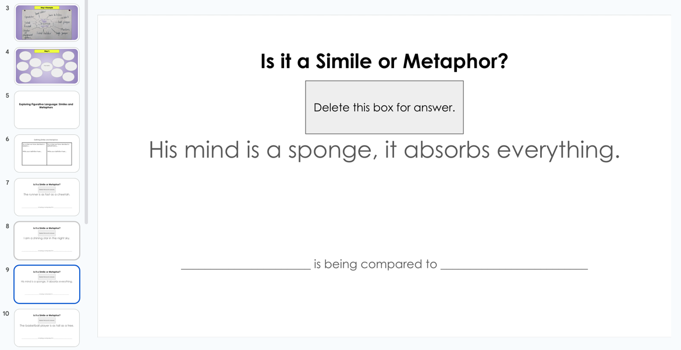](https://docs.google.com/presentation/d/1yWUjSJyOCYGkgHKV4TxfXpBhccIZXO2l-2TucvscWf8/edit#slide=id.g27fb98b8ad6_0_58)

Slide 9 of the lesson slide deck is one of four simile and metaphor activities slides.

#### Assessment opportunity

Invite students to create their own similes and metaphors (slides 11 – 12), checking that they are making a distinction between the two and that students are being figurative rather than creating literal comparisons. Provide feedback as needed to support students’ use of similes and metaphors in their own writing.

### Using mentor texts

1. Project or hand out a copy of the poem, “Allow Me to Introduce Myself” by Charles R. Smith Jr. (Mentor text 1 (Appendix A)) to use as a mentor text (slide 14). The poem is also available [on his YouTube channel (external resource)](https://youtu.be/Vf2185xss6o).

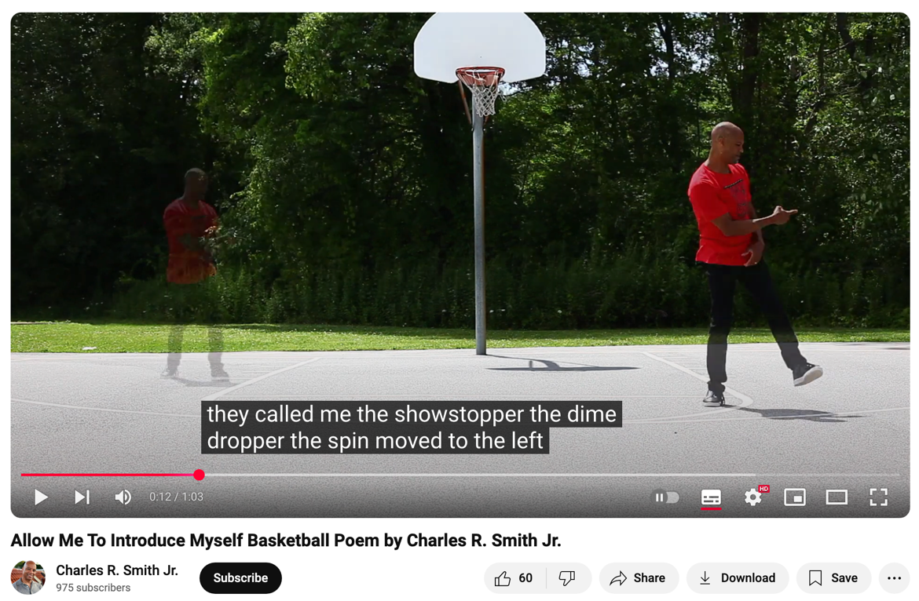

Including different modalities in a lesson can enhance learning. Here Charles R. Smith Jr. performs his poem on a basketball court in a YouTube video. Captions can be turned on to support better accessibility.

1. As they read and/or listen to the poem, ask students to list the descriptors the writer uses to describe himself. Record their thinking. Point out how the writer uses mostly nouns to indicate his personal traits (e.g., “the creator,” “the legend”, “the net-shaker”). Using a turn-and-talk, invite students to discuss what these descriptors mean. Invite students to share their thinking.
2. As an extension, invite students to generate some adjectives that might be suggested by these descriptions used in the poem. Add these to the record of thinking (e.g., on chart paper).
3. Shift the exploration to looking at the way the poem is put together. As a mentor text, invite students to describe what they see in terms of the writer’s craft (e.g., the structure of the poem). It may be useful to annotate the poem (e.g., on the board), incorporating the students’ thinking. Responses may include how the writer uses a list and how the writer uses rhyme.
4. Use additional mentor texts to show the writer’s craft (e.g., by asking students to notice and by gathering students’ thinking by annotating the poem on the board). For example, “Dion life” (Mentor text 2 (Appendix B)) uses a different structure compared to “Allow Me to Introduce Myself.” Also note that “Dion life” uses similes.

### Generating content

1. Give each student 10 strips of paper. (Offering different ways (e.g., voice to text, word processing) of generating content can support a diversity of needs that educators may or may not be aware of in a cohort.)
2. Invite students to create lines (that may be used to create their poems), specifically by making similes, metaphors and statements about themselves and their identity. After some initial drafting, ask students to write their similes, metaphors and statements, one on each strip of paper. Provide a range of support for students as they are drafting their content, including using translanguaging for Multilingual Learners.
3. Once students have generated a collection of strips, invite them to explore ways to arrange their lines in an order that makes sense to them, focusing on how the lines flow together and how the similes, metaphors and statements build upon each other. Through this exploration, students may want to create additional lines to enhance the meaning, connections or flow of their poem. Be sure to encourage creativity and let them know there is no “right” order. Students can play with different combinations until they find one that resonates.
4. Referring to the mentor texts, let students know they can also adjust and add words if they want to make certain parts rhyme or introduce a bit of repetition.

### Exploring spoken word

1. Focusing on [Charles R. Smith Jr.’s delivery of his poem (YouTube video)](https://youtu.be/Vf2185xss6o), ask students to name speaking strategies (e.g., expression, gestures, body language) the poet uses to make his delivery more effective and to enhance the meaning of the poem. Record student ideas on an anchor chart. Multiple viewings may be beneficial, setting a purpose for each viewing (e.g., listen for expression, watch for use of gestures).
2. Invite students to revisit their own poems, and based on the analysis of the spoken word delivery, ask them to consider if there are further revisions they might make.
3. Once students find a form of their poem that resonates with them, have them experiment with different ways to present it, such as adding rhythm and beats.

#### Assessment opportunity

As students are experimenting with ways to deliver their poem, prompt them to refer to the speaking strategies anchor chart. Conference with students, individually or in small groups, about their choices related to the speaking strategies and why they have made those decisions (as assessment *as* learning).

## Consolidation

### Creating spoken word

1. Invite students to rehearse their delivery to an elbow partner. Each partner can share what they appreciated about their partner’s poem and give them one suggestion to help make it even better. Remind students to use the anchor charts to help them make helpful statements about their peers’ work.
2. After opportunities to rehearse their poems, ask each student to put a star on their favourite line from their poem and share why they chose it with a classmate or their table group.

#### Assessment opportunity

Once students have had a chance to rehearse and make changes based on feedback, they can present their polished spoken word poems to the class.

## Possible extensions

* Students can create a poster that explains the difference between similes and metaphors, including examples and then present them to the class.
* Creative writing: Use a writing prompt that requires the students to use similes and metaphors. (i.e. Describe your perfect day using at least 3 similes and 3 metaphors).
* Use famous Canadians that your students admire (e.g., Andre De Grasse (sprinter), Norval Morrisseau (visual artist)) and have them generate a list of traits about them.
* Create a visual collage using images, words, and colors that represent different aspects of their identity.
* Create a class poetry anthology.
* Invite students to perform their pieces at a spoken word “café.”
* Students can illustrate their poem or to visually represent the similes, metaphors and statements.

# Appendix A

## Mentor text 1

### Allow Me to Introduce Myself

by Charles R. Smith, Jr.

They call me the showstopper

the dime dropper

the spin-move-to-the-left reverse jam poppa.

The high flier on the high wire.

The intense rim-rattin’ noise amplifier.

The net-shaker

Backboard breaker

Creator of the funky dunk hip-shaker

The man Sir Slam

The Legend

I Be.

Those are a few

Of the names

They call me.

From *Hip Hop Speaks to Children: A Celebration of Poetry with a Beat* written by Nikki Giovanni and illustrated by Alicia Vergel de Dios and Damian Ward

# Appendix B

## Mentor text 2

### Dion life

Dion T.

My life is as great as a millionaire, I can play games

I can eat like a panda

I can sleep like a ninja

I have a cool life as a famous guy

I have a fun life like at a party

I have a great life like it’s hot outside

Who doesn’t like games? They are as fun as going outside!

Who doesn’t like food? Tasty as a hotdog!

Who doesn’t like sleep? It feels like you are laying on the clouds!

From [4th Graders Write About Identity (external resource)](https://www.poetrycenter.org/4th-graders-write-about-identity/)

# Appendix C

## Curriculum expectations

### A3. Applications, Connections, and Contributions

apply language and literacy skills in cross-curricular and integrated learning, and demonstrate an understanding of, and make connections to, diverse voices, experiences, perspectives, histories, and contributions, including those of First Nations, Métis, and Inuit individuals, communities, groups, and nations

#### A3.2 Identity and Community

demonstrate an understanding of the historical contexts, contributions, lived experiences, and perspectives of a diversity of individuals and communities, including those in Canada, by exploring the concepts of identity, self, and sense of belonging in a variety of culturally responsive and relevant texts

### B1. Oral and Non-Verbal Communication

apply listening, speaking, and non-verbal communication skills and strategies to understand and communicate meaning in formal and informal contexts and for various purposes and audiences

#### B1.5 Word Choice, Syntax, and Grammar in Oral Communication

use appropriate word choice, including new vocabulary, varied adjectives and adverbs to elaborate, a variety of sentence types, and cohesive sentences during formal and informal communication, to support audience comprehension

### C3. Critical Thinking in Literacy

apply critical thinking skills to deepen understanding of texts, and analyze how various perspectives and topics are communicated and addressed in a variety of texts, including digital, media, and cultural texts

#### C3.1 Literary Devices

describe literary devices, including personification and anthropomorphism, in a variety of texts, and explain how they help create meaning and are appropriate for the intended purpose and audience

### D1. Developing Ideas and Organizing Content

plan, develop ideas, gather information, and organize content for creating texts of various forms, including digital and media texts, on a variety of topics

#### D1.2 Developing Ideas

generate and develop ideas about various topics, such as topics related to diversity, equity, and inclusion and to other subject areas, using a variety of strategies, and drawing on various resources, including their own lived experiences.

### D2. Creating Texts

apply knowledge and understanding of various text forms and genres to create, revise, edit, and proofread their own texts, using a variety of media, tools, and strategies, and reflect critically on created texts

#### D2.3 Voice

establish a personal voice in their texts, using varied language and elements of style to express their thoughts, feelings, and opinions about a topic, and using a tone appropriate to the form and genre

#### D2.5 Revision

make revisions to the content of draft texts and to elements of style, such as word choice and adding or deleting sentences, to improve clarity, focus, and coherence, seeking feedback

# Attribution license

This lesson plan is published under a [CC BY-NC-SA](https://creativecommons.org/licenses/by-nc-sa/4.0/) license. Third-party resources are subject to their own copyright.



This license enables reusers to distribute, remix, adapt, and build upon the material in any medium or format for noncommercial purposes only, and only so long as attribution is given to the creator. If you remix, adapt, or build upon the material, you must license the modified material under identical terms. CC BY-NC-SA includes the following elements:

  BY: credit must be given to the creator.  
  NC: Only noncommercial uses of the work are permitted.  
  SA: Adaptations must be shared under the same terms.

# Updates

When updates are made to this document, they are tracked below with date and description of update.

* February 2025: initial release