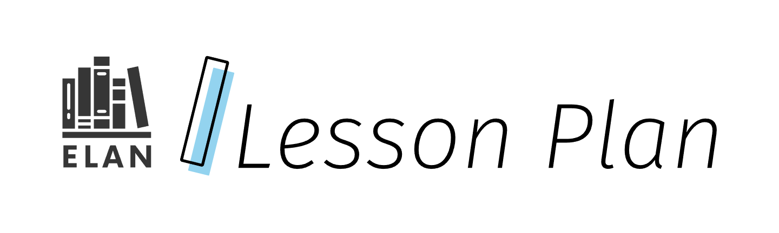

What Brings Me Joy

In this multi-block/multi-day lesson, students will explore the concept of joy and how it relates to their personal identity. Through a series of provocations and creation activities, students will explore what brings them joy, recognize the importance of these sources in their lives, and learn strategies to cultivate joy on a regular basis. By connecting joy with their sense of self, students will plan and create digital media (a one-minute video) that expresses who they are. This lesson aims to empower students to embrace their unique sources of joy and integrate them into their daily lives, fostering a positive and fulfilling sense of identity.

Grade

6

Curriculum expectations

A2., A2.6, C1, C1.4, D1, D1.5, D3, D3.2 (see Appendix A for full descriptions)

Strands

A. Literacy Connections and Applications

C. Comprehension: Understanding and Responding to Texts

D. Composition: Expressing Ideas and Creating Texts

# Contents

Grade 1

Curriculum expectations 1

Strands 1

Contents 2

Learning goals 4

Success criteria 4

Lesson path 5

Time 5

Materials and resources 5

Minds on 5

Action 7

Exploring the meaning of joy 7

Using a design process 8

Posing a design question 8

Designing 9

Building 10

Testing and refining 10

Improving 11

Consolidation 11

Share the joy 11

Possible extensions 12

Appendix A 14

Curriculum expectations descriptions 14

A2. Digital Media Literacy 14

C1. Knowledge about Texts 14

D1. Developing Ideas and Organizing Content 15

D3. Publishing, Presenting, and Reflecting 15

Attribution license 15

Updates 16

# Learning goals



We are learning …

1. Explain what it means to be a content creator who uses various processes, skills, strategies and tools to create digital media.
2. Use a design process to create digital media in order to communicate what joy means in our lives.

# Success criteria



I can …

* describe aspects in my life that bring me joy.
* describe how these aspects have meaning in relation to my identity.
* identify the steps of a design process (e.g., [engineering design process (external resource)](https://www.dcp.edu.gov.on.ca/en/curriculum/science-technology/context/processes#:~:text=publish%20the%20work-,Engineering%20Design%20Process,-An%20engineering%20design)).
* use a design process to help me through iterations of my digital media project.
* describe how techniques of digital and media texts (e.g., animations, text size, colour, audio elements, graphics) impact the audience.
* generate ideas and content about what brings me joy.
* apply digital and media techniques in my digital media creation for specific purposes and audiences.
* self-assess the digital and media techniques I used in my digital media creation.
* offer feedback to peers’ digital media to provide critical self-reflection and constructive feedback for my peers.

# Lesson path



## Time

180 Minutes

This is a suggested amount of time. This lesson may be implemented over a series of days. Educators will make the best judgement on how to implement.

## Materials and resources

* [Lesson slide deck: What Brings Me Joy (Google Slides)](https://docs.google.com/presentation/d/1WvFKW_LUgPNKruoyGqRLwpBT94WzFu2lb6eQMmNDWh0/edit?usp=sharing)
* Video editing application (e.g., WeVideo, CapCut, iMovie) to create one-minute videos

## Minds on

1. Invite students to stand in response to a number of “This or That” images (provocations) to foster enthusiasm and participation. (Slides 2-17). Students will move towards the side of the space (e.g., left to right) that corresponds with their preferred image (e.g., salty snacks or savoury snacks; indoor physical education or outdoor physical education). Upon completion of this activity, ask students to take a seat.

[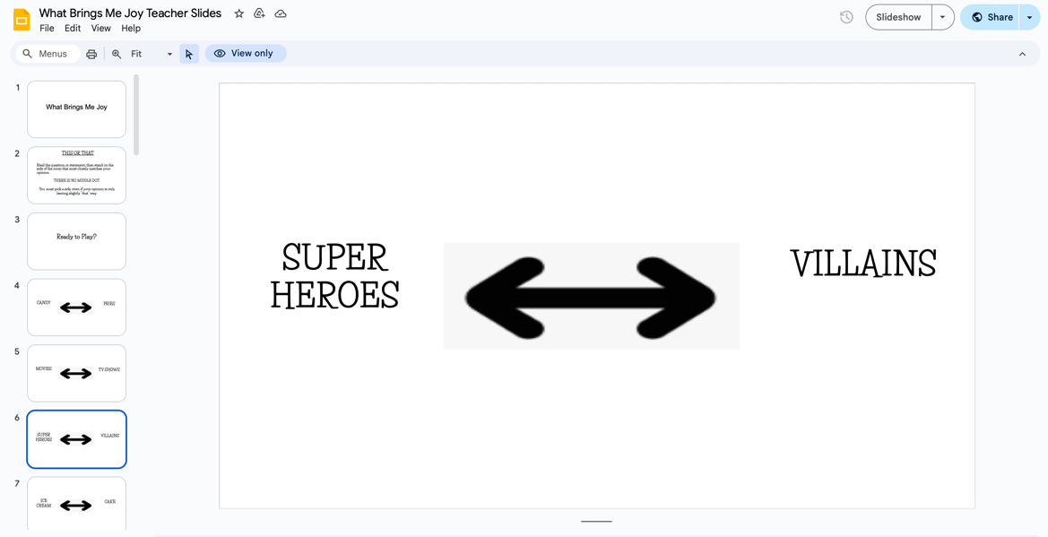](https://docs.google.com/presentation/d/1WvFKW_LUgPNKruoyGqRLwpBT94WzFu2lb6eQMmNDWh0/edit#slide=id.g2eae443557a_0_519)

Slide 6 is one of several “this or that” examples found in the lesson slide deck.

1. Post the following questions to guide a whole class discussion (Slide 18):
2. What helped you make a decision?
3. Were some harder to choose between than others?
4. Does the one you chose bring you joy?
5. How do you know it brings you joy?

[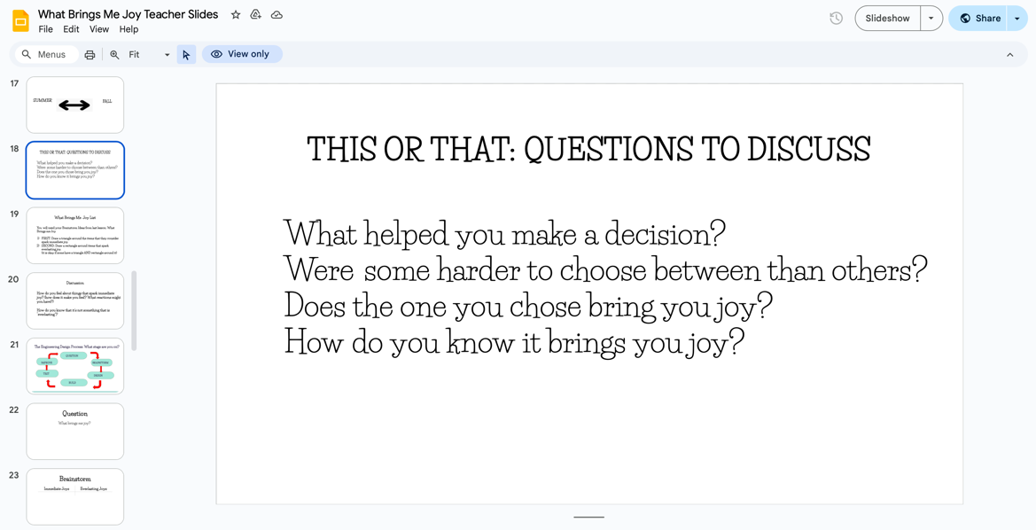](https://docs.google.com/presentation/d/1WvFKW_LUgPNKruoyGqRLwpBT94WzFu2lb6eQMmNDWh0/edit#slide=id.g2eae443557a_0_591)

Slide 18 of the lesson slide deck includes the four prompt questions for class discussion.

1. Invite students to individually brainstorm (e.g., by jotting ideas or using other brainstorm strategies) some items that bring them joy. Using their generated ideas, have students think of a few that hold the most meaning to them.
2. Through class discussion, have students volunteer some of the items and record responses (e.g., on the board). Extend the discussion by posing the question: What are ways we could categorize any of these items (e.g., hobbies, food, family, friends)?
3. Share the lesson’s big idea: While it’s important to enjoy the small, immediate joys of life, it’s equally important to invest in activities and goals that provide lasting satisfaction and meaning.

## Action

### Exploring the meaning of joy

1. Building on the Minds On brainstorm, pose the question to do a re-sort: How could we re-group some of your ideas into immediate joy and lasting joy?
2. These items may be coded (e.g., draw a triangle around the items that they consider to spark immediate joy and a rectangle around items that spark everlasting joy). Provide examples, as needed, to guide students’ thinking (e.g., “I get a free taster sample at Costco and it’s delicious!” versus, “I come home from a long day at school and I get to relax with a good book”). Note that students may suggest identifying some items as both immediate and everlasting. (Slide 19)
3. Have students return to their individual brainstorming and invite them to sort or code items that they consider to be sources of immediate joy and everlasting joy. Invite students to turn and talk and share how they have identified or organized their ideas (Slide 20).
   * + 1. How do you feel about things that spark immediate joy?
       2. How do you know that it’s not something that is “everlasting”?

### Using a design process

1. Share with students (or co-create) a design process (e.g., [engineering design process (external resource)](https://www.dcp.edu.gov.on.ca/en/curriculum/science-technology/context/processes#:~:text=publish%20the%20work-,Engineering%20Design%20Process,-An%20engineering%20design)). Post the process (e.g., as an anchor chart) (Slide 21 in the lesson slide deck provides a sample process). Walk students through where they are in the process. During the process, note that students may be at different stages. Explain to students that the design process is *iterative*, meaning that it’s fluid and they can move in either direction depending on what stage we are. The process may not always be linear.

[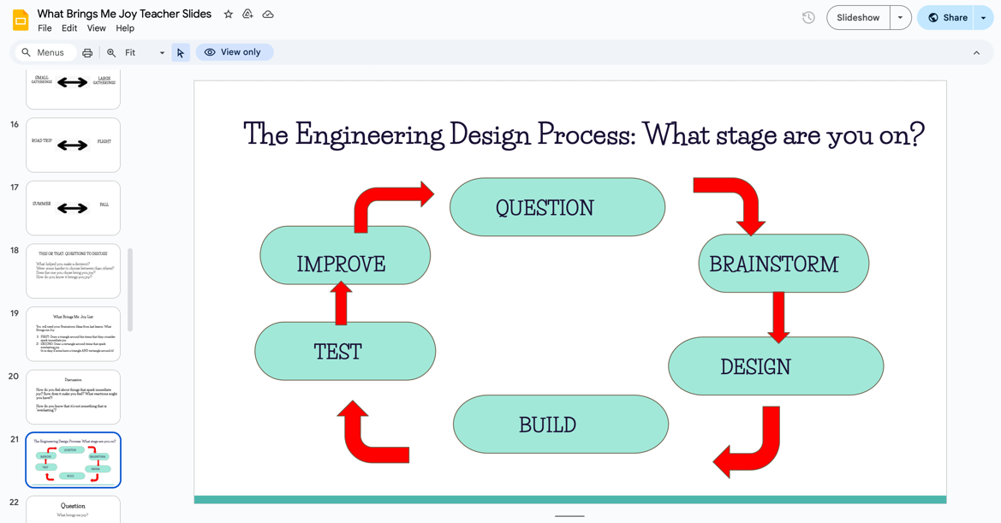](https://docs.google.com/presentation/d/1WvFKW_LUgPNKruoyGqRLwpBT94WzFu2lb6eQMmNDWh0/edit#slide=id.g2eae6eb0ae6_0_76)

Slide 21 of the lesson slide deck shows the engineering design process in a diagram so students can identify where they are in the process.

### Posing a design question

1. To begin the design process, **pose the question:** What brings me joy (Slide 22)? Use the prompt to move into brainstorming. Have each student generate ideas about what are their personal immediate joys and everlasting joys (Slide 23). Encourage students to draw on ideas that were generated earlier in the lesson.

### Designing

1. Have students begin to design what their one-minute videos might look like. Remind students that, in their video, they will include images that represent their sources of joy, both immediate and everlasting. During the **Design** phase (Slide 24), students may begin to
2. Gather images that represent the joys they identified.
3. Draft content (e.g., for voice overs) or plan audio to accompany their images.
4. Determine a sequence for the images and content for their video. Students may wish to use a set of slides or other tools to storyboard their video.
5. **Pose the question:** What makes a video engaging and effective? Co-construct a set of characteristics to post (e.g., as an anchor chart). Revisit these characteristics at various times during the process to add or revise characteristics and as a way for students to self-assess their products.

#### Assessment opportunity

At various points in the process, assess students’ progress. For assessment *for* learning, gather evidence to gauge how students are doing. Some may need a midpoint check as a whole class to review their task. For assessment *as* learning, ask students to self-assess their content so far by posing the following questions:

1. What stage of the process are you at?
2. Do the items that you have chosen reflect your identity?
3. Are any additions or revisions required?

### Building

During the **Build** phase of the process, have students use a video editor software (e.g., WeVideo, CapCut, iMovie) to input images, audio and text to make draft video. (Slides 26-34 in the lesson slide deck outline steps to create a video.)

* Explicitly teach students how to import images, files, videos into the desired program. They may add to the number of items that they brainstormed as new ideas emerge. Stock photos may be used. Ensure images of others are not included without permission.
* Explicitly teach students how to publish/export file so that they can share with their teacher. Remind students that this is the first version of their video, and that they may be making revisions based on feedback.

### Testing and refining

1. During the **Test** phase of the process, return to the list of characteristics generated for What makes a video engaging and effective. In a whole class discussion, ask students if there are any other characteristics that should be added. Remind students that these characteristics can be used to assess their draft videos (Slide 35).

[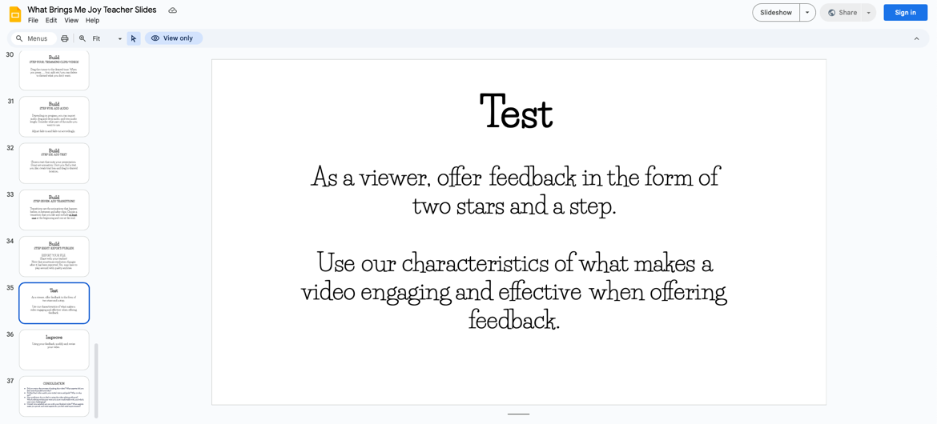](https://docs.google.com/presentation/d/1WvFKW_LUgPNKruoyGqRLwpBT94WzFu2lb6eQMmNDWh0/edit#slide=id.g32f9803e88e_0_27)

Slide 35 of the lesson slide deck is the test phase after the eight-step building phase.

#### Assessment opportunity

Establish small groups so that students can give each other feedback on their draft videos. Peer feedback may take the form of sharing two stars and a step related to the engaging and effective video characteristics.

### Improving

1. During the improve phase of the design process, students use their feedback to make modifications to their draft video (Slide 36).

## Consolidation

### Share the joy

1. Once students have completed their videos, have them share with an audience. This could include within the class and sharing with others in the school community.

#### Assessment opportunity

As an assessment as learning, invite students to respond to the following questions (e.g., in a journal or a think-pair-share) (Slide 37):

1. Did you enjoy the process of making this video? What aspects did you find most enjoyable and why?
2. Did the final video match your initial vision and goals? Why or why not?
3. How proficient do you feel in using the video editing software? Which editing techniques were you most comfortable with, and which ones were challenging?
4. Overall, how satisfied are you with your finished video? What aspects make you proud, and what aspects do you feel need improvement?

## Possible extensions

* Incorporate read alouds on the theme of joy, for example,

1. *My Heart Fills with Happiness* by Monique Gray Smith: A book written to support the wellness of Indigenous children and families reminds both children and grownups to cherish the moments of joy that we have in life (both people and things!)
2. *Maybe Something Beautiful: How Art Transformed a Neighbourhood* by Theresa Howell and Rafael Lopez: A book based on a true story that talks about how art can uplift a neighborhood and spread joy.
3. *Happy Right Now* by Julie Berry and Holly Hatam: A book about finding moments of joy in every situation.

* Make cross-curricular connections to the theme of joy, for example,
  1. In Social Studies: Examine how different cultures within Canada find and express joy through traditions, celebrations, and community activities (e.g., share videos, create slideshows, create posters, invite students to share items from home).
  2. In Language: Use writing and oral communication activities to express personal sources of joy and how they relate to individual identity (e.g., journal prompts, letter writing, “Speakers’ Corner”).
  3. In The Arts: Create visual art projects that depict personal sources of joy and how they contribute to the students’ sense of identity (e.g., picture collage, photography montage).

# Appendix A

## Curriculum expectations descriptions

### A2. Digital Media Literacy

Demonstrate and apply the knowledge and skills needed to interact safely and responsibly in online environments, use digital and media tools to construct knowledge, and demonstrate learning as critical consumers and creators of media.

#### A2.6 Innovation and Design

Select and use appropriate digital and media tools to support the design process and address authentic, relevant, real-world problems by developing innovative solutions.

### C1. Knowledge about Texts

Apply foundational knowledge and skills to understand a variety of texts, including digital and media texts, by creators with diverse identities, perspectives, and experience, and demonstrate an understanding of the patterns, features, and elements of style associated with various text forms and genres.

#### C1.4 Visual Elements of Text

Analyze and compare how images, graphics, and visual design create, communicate, and contribute to meaning in a variety of texts.

### D1. Developing Ideas and Organizing Content

Plan, develop ideas, gather information, and organize content for creating texts of various forms, including digital and media texts, on a variety of topics.

#### D1.5 Reflecting on Learning

Explain and compare how the strategies and tools used helped them develop ideas and organize content for texts of the chosen forms, genres, and media, and how they helped them improve as a text creator.

### D3. Publishing, Presenting, and Reflecting

Select suitable and effective media, techniques, and tools to publish and present final texts, and critically analyze how well the texts address various topics.

#### D3.2 Publishing and Presenting Texts

Publish and present texts they have created, using selected media and tools, and analyze how their choices helped them communicate their intended message.

# Attribution license

This lesson plan is published under a [CC BY-NC-SA](https://creativecommons.org/licenses/by-nc-sa/4.0/) license. Third-party resources are subject to their own copyright.



This license enables reusers to distribute, remix, adapt, and build upon the material in any medium or format for noncommercial purposes only, and only so long as attribution is given to the creator. If you remix, adapt, or build upon the material, you must license the modified material under identical terms. CC BY-NC-SA includes the following elements:

  BY: credit must be given to the creator.  
  NC: Only noncommercial uses of the work are permitted.  
  SA: Adaptations must be shared under the same terms.

# Updates

When updates are made to this document, they are tracked below with date and description of update.

* February 2025: initial release