

Exploring Perspectives through Poetry

This lesson provides students with the opportunity to read a collection of poems focusing on similar content and analyze them for themes, language, and structure. From here, students will make connections about the relationships between perspectives of the poets and their poems. Finally, students will draw conclusions about the importance of learning from others’ perspectives.

Grade

7

Curriculum expectations

A3, A3.2, C1, C1.2, C3, C3.1, C3.3, C3.6 (see Appendix F for full descriptions)

Strands

A. Literacy Connections and Applications

C. Comprehension: Understanding and Responding to Texts

# Contents

Grade 1

Curriculum expectations 1

Strands 1

Contents 2

Learning goals 4

Success criteria 4

Lesson path 5

Time 5

Materials and resources 5

Minds on 6

Action 7

Reading a poem 7

Using literary devices 7

Exploring more poems 8

Defining terms 9

Exploring perspectives 9

Consolidation 10

Determining symbolic meanings 10

Possible extensions 11

Appendix A 12

Allowables 12

Appendix B 13

Mercy 13

Appendix C 14

Mimesis 14

Appendix D 15

Hexagons 15

Appendix E 16

Exit ticket 16

Appendix F 17

Curriculum expectations 17

A3. Applications, Connections, and Contributions 17

C3. Critical Thinking in Literacy 18

References 19

Attribution license 20

Updates 20

# Learning goals



We are learning …

1. use critical thinking skills and comprehension strategies to analyze and understand texts.
2. explain what and how we can learn from other perspectives and people’s lived experiences

# Success criteria



I can …

* define symbolism and allegory
* define community, diversity, identity, lived experience, perspective, sense of belonging, and voice
* determine key information in a text
* explain the symbolism and use of allegory in a text
* explain how a text might reflect information and ideas related to perspectives and lived experiences
* describe connections I am making among concepts, ideas and with the perspectives and lived experiences evident in texts

# Lesson path



## Time

100 Minutes

This is a suggested amount of time. This lesson may be implemented over a series of days. Educators will make the best judgement on how to implement.

## Materials and resources

* + “Allowables” by Nikki Giovanni (Appendix A)*
  + “Mercy” by Rudy Francisco (Appendix B)*
  + “Mimesis” by Fady Joudah (Appendix C)*
  + [Video of Rudy Francisco reading “Mercy”](https://www.youtube.com/watch?v=NLwhM13Qnrg) (external resource)
  + Hexagons (Appendix D)
  + Exit ticket (Appendix E)

* These poems were selected because they are contemporary texts from diverse poets. They are linked by content and theme, and are short and accessible. Each employs both symbolism and allegory, two literary devices named specifically in SE C3.1. Teachers may, of course, replace these poems with other texts based on their knowledge of their students’ specific learning needs and interests.

## Minds on

1. Engage students in a brief whole-group discussion: “Who has heard that you eat eight spiders per year by swallowing them while you’re sleeping?” (This is, of course, false. Students may want a minute or two to fact-check the story. A quick web search will reveal any number of articles and videos that debunk the myth. One site to use is [Snopes (external resource)](https://www.snopes.com/))
2. Discuss: “What makes this story so ‘sticky’ (in other words, why is this myth so persistent and repeated)?”
3. Organize small groups (e.g., 3-4 students). Give each group a set of hexagons (Appendix D). Instruct groups to take “spiders” as their topic and record one word related to this topic per hexagon. Alternatively, provide groups with hexagons that already have words recorded on them; for example: *web, arachnophobia, Halloween, venom, insect, predator, bite, Black Widow, Spiderman, silk*.
4. Instruct groups to discuss connections between the words and collaboratively arrange the hexagons so that connected concepts touch one another. (See [Background to Hexagonal Thinking (external resource)](https://www.cultofpedagogy.com/hexagonal-thinking/).) Emphasize that there are no right or wrong answers with this activity; the goal is to think about, discuss and be able to explain possible connections.
5. Do a gallery walk by inviting students to view other groups’ hexagonal thinking arrangements. Following the gallery walk, invite spokespeople of groups to share and explain one or two of their hexagonal connections with the whole group.
6. Students will be revisiting their hexagonal thinking as the lesson progresses (e.g., to add and/or modify their thinking). Establish a way of having students keep their arrangements, or have them take a photo (e.g., using a classroom device or, if permitted, using the students’ phones) of the hexagons to recreate the arrangement later.

## Action

### Reading a poem

1. Read aloud Nikki Giovanni’s poem, “Allowables” (Appendix A). Identify and clarify vocabulary that may be unfamiliar (e.g., recluse, black widow) before reading it aloud again.  
   Invite students to discuss the poem with a partner using one or more of the following prompts to guide turn-and-talk:
   1. What happens?
   2. What surprises you?
   3. What sticks out to you?

#### Assessment opportunity

Listen to students’ paired talk and determine their understanding of the poem. Monitor which questions students are using to guide their talk. For example,

* + If students are using the “What happens?” question, assess their abilities to retell the sequence of events in the poem in a coherent and concise manner.
  + If students are using the “What surprises you?” question, assess their abilities to identify and describe meaningful shifts or turns in the poem.
  + If students are using the “What sticks out to you?” question, assess their abilities to describe key ideas related to the poem.

### Using literary devices

1. Share the definitions of [allegory (external resource)](https://www.dcp.edu.gov.on.ca/en/curriculum/elementary-language/grades/grade-7/glossary) and [symbolism (external resource)](https://www.dcp.edu.gov.on.ca/en/curriculum/elementary-language/grades/grade-7/glossary#s) (e.g., on an anchor chart).
2. Invite students to analyze the poem, including how allegory and symbolism is used, in one or more of the following ways:
   1. Whole class instruction in which the teacher models the analysis process through a think-aloud,
   2. Student-led work in which small groups support one another in the analysis and the teacher circulates and offers support as required, or
   3. A hybrid approach in which some groups are guided by the teacher in the analysis and other groups work independently.
3. Guide students to make connections between the use of the literary devices and the meaning and message of the poem.

#### Assessment opportunity

Engage students in assessment *as* learning/metacognitive reflection by asking:

* + Name some of the activities we have done so far that helped our learning?” (Sample answers may include: activating prior knowledge, web search/fact checking, brainstorming, whole group discussion, small group discussion, hexagonal thinking, making connections, individual listening to a reading, textual analysis, reflection, small group work, partner discussion, guided practice.)

Invite students to share: “Which activities did you find most helpful? Why?”

### Exploring more poems

1. Share the poems “Mercy” by Rudy Francisco (Appendix B) and “Mimesis” by Fady Joudah (Appendix C). Read each poem aloud, and/or view the [video of Rudy Francisco reading “Mercy” (external resource)](https://www.youtube.com/watch?v=NLwhM13Qnrg). Identify and clarify vocabulary that may be unfamiliar (e.g., mimesis).
2. Instruct students to select one of these poems to analyze, specifically thinking about how symbolism and allegory are used, with an ultimate focus on the poem’s message/theme. Give students the opportunity to explore their chosen poem through one or more of the following approaches based on student needs:
   1. Guided groups with teacher support
   2. Small group work
   3. Individual analysis.

### Defining terms

1. Reconvene small groups. Have students use the hexagonal thinking strategy again, this time using the following set of terms: community, diversity, identity, lived experience, perspective, sense of belonging, and voice. Ask groups to use AI or another source to generate or find definitions of each of the terms.
2. Gather groups’ definitions of these terms and come to a shared understanding of what each of these mean. Record these definitions (e.g., on an anchor chart).
3. Invite groups to make connections among the terms using hexagonal thinking. Have groups describe their connections and explain their arrangement of terms as shown through their hexagons.

### Exploring perspectives

1. As a whole class, pose the question for discussion: What do you think each poet wants us to understand (based on each of poems)? As students share their thinking, point out how the responses may relate to the themes of the poems. Prompt students to extend their thinking (e.g., What are you using from the poem to give you that idea?).
2. Share short bios for each of the poets: [Nikki Giovanni (external resource)](https://www.poetryfoundation.org/poets/nikki-giovanni), [Rudy Francisco (external resource)](https://www.iamrudyfrancisco.com/bio), and [Fady Joudah (external resource)](https://www.poetryfoundation.org/poets/fady-joudah). Ask students to read (or read aloud to the students) to
   1. identify key information about the poets’ backgrounds, and
   2. generate questions students would want to ask (e.g., the poets themselves) to know about the poets’ lived experiences.
3. Extend the discussion by asking students
   1. How might the individual poems reflect something related to the poets’ experiences?
   2. How might reading (in general) help us think about and understand others?

## Consolidation

### Determining symbolic meanings

1. Have groups return to their initial spider hexagonal thinking arrangements. Explain to students that their initial thinking about spiders may have been based more on literal meanings, and that now they may have ideas about spiders that are based more on symbolic meanings as a result of looking at the poems.
2. Ask groups to revise and / or recreate their spider hexagonal thinking to reflect symbolic meanings of spiders. Tell students they can reuse some of their original words and add new words that are relevant.
3. Invite students to share the connections in their new hexagonal arrangement.

#### Assessment opportunity

Invite students to complete an exit ticket (Appendix E). Use the responses to the prompts on the exit ticket to assess the degree to which students are able to

* + describe symbolic meaning in relevant ways (through the sentence stems)
  + explain how they are relating to one of the perspectives meaningfully (though the second question), and
  + draw conclusions about understanding perspectives and lived experiences as they are reflected in texts.

## Possible extensions

* + Students create a visual representation of their interpretation of one of the poems studied (e.g., collage, digital poster, short video, etc.). Students are encouraged to think about how they might convey the poem’s themes and emotions through visuals.
  + Do further inquiry on the work and lives of the poets in this lesson, or by exploring the perspectives of other poets.
  + Have students curate collections of poems that are all related to a central object or idea, and then have students explain what each of the poems and poets say about that object or idea.
  + Students create mini-anthologies of poems of a poet they have selected and researched. In the mini-anthology, students explain the connection between the meanings in their collection of poems and how they may reflect the lived experiences of the poets they have chosen.

# Appendix A

## Allowables

Nikki Giovanni

I killed a spider

Not a murderous brown recluse

Nor even a black widow

And if the truth were told this

Was only a small

Sort of papery spider

Who should have run

When I picked up the book

But she didn’t

And she scared me

And I smashed her

I don’t think

I’m allowed

To kill something

Because I am

Frightened

# Appendix B

## Mercy

*Rudy Francisco*

*after Nikki Giovanni*

She asked me to kill the spider

Instead, I get the most

peaceful weapons I can find.

I take a cup and a napkin.

I catch the spider, put it outside

and allow it to walk away.

If I am ever caught in the wrong place

at the wrong time, just being alive

and not bothering anyone,

I hope I am greeted

with the same kind

of mercy.

# Appendix C

## Mimesis

*Fady Joudah*

My daughter

wouldn’t hurt a spider

That had nested

Between her bicycle handles

For two weeks

She waited

Until it left of its own accord

If you tear down the web I said

It will simply know

This isn’t a place to call home

And you’d get to go biking

She said that’s how others

Become refugees isn’t it?

# Appendix D

## Hexagons

For the Hexagonal Thinking strategy, copy and cut out the shapes, 8 to 10 per group. Each hexagon will include one word related to a topic, and students can either generate the words that will be included, or the words can be predetermined.

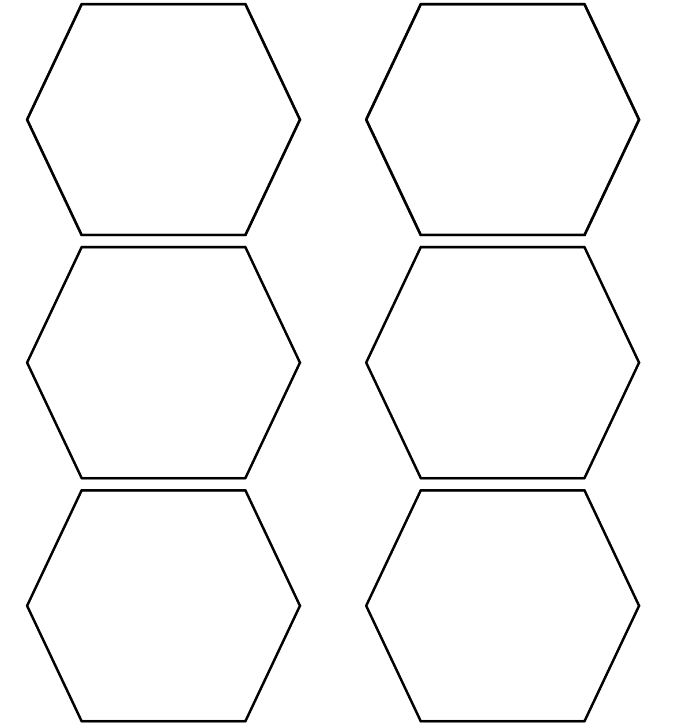

# Appendix E

## Exit ticket

Respond to the following:

1. Use the sentence stems to share your thinking.
   1. For Nikki Giovanni, the spider represents…
   2. For Rudy Francisco, the spider represents…
   3. For Fady Joudah, the spider represents…
2. Which poet do you connect with or feel you understand the most? Explain why you chose that poet.
3. How do the poems you read today help you to think about and understand others (e.g., their perspectives, lived experiences, and contributions)?

# Appendix F

## Curriculum expectations

### A3. Applications, Connections, and Contributions

apply language and literacy skills in cross-curricular and integrated learning, and demonstrate an understanding of, and make connections to, diverse voices, experiences, perspectives, histories, and contributions, including those of First Nations, Métis, and Inuit individuals, communities, groups, and nations

#### A3.2. Identity and Community

demonstrate an understanding of the historical contexts, contributions, lived experiences, and perspectives of a diversity of individuals and communities, including those in Canada, by exploring and analyzing the concepts of identity, self, and sense of belonging in a variety of culturally responsive and relevant texts

#### C1. Knowledge About Texts

apply foundational knowledge and skills to understand a variety of texts, including digital and media texts, by creators with diverse identities, perspectives, and experience, and demonstrate an understanding of the patterns, features, and elements of style associated with various text forms and genres

#### C1.2. Text Forms and Genres

analyze a variety of text forms and genres, including cultural text forms, and explain how their characteristics help communicate meaning

### C3. Critical Thinking in Literacy

apply critical thinking skills to deepen understanding of texts, and analyze how various perspectives and topics are communicated and addressed in a variety of texts, including digital, media, and cultural texts

#### C3.1. Literary Devices

describe literary devices, including foreshadowing, allegory, and symbolism, in a variety of texts, and explain how they help create meaning and are appropriate for the intended purpose and audience

#### C3.3. Analyzing Texts

analyze complex texts, including literary and informational texts, by evaluating, synthesizing, and sequencing relevant information and formulating conclusions

#### C3.6. Analysis and Response

explain how various topics, such as diversity, inclusion, and accessibility, are addressed in texts, analyze the insights or messages conveyed, and identify different positions presented

# References

Edutopia. (2021, October 22). Using hexagons to build critical thinking skills. <https://www.edutopia.org/video/using-hexagons-build-critical-thinking-skills/>

Francisco, R. (n.d.). “Bio.” *Rudy Francisco.* <https://www.iamrudyfrancisco.com/>

Francisco, R. (2017). “Mercy, after Nikki Giovanni.” *GetLit: Words ignite.* <https://getlitanthology.org/poemdetail/306/>

Giovanni, N. (2017). “Allowables.” *GetLit: Words ignite.* <https://getlitanthology.org/poemdetail/125/>

Joudah, F. (2013). “Mimesis.” *Poetry Foundation.* <https://www.poetryfoundation.org/poems/56351/mimesis>

notacult.media. (2018, July 6). *Rudy Francisco - “Mercy”* [Video]. YouTube. <https://www.youtube.com/watch?v=NLwhM13Qnrg>

Poetry Foundation. (2025). “Fady Joudah.” *Poetry Foundation.* <https://www.poetryfoundation.org/poets/fady-joudah>

Poetry Foundation. (2025). “Nikki Giovanni.” *Poetry Foundation.* <https://www.poetryfoundation.org/poets/nikki-giovanni>

Potash, B. (2020, September 11). *Hexagonal thinking: A colorful tool for discussion*. Cult of Pedagogy. <https://www.cultofpedagogy.com/hexagonal-thinking/>

# Attribution license

This lesson plan is published under a [CC BY-NC-SA](https://creativecommons.org/licenses/by-nc-sa/4.0/) license. Third-party resources are subject to their own copyright.



This license enables reusers to distribute, remix, adapt, and build upon the material in any medium or format for noncommercial purposes only, and only so long as attribution is given to the creator. If you remix, adapt, or build upon the material, you must license the modified material under identical terms. CC BY-NC-SA includes the following elements:

  BY: credit must be given to the creator.  
  NC: Only noncommercial uses of the work are permitted.  
  SA: Adaptations must be shared under the same terms.

# Updates

When updates are made to this document, they are tracked below with date and description of update.

* February 2025: initial release