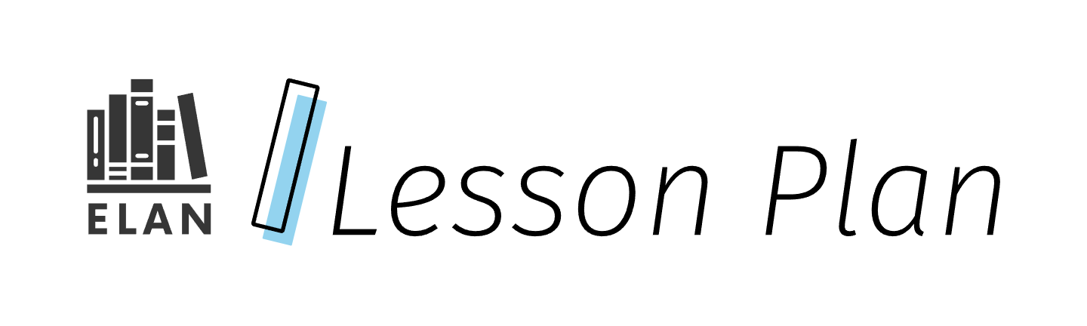

Building a Foundation for Multimodal Mentor Text Study & Composition

This lesson will introduce the concept of multimodality in text composition. Students will explore and analyze a variety of short, multimodal texts in order to start building a routine for how to study mentor texts and apply learning to their own multimodal design process.

Grade

9 (ENL1W)

Curriculum expectations

A1, A1.2, A2, A2.4, A2.5, C1, C1.2, C1.3, C1.4, D1, D1.1, D1.2, D1.4 (see Appendix F for full descriptions)

Strands

A. Literacy Connections and Applications

C. Comprehension: Understanding and Responding to Texts

D. Composition: Expressing Ideas and Creating Texts

# Contents

Grade 1

Curriculum expectations 1

Strands 1

Contents 2

Learning goals 4

Success criteria 4

Lesson path 5

Time 5

Materials and resources 5

Minds on 6

Action 7

Establishing vocabulary 7

Exploring mentor texts 10

Design session 12

Consolidation 15

Reflection 15

Possible extensions 15

Appendix A 16

Analyzing multimodal mentor texts framework 16

Approaches 16

Framework questions 16

Appendix B 18

Multimodal text set 18

Multimodal text sample 18

Appendix C 20

Table card for collaboration 20

Collaborative language for thinking through the design process 20

Appendix D 21

Mid-process check in (feedback) & student reflection tool 21

Criteria and prompts 22

Writing reflection 24

Appendix E 24

Example design process conference script 24

Appendix F 25

Curriculum expectations 25

A1. Transferable Skills 25

C.1. Knowledge about Texts 26

D1. Developing Ideas and Organizing Content 27

Glossary 28

References 29

Attribution license 32

Updates 33

# Learning goals

We are learning …

1. a routine for studying multimodal mentor texts to build our knowledge of how texts are created using multiple modes to communicate meaning.
2. to apply our knowledge of text design and express our voices as text creators who are independent and take creative risks during the composition process.

# Success criteria

I can …

* describe the characteristics of a variety of texts.
* evaluate how the characteristics work together in a text to communicate meaning effectively for an audience.
* select a topic and purpose for a multimodal text composition based on my own interests, values, and/or experiences.
* make my process visible by selecting tools to plan my ideas, text form, modes of communication, and possible design features.
* evaluate and justify why my choices will be effective in communicating with my audience.
* reflect on how my experience engaging in unconventional thinking and risk taking has allowed me to engage in learning, express my voice, and develop my capability as a creator.

# Lesson path

## Time

225 Minutes

This is a suggested amount of time. This lesson may be implemented over a series of days. Educators will make the best judgement on how to implement.

## Materials and resources

* [Lesson slide deck: Building a Foundation for Multimodal Mentor Text Study & Composition (Google slides)](https://docs.google.com/presentation/d/1B-Wnyfx3VJJNfd0e8wtmrr6HJFH14Ih0QDBvW_S0OJY/edit?usp=sharing)
* Tool for students to create text timeline (notebook, [digital template: My Text Timeline (Google slides)](https://docs.google.com/presentation/d/1ysk7j0Pd2MroaKOHyJzrDsCw7Ny-mzmd9n66NHizTSI/edit?usp=sharing))
* Student materials for design session (e.g., loose parts (Glossary), sticky notes, whiteboards, dry erase markers, paper, coloured pens/pencils)
* Projector and/or document camera for modeling
* Analyzing multimodal mentor texts framework (Appendix A)
* Multimodal text set (Appendix B)
* Table card for collaboration (Appendix C)
* Mid-process check in (feedback) & student reflection tool (Appendix D)
* Example design process conference script (Appendix E)

## Minds on

1. Provide a definition of the word “text” to students (slide 4). Consider creating an anchor chart that can be added to during the course. Explain that the definition of “text” and how ideas and information are communicated have changed over time with advances in technology. New text forms continue to evolve. Review a few examples of text forms listed below the definition.

[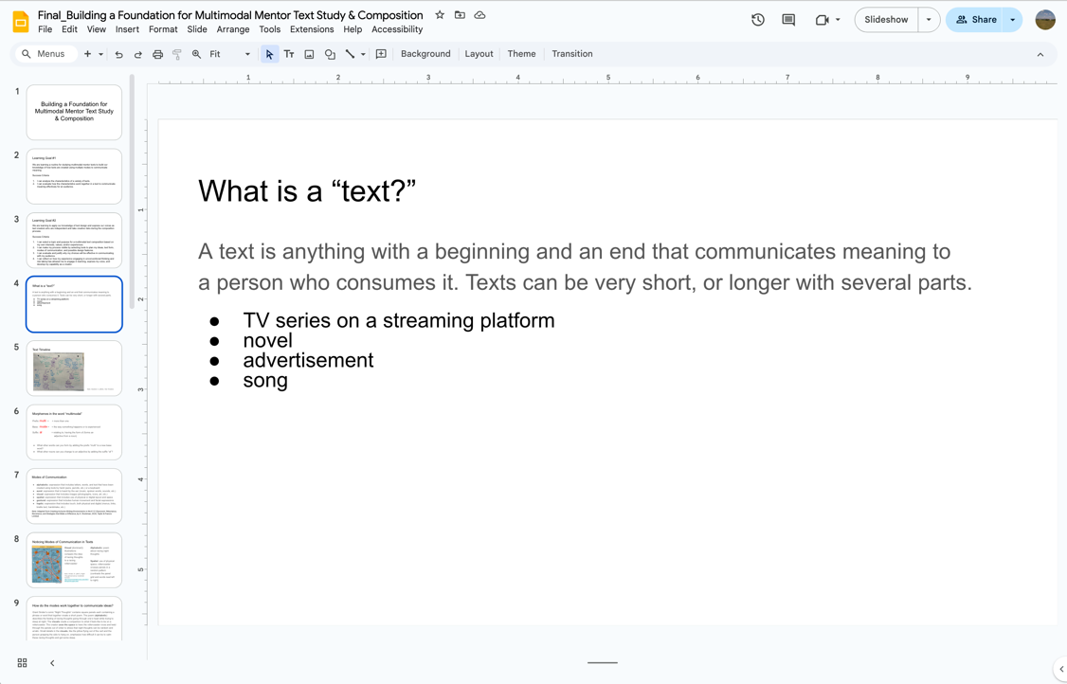](https://docs.google.com/presentation/d/1IimX8_zcO6PVuTyAo0i4un8uaFUQHLwaQkuqf8PbZuY/edit#slide=id.g2ebfd867980_0_0)

Slide 4 of the lesson slide deck gives a definition of what a “text” is.

1. Engage students by asking them to jot down on a sticky note one or two additional examples of text forms that are familiar to them. They can then add them to the anchor chart or to another location. Review added text forms with the class.
2. As a 10-15 minute quick write activity (Glossary), have students create a timeline of the specific texts that have been important in their lives, keeping in mind all types of texts. Show an example (slide 5) or hand write a model with students on the board or under a document camera. Suggestions:
   1. Provide students with small sticky notes so that they can move them on their timeline as new texts are added.
   2. Offer a digital template for students to organize their texts digitally. ([digital template: My Text Timeline (Google slides)](https://docs.google.com/presentation/d/1ysk7j0Pd2MroaKOHyJzrDsCw7Ny-mzmd9n66NHizTSI/edit?usp=sharing)).
3. Share Learning Goals and Success Criteria for the lesson (slides 2-3). Inform students that the Success Criteria are very general, and they will be able to personalize them by making decisions about the characteristics of effective texts.

## Action

### Establishing vocabulary

1. Introduce the term “multimodal” to students (slide 6). Note: optional connection to Strand B expectations related to morphology.
   1. multi (prefix) + mode (base) + al (suffix)
   2. Ask students to form new words by adding the prefix “multi” and suffix “al” to new base words.

[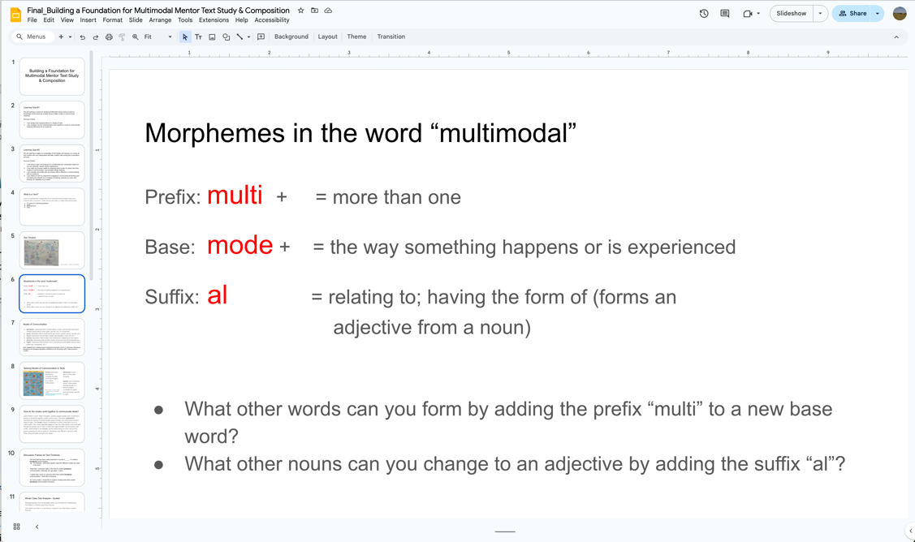](https://docs.google.com/presentation/d/1IimX8_zcO6PVuTyAo0i4un8uaFUQHLwaQkuqf8PbZuY/edit#slide=id.g2ebfd867980_0_14)

Slide 6 of the lesson slide deck introduces the term “multimodal”.

1. Introduce the six modes of communication to students: alphabetic, aural, visual, spatial, gestural, and haptic. Explain that they will be exploring and learning more about these six modes and how they are combined in texts to communicate meaning effectively (slide 7).
2. Show students Grant Snider’s comic “Night Thoughts.” Point out the different modes of communication and how they work together as an example (slides 8-9).

[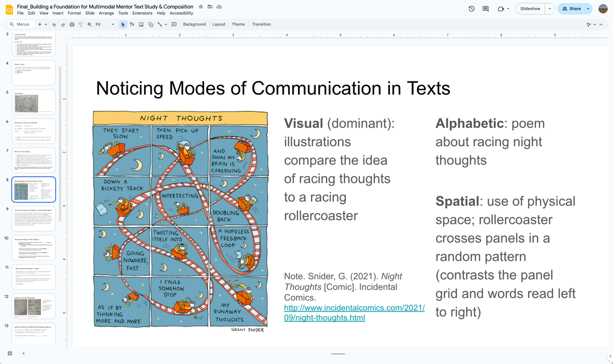](https://docs.google.com/presentation/d/1IimX8_zcO6PVuTyAo0i4un8uaFUQHLwaQkuqf8PbZuY/edit#slide=id.g2ef37b62238_1_15)

Slide 8 of the lesson slide deck illustrates a way to notice modes of communication in text

1. Prompt students to go back to their text timeline and consider what modes of communication are used in the texts that they listed by labeling or colour coding. Encourage discussion and questioning as students build understanding of the different modes of communication. Model this with your own timeline.
2. In small groups, have students talk about what they notice about the modes of communication in the texts that have been important to them. Encourage the use of vocabulary related to the six modes of communication by referring to the anchor chart and/or using discussion frames. Provide possible discussion sentence frames (slide 10).

#### Assessment opportunity

Gather information about use and understanding of vocabulary as well as students’ interests by observing discussions and text timelines.

### Exploring mentor texts

1. Prior to class, create a collaborative space with the Analyzing Multimodal Mentor Texts Framework (Appendix A) on it. This could be a chart paper with the six headings from the framework, or a collaborative document/platform.
2. Provide each student with a copy of the Analyzing Multimodal Mentor Texts Framework (Appendix A). Explain that the framework is meant to be an extensive collection of questions to ask oneself when thinking about texts; generally, they can start with the top questions and work their way down, but not all questions will be relevant to every text. Part of the process of analyzing the what, how, and why of text creation is noticing which characteristics are most prominent and how they work together to communicate ideas effectively. The next part of class will model this thinking process, though it will be slightly different every time.
3. Prepare students to engage with a short text that can be used for modeling as a whole class. Ask students to keep the prompts in mind as they observe the text, and highlight two or three that they feel they can respond to. See sample text: [Waubgeshig Rice’s oral meditation text (external resource)](https://wildwriters.ca/meditations-waubgeshig-rice/). A link to the meditation and text analysis information is also available on slide 11.

[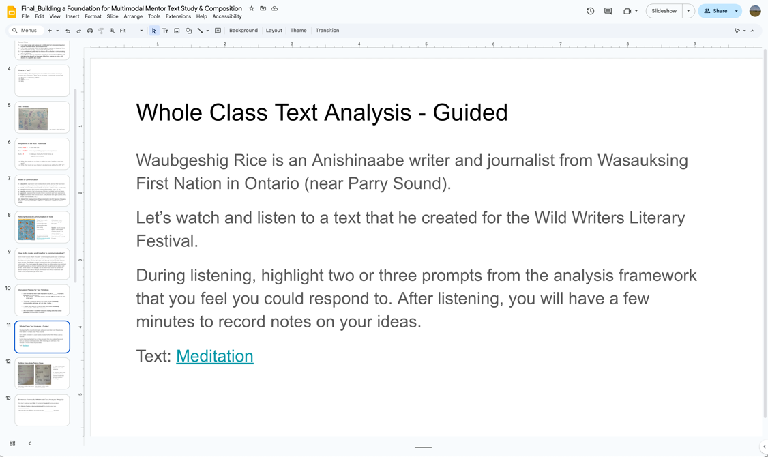](https://docs.google.com/presentation/d/1IimX8_zcO6PVuTyAo0i4un8uaFUQHLwaQkuqf8PbZuY/edit#slide=id.g2ebfe1c8fe4_0_5)

Slide 11 of the lesson slide deck shares a guided text analysis exercise that can be done with a group of learners.

1. Play the video.
2. Engage students by asking them to jot down a response for one of the prompts and add it to the collaborative space.
3. Model an analysis of the text’s characteristics, using and adding to student responses. Model the thinking out loud, as well as how to make notes to collect ideas for possible future use in compositions using the framework (slide 12).
4. Introduce the Multimodal Text Set (Appendix B). This set can be modified by swapping out texts to be responsive to students. Students will select a few texts to explore for a prescribed amount of time and record their ideas in their notebooks using the headings and prompts provided in the Analyzing Multimodal Mentor Texts Framework (Appendix A). (As the texts are all different lengths, a prescribed time rather than a prescribed number of texts will encourage students to engage with as many texts as they can, focusing on process over product.) Consider allowing students to work with a partner if this would benefit the learning.
5. Conclude by having each student share one design feature they thought was effective from a text they explored. This can be done in a small group discussion or by providing students with cue cards to record their thinking. These cards could be posted in the classroom as a “design thinking” wall to be added to throughout the course. See possible response frames (slide 13).

[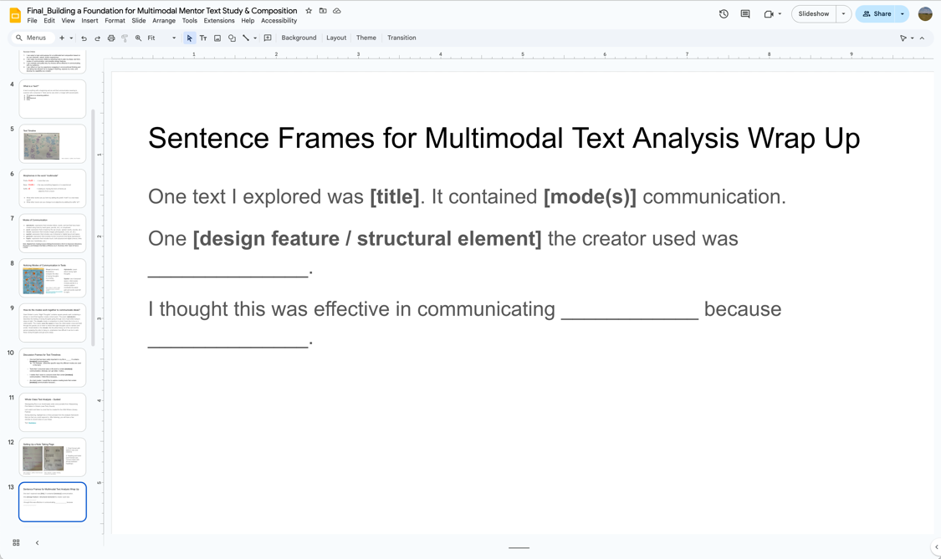](https://docs.google.com/presentation/d/1IimX8_zcO6PVuTyAo0i4un8uaFUQHLwaQkuqf8PbZuY/edit#slide=id.g2ecef68389c_0_0)

Slide 13 of the lesson slide deck has sentence frames to use for a concluding exercise.

#### Assessment opportunity

Collect student notes to assess initial text analysis and identify areas of potential focus for feedback and further learning in the design session. It is not expected that students would answer all questions with proficiency at this point. Seeing which questions students gravitate to, which questions are left blank, and the nature of the thinking should help to inform future instruction.

### Design session

1. Engage students with a quick write to brainstorm “Writing Territories” (Glossary) they have authority to write about. This may include topics they are interested in writing about but that will require research. Students can note these topics with “R”. This will get students in the habit of considering what they already know and have authority over versus what they may have difficulty generating initial ideas about without further learning. Provide categories or headings, but encourage students to create their own as well based on their experiences. Consider creating your own “Writing Territories” page to use for modeling during the course (slide 14).
2. In small groups, ask students to share one or two topics they wrote down. Encourage students to add to their lists if the sharing sparks any new ideas. Alternatively, try an [inside-outside circle activity (external resource)](https://www.theteachertoolkit.com/index.php/tool/inside-outside-circles) so that students get to hear a variety of ideas.
3. Have students choose one topic from their list that they want to develop further. Explain that they are going to spend time engaging in a design session for how they might compose a short text around this topic. The focus will be on the thinking, planning, and process, not on a finished product at this time.
4. Review the posted Success Criteria.
5. Introduce materials that students can use (e.g., sticky notes, whiteboards and markers, blank paper, scissors, loose parts (Glossary)). Emphasize that thinking and planning need to be visible and saved or captured for future review or use, but can take whatever form they want. See examples of multimodal planning for various composition purposes (slides 15-21).

[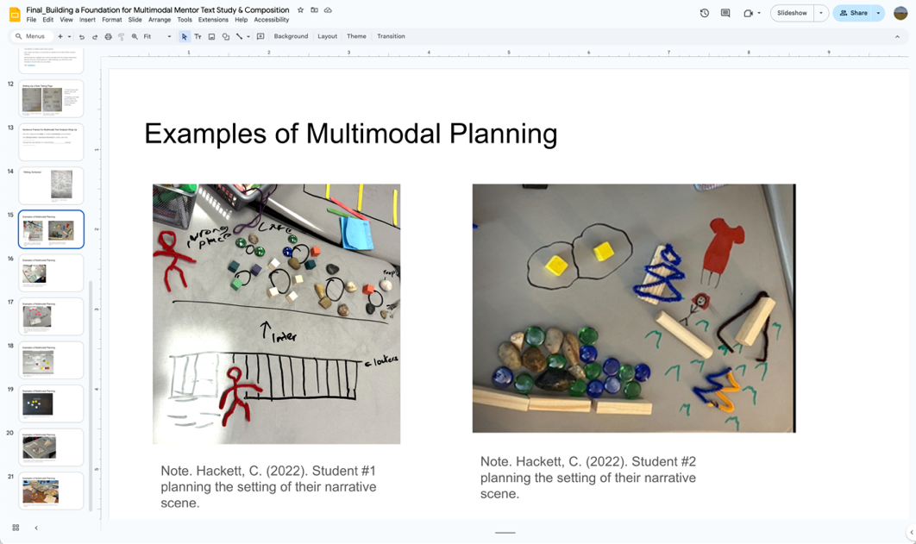](https://docs.google.com/presentation/d/1IimX8_zcO6PVuTyAo0i4un8uaFUQHLwaQkuqf8PbZuY/edit#slide=id.g2ef37b62238_1_3)

Slide 15 of the lesson slide deck shows examples of multimodal planning with loose parts.

1. Provide time to generate ideas, develop their topic, choose a text form, outline ideas for their structure, and note design feature ideas. Have spaces in the room for collaborative planning where students can use talk to work through their planning, as well as areas for quiet, independent work. Consider using prompt cards for collaborative tables to provide language for design thinking (Table card for collaboration (Appendix C)).

#### Assessment opportunity

During the process, conference with students about their planning, asking them to articulate their process up to that point. Use the criteria on the Mid-Process Check In (Feedback) & Student Reflection Tool (Appendix D) to prompt students to consider parts of the process they may not have considered yet (feedback). Note student reflections and feedback on the rubric before moving on to the next student. See the Example Design Process Conference Script (Appendix E).

## Consolidation

### Reflection

1. After the design process session, students complete a reflection on their process using the reflection columns on the Mid-Process Check In (Feedback) & Student Reflection Tool (Appendix D), adding to teacher notes.

#### Assessment opportunity

Conference notes and student-written reflections from the mid-process check in can be used to assess the degree to which students met the Success Criteria for Learning Goal #2. Note: As this is an introductory activity, this information would be best considered Assessment as/for Learning to inform future instruction. However, it could be used as evidence at the end of a period of learning to evaluate learning related to Overall Expectations.

## Possible extensions

* Students might engage in multiple design sessions over a period of time for a variety of topics and purposes one they want to develop further and publish. Note: Returning to the mid-process check-in could be a useful tool to monitor and assess student process through observations and conversations.
* Provide increasingly longer or complex mentor text sets for students to study that include the genres of composition specifically mentioned in expectation D2.1 (narrative, persuasive, expository, informational). This could be part of subsequent units, or an extension opportunity for students who may finish other course work quickly.

# Appendix A

## Analyzing multimodal mentor texts framework

The questions are intended to be a guide to help students recognize the relationship between the what, the how, and the why of texts to develop their own creativity and independence as text creators. Some of the questions in the framework may be more relevant to some texts than others.

### Approaches

Have learners use a notebook and write down the headings, leaving space to write notes. You might consider creating an accessible chart, a document with headings and bullet points, or other organizational approaches that are inclusive and accessible for your diversity of learners.

### Framework questions

#### What?

##### Content

* What is the topic of this text?
* What ideas or themes does it communicate?

#### How?

##### Structure

* How does this text start? How does it end?
* How are ideas sequenced (ordered)?
* Are there any patterns? (e.g., compare/contrast, chronological order, use of flashbacks, etc.)

##### Design features / writing craft

* What modes of communication are used? Which mode is dominant?
* What specific design features and/or writing craft are used to communicate ideas and themes?
* How do these modes and design features work together for effective communication?

#### Why?

##### Purpose

* Why was this text produced?
* What might have inspired the creator(s)?
* Is the creator trying to teach, inform, explain, entertain, inspire, persuade, raise awareness, or something else?

##### Creator Identity

* Who created this text?
* Whose point of view does it represent?
* What aspects of the creator’s identity may have influenced their choices?

##### Audience

* Who is this text intended for?
* Why might the creator want certain people or communities to hear their message?
* What aspects of the intended audience’s identity may have influenced the creator’s choices?

##### Contextual Importance

* What makes this text relevant or important right now?
* How is it connected to events or ideas in the world?
* Who else is writing about this? What communities does the creator belong to?

# Appendix B

## Multimodal text set

Select a variety of texts that use different modes of communication including words, images, sounds, and other modalities. Place them in a choice board, on individual cards, or in another format. You may want to consider having different formats available to support your diversity of learners.

### Multimodal text sample

[The text set can be modified by swapping out texts to be responsive to students. When choosing external resources make sure they meet the accessibility needs of your learners. For example, closed captions in videos.]

Watch a video of artwork by Banksy. Title: [Season’s Greetings (external resource)](https://www.yout-ube.com/watch?v=wIY-pZFi6YI)

Read a poetry comic by Grant Snider. Title: [invisible poem (external resource)](https://blogger.googleusercontent.com/img/b/R29vZ2xl/AVvXsEhkp4toB3gg2B4fzp-SkvWuC2nzUFKoznUkh59PnodUUVciqF2TKbNF_lNwZNS1mBkEkGQJYCzKzi1Pg95UY4QBQHtSOrSLtNiLnFvd1OZv795qSJWlYnxUbVq6bhBYvQmlLvOyTRKwZyMjfSyfoVpKhqI-cOp1dUAKaUYGUbcUnMtLo_wRf4LepjziEASw/w717-h896/InvisiblePoem-IG.jpg)

Read a graphic sketch by Mari Andrew. Title: [Washington, D.C. (external resource)](https://www.washingtonian.com/2018/03/26/illustrator-mari-andrew-shares-her-favorite-dc-spots/)

Watch and listen to spoken word artist Wali Shah. Title: [Dear Humanity, It’s Time To Give Up (external resource)](https://www.yout-ube.com/watch?v=jdXPQRvw3xw)

Read a comic by Michael F. Giangreco and Kevin Ruelle. Title: [Clearing a Path for Everyone! (external resource)](https://npr.brightspotcdn.com/dims4/default/2d83f21/2147483647/strip/true/crop/903x915+0+0/resize/1760x1784!/format/webp/quality/90/?url=http%3A%2F%2Fnpr-brightspot.s3.amazonaws.com%2Flegacy%2Fsites%2Fvpr%2Ffiles%2F202102%2Fmichael-giangreco-cartoons-comics-absurdities-realities-special-education-clearing-a-path-for-everyone-02210216.jpg)

Explore this collection of three photo essays by Lalaine Alindogan and Jasmine Foong. Title: [Close to home (external resource)](https://ubyssey.ca/photo/photo-essay-close-to-home/)

Watch a video by Hoopla Recipes. Title: [Frosting Hack cake (external resource)](https://www.youtube-nocookie.com/embed/n_y6UEiUs-o?playlist=n_y6UEiUs-o&autoplay=1&iv_load_policy=3&loop=1&start=)

Read this infographic by Dan Meth. Title: [Futuristic Movie Timeline (external resource)](https://images.squarespace-cdn.com/content/v1/61f005a91a602f6587a29ede/1643384146801-XRYPD684WTZEEM0I2MLU/image-asset.png?format=1500w)

Watch this short Ted Talk / spoken word by Clint Smith. Title: [The danger of silence (external resource)](https://www.ted.com/talks/clint_smith_the_danger_of_silence?subtitle=en)

Watch a personal information video by Harris Taylor. Title: [My Global Warming (external resource)](https://digitalstories.ca/video/my-global-warming/)

Watch this stop motion video by Matthew Bunin. Title: [Candy (external resource)](https://www.yout-ube.com/watch?v=3DFzjP6PbnU)

Read this graphic article by Adam Ruggiero. Title: [How to Lace Running Shoes the Right Way: 12 Variations to Fit Your Foot (external resource)](https://gearjunkie.com/footwear/running-footwear/how-to-lace-running-shoes)

Watch this spoken word Olympic video montage by Randell Adjei and Phylicia George. Title: [The Gold Within (external resource)](https://www.cbc.ca/player/play/video/9.6460079)

Watch Yoann Bourgeois in this trampoline performance. Title: [Fugue / Trampoline (external resource)](https://www.numeridanse.tv/en/dance-videotheque/fugue-trampoline)

Watch this Major League Baseball video by Mike Trout. Title: [That Opening Day Feeling (external resource)](https://www.mlb.com/video/that-opening-day-feeling-by-mike-trout)

Watch this spoken word video by Ewurakua Dawson-Amoah. Title: [To The Girl That Looks Like Me (external resource)](https://www.beyondtheshort.com/art-experimental/to-the-girl-that-looks-like-me-ewurakua-dawson-amoah)

Watch this video produced by Mondelez International (for Oreo) & PFLAG. Title: [Proud Parent (external resource)](https://www.yout-ube.com/watch?v=wj_MaUxlnjc)

Watch this video produced by Parks Canada. Title: [Discover Rouge National Urban Park (external resource)](https://www.yout-ube.com/watch?v=m7dV2pV-dAw)

# Appendix C

## Table card for collaboration

The following content can be used for prompt cards to provide language for design thinking in collaborative discussions. Consider printing out table cards for in-person learners and create inclusive and accessible versions for on-line and alternative access learner needs.

### Collaborative language for thinking through the design process

[Note: spaces for answers may need to be adjusted to meet the accessibility needs of learners, depending on the format you use for the activity.]

I’ve chosen my **topic** because _______________. What about you?

I’m thinking that the best **text form** to communicate **ideas about** _______________ to my **audience** might be _______________. What are you thinking?

I want to combine _______________ **[modes of communication]** because _______________. What modes are you considering?

I noticed in the **mentor text** about _______________ that it was really effective when the **creator chose to** _______________. What did you notice?

I think that an effective way to **start/end my text** would be to discuss **[content]** and/or **apply [design feature / writing craft]** _______________.

I noticed you used _______________ **[material / tool].** Can you tell me more about how you’re using it to **capture your thinking?**

I was thinking **I might try** _______________, but now I’m **rethinking** that _______________ might work better because _______________.

I’m not sure how to _______________. Do you have any suggestions?

# Appendix D

## Mid-process check in (feedback) & student reflection tool

Use the criteria below to prompt students to consider parts of the process they may not have considered yet. You may want to use a checkbric format. In the checkbric example the category heading and criteria for each of the assessment areas appears in the centre column of the checkbric. The assessment questions for ‘What’ (appearing on the left column) and ‘Why’ (appearing on the right column) are given with each sub-set of criteria in the “Criteria & prompts” content below.

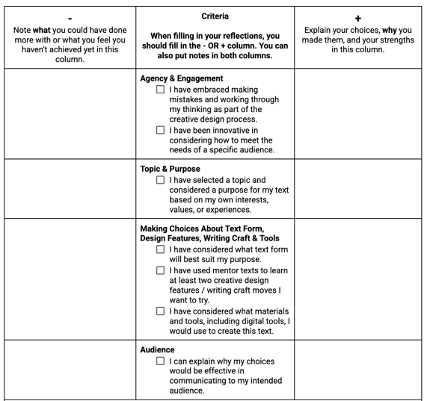

This example of a checkbric may work for learners who prefer paper format. Note: If you choose to create a digital checkbric the layout of the criteria and prompts may need to be adjusted to meet accessibility needs.

### Criteria and prompts

Using as the criteria and descriptions, reflect on the choices you have made in your text, and why you made them.

#### Agency & engagement

* I have embraced making mistakes and working through my thinking as part of the creative design process.
* I have been innovative in considering how to meet the needs of a specific audience.

##### What

Note **what** you could have done more with or what you feel you haven’t achieved yet.

##### Why

Explain your choices, **why** you made them, and your strengths.

#### Topic & purpose

* I have selected a topic and considered a purpose for my text based on my own interests, values, or experiences.

##### What

Note **what** you could have done more with or what you feel you haven’t achieved yet.

##### Why

Explain your choices, **why** you made them, and your strengths.

#### Making choices about text form, design features, writing craft & tools

* I have considered what text form will best suit my purpose.
* I have used mentor texts to learn at least two creative design features / writing craft moves I want to try.
* I have considered what materials and tools, including digital tools, I would use to create this text.

##### What

Note **what** you could have done more with or what you feel you haven’t achieved yet.

##### Why

Explain your choices, **why** you made them, and your strengths.

#### Audience

* I can explain why my choices would be effective in communicating to my intended audience.

##### What

Note **what** you could have done more with or what you feel you haven’t achieved yet.

##### Why

Explain your choices, **why** you made them, and your strengths.

### Writing reflection

After this planning, what is your motivation to follow through with the creation of this text?

* I would scrap it and start fresh.
* My ideas are flowing and I want to continue creating this text!
* I’m not sure yet. I need to explore ideas further.

# Appendix E

## Example design process conference script

[This is an assessment *as/for* learning]

**Teacher:**Tell me about what you have planned so far? [Invite the student to lead the conversation.]

**Student:** I have chosen to create a text about my experiences playing rep hockey. I’m thinking that I want to create a video that includes video clips of myself playing and some music to capture the different highs and lows of playing and that it’s hard work, but definitely worth it. I really liked how the Olympic video showed the poets in between the clips. Maybe I could do something like that as well.

**Teacher:**You’ve leaned into your own passion to decide on a topic.[Note something from the criteria that the student has addressed.] Have you considered who this text would be for? Who would be your intended audience? [Prompt the student to think about additional criteria.]

**Student:** Well, I remember when I first started, I wasn’t the greatest player. I had to work really hard. I’m thinking I might make it for kids who need some inspiration, to actually see the struggles and what happens behind the scenes in between the victories.

**Teacher:**It sounds like you’re thinking about audience and purpose now. Be sure to add this to your planning to make it visible. Consider what tools you would need to create this text. [Paraphrase how the student decides to use the feedback. Offer feedback for next steps. Next steps should be attainable within the time given rather than pointing out everything the student has not yet achieved from the criteria.]

# Appendix F

## Curriculum expectations

### A1. Transferable Skills

demonstrate an understanding of how the seven transferable skills are used in various language and literacy contexts

#### A1.2. Student Agency and Engagement

evaluate and explain how transferable skills help them to express their voice, be engaged in their learning, and implement a plan to develop their capabilities and potential

#### A2.3 Digital Media Literacy

demonstrate and apply the knowledge and skills needed to interact safely and responsibly in online environments, use digital and media tools to construct knowledge, and demonstrate learning as critical consumers and creators of media

#### A2.4. Forms, Conventions, and Techniques

evaluate the use of the various forms, conventions, and techniques of digital and media texts, consider the impact on audience, and apply this understanding when analyzing and creating texts

#### A2.5 Media, Audience, and Production

demonstrate an understanding of the interrelationship between the form, message, and context of texts, the intended audience, and the purpose for production

### C.1. Knowledge about Texts

apply foundational knowledge and skills to understand a variety of texts, including digital and media texts, by creators with diverse identities, perspectives, and experience, and demonstrate an understanding of the patterns, features, and elements of style associated with various text forms and genres

#### C1.2. Text Forms and Genres

analyze and compare the characteristics of various text forms and genres, including cultural text forms, and provide evidence to explain how they help communicate meaning

#### C1.3. Text Patterns and Features

compare the text patterns, such as compare and contrast in an expository essay, and text features, such as footnotes and copyright information, associated with different text forms, including cultural texts, and evaluate their importance in helping readers, listeners, and viewers understand the meaning

#### C1.4. Visual Elements of Texts

evaluate how images, graphics, and visual design create, communicate, and contribute to meaning in a variety of texts

### D1. Developing Ideas and Organizing Content

plan, develop ideas, gather information, and organize content for creating texts of various forms, including digital and media texts, on a variety of topics

#### D1.1. Purpose and Audience

identify the topic, purpose, and audience for various texts they plan to create; choose a text form, genre, and medium to suit the purpose and audience, and justify their choices

#### D1.2. Developing Ideas

generate and develop ideas and details about complex topics, such as topics related to diversity, equity, and inclusion and to other subject areas, using a variety of strategies, and drawing on various resources, including their own lived experiences

#### D1.4. Organizing Content

classify and sequence ideas and collected information, selecting effective strategies and tools, and identify and organize relevant content, evaluating the choices of text form, genre, and medium, and considering alternatives

# Glossary

**Loose Parts:** Physical materials (blocks, beads, pine cones, pipe cleaners, string, etc.) that can be used during the idea generation and sequencing process to create an abstract representation of complex ideas. Loose parts allow for alternative modes of expression in place of alphabetic writing which can potentially be a barrier to communicating complex ideas. Loose parts can be combined with oral and/or written explanations to create end products, or used as a bridge to print writing depending on goals for student writers. See slides 15-21 for examples. For further information, read “[Fifteen Reasons to Use Loose Parts in Middle School and High School Classrooms (external link)](https://angelastockman.com/blog/2021/01/16/fifteen-reasons-to-use-loose-parts-for-learning-in-middle-and-high-school-classrooms/),” by Angela Stockman.

**Quick Writes:** Quick writes are short periods of writing, generally under 10 minutes, during which students focus on generating ideas, often using inspiration from a mentor text. The focus may be on brainstorming ideas, practising a structural or writing craft move, or a combination of both.

**Writing Territories:** A term coined by Nancie Atwell to describe the process of categorizing potential topics for writing based on one’s life experiences, interests, and values. For further information, read “From Lessons That Change Writers: About Topics” in “[Writing Masters: Lessons That Change Writers with Nancie Atwell (external link)](https://blog.heinemann.com/writingmasters-atwell1),” by Nancie Atwell.

# References

Adjei, R., & George, P. (2024, July 26). *The Gold Within* [Video]. CBC. <https://www.cbc.ca/player/play/video/9.6460079>

Alindogan, L., & Foong, J. (2021, March 19). *Close to Home*. The Ubyssey. <https://ubyssey.ca/photo/photo-essay-close-to-home/>

Andrew, M. (2018, March 26). Washington, D.C. [Illustration]. In *Illustrator Mari Andrew Shares Her Favorite DC Spots*. Washingtonian. <https://www.washingtonian.com/2018/03/26/illustrator-mari-andrew-shares-her-favorite-dc-spots/>

Atwell, N. (2015, September 9). *Writing Masters: Lessons That Change Writers with Nancie Atwell*. Heinemann Blog. Retrieved July 30, 2024, from <https://blog.heinemann.com/writingmasters-atwell1>

bansky.blog. (2018, December 19). *Season's Greetings from Bansky (December 19, 2018)* [Video]. YouTube. <https://www.youtube.com/watch?v=wIY-pZFi6YI>

Bourgeois, Y. (2016). *Fugue Trampoline* [Film]. Numeridanse. <https://www.numeridanse.tv/en/dance-videotheque/fugue-trampoline>

Bunin, M. (2013, July 19). *Candy* [Film]. YouTube. <https://www.youtube.com/watch?v=3DFzjP6PbnU>

Dawson-Amoah, E. (Director). (2021). *To the Girl That Looks Like Me* [Film]. <https://www.beyondtheshort.com/art-experimental/to-the-girl-that-looks-like-me-ewurakua-dawson-amoah>

Giangreco, M. F., & Ruelle, K. (2021, February 16). Clearing a Path for Everyone [Comic]. In *A Comics Collection Of The 'Absurdities & Realities of Special Education'*. Vermont Public. <https://www.vermontpublic.org/vpr-news/2021-02-16/a-comics-collection-of-the-absurdities-realities-of-special-education>

Hackett, C. (2024). *Text Timeline* [Photograph].

Hackett, C. (2024). Chart structure for notetaking[Photograph].

Hackett, C. (2021). Group of students planning information piece [Photograph].

Hackett, C. (2021). Group of students sequence ideas for a theme analysis [Photograph].

Hackett, C. (2024). Heading structure for notetaking [Photograph].

Hackett, C. (2022). Student #1 planning the setting of their narrative scene [Photograph].

Hackett, C. (2022). Student #2 planning the setting of their narrative scene [Photograph].

Hackett, C. (2022). Student plans how the plot will reveal clues in a narrative mystery.

Hackett, C (2021). Student plans ideas for a theme analysis [Photograph].

Hackett, C (2021). Student plans key organizational ideas and specific life events for

theme analysis [Photograph].

Hackett, C. (2023). Students organize values to create value statements [Photograph].

Hackett, C. (2022). *Writing Territories* [Photograph].

Hoopla Recipes. (2024, June 12). *Frosting cake hack* [Video]. YouTube. <https://www.youtube.com/watch?v=n_y6UEiUs-o>

*Inside/Outside Circles*. (n.d.). The Teacher Toolkit. Retrieved August 6, 2024, from <https://www.theteachertoolkit.com/index.php/tool/inside-outside-circles>

Major League Baseball. (2024, March 28). *That Opening Day Feeling* [Video]. MLB. <https://www.mlb.com/video/that-opening-day-feeling-by-mike-trout>

Meth, D. (n.d.). Futuristic Movie Timeline [Infographic]. In *Pop Cultural Charts*. Dan Meth Art Director. <https://www.danmeth.com/illustration#/pop-cultural-charts/>

Modelez International & PFLAG. (2020). *Proud Parent* [Advertisement]. YouTube. <https://www.youtube.com/watch?v=wj_MaUxlnjc>

Parks Canada. (2020, February 22). *Discover Rouge National Urban Park - An Urban Escape* [Video]. YouTube. <https://www.youtube.com/watch?v=m7dV2pV-dAw>

Ruggiero, A. (2024, April 17). How to Lace Running Shoes the Right Way: 12 Variations

*to Fit Your Foot*. GearJunkie. Retrieved July 28, 2024, from <https://gearjunkie.com/footwear/running-footwear/how-to-lace-running-shoes>

Shah, W. (2021, January 3). *Dear Humanity* [Video]. YouTube. https://www.youtube.com/watch?v=jdXPQRvw3xw

Smith, C. (2014, July). *The Danger of Silence* [Video]. Ted. <https://www.ted.com/talks/clint_smith_the_danger_of_silence?subtitle=en>

Snider, G. (2024, May 25). *Invisible Poem*. INCIDENTAL COMICS. Retrieved July 25, 2024, from <http://www.incidentalcomics.com/2024/05/invisible-poem.html>

Snider, G. (2021, September 3). *Night Thoughts* [Comic]. INCIDENTAL COMICS. <http://www.incidentalcomics.com/2021/09/night-thoughts.html>

Stockman, A. (2020). Creating Inclusive Writing Environments in the K-12 Classroom: Reluctance, Resistance, and Strategies that Make a Difference. Taylor & Francis Limited (Sales).

Tatum, A. W. (2009). Reading for Their Life: (re)building the Textual Lineages of African

American Adolescent Males. Heinemann.

Taylor, H. (2024, January 3). *My Global Warming* [Video]. Digital Stories Canada. <https://digitalstories.ca/video/my-global-warming/>

# Attribution license

This lesson plan is published under a [CC BY-NC-SA](https://creativecommons.org/licenses/by-nc-sa/4.0/) license. Third-party resources are subject to their own copyright.



This license enables reusers to distribute, remix, adapt, and build upon the material in any medium or format for noncommercial purposes only, and only so long as attribution is given to the creator. If you remix, adapt, or build upon the material, you must license the modified material under identical terms. CC BY-NC-SA includes the following elements:

  BY: credit must be given to the creator.  
  NC: Only noncommercial uses of the work are permitted.  
  SA: Adaptations must be shared under the same terms.

# Updates

When updates are made to this document, they are tracked below with date and description of update.

* February 2025: initial release