

Community Building in the English Classroom

In this lesson, students are offered various multimodal provocations (e.g., art, the natural world, photographs, videos, thinking tools) to surface prior knowledge, including lived experiences, and to elicit thinking about what makes a strong community.

Grade

9

Curriculum expectations

A3, A3.2, C1, C1.4, C1.7, C2, C2.1, C2.5, C2.6, C2.7 (see Appendix F for full descriptions)

Strands

A. Literacy Connections and Applications

C. Comprehension: Understanding and Responding to Texts

# Contents

Grade 1

Curriculum expectations 1

Strands 1

Contents 2

Learning goals 4

Success criteria 4

Lesson path 5

Time 5

Materials and resources 5

Minds on 5

Action 7

Building ideas about relationships 7

Finding connections 9

Nature journaling 10

Engaging in a gallery walk 13

Exploring digital stories 14

Creating a concept circle 15

Consolidation 17

Reflection 17

Possible extensions 17

Personal storytelling 17

Morphology using Hexagonal Thinking or Concept Circles 18

Appendix A 19

Hexagonal Thinking handout with terms 19

Appendix B 20

Blank Hexagonal Thinking handout 20

Appendix C 21

Concept Circle with terms provided 21

Appendix D 22

Blank 4-segment concept circle 22

Appendix E 23

Blank 8-segment concept circle 23

Appendix F 24

Curriculum expectations 24

A3. Applications, Connections, and Contributions 24

C1. Knowledge about Texts 24

C2. Comprehension Strategies 25

References 26

Attribution license 28

Updates 28

# Learning goals



We are learning …

1. value the diversity of thinking in our classroom and beyond.
2. engage in inquiry learning and apply our prior knowledge to interpret and analyze a variety of multimodal texts.

# Success criteria



I can …

* Define community, perspective, lived experiences
* Describe images and visual design that I see in texts
* Explain about the relationships and meaning in visual and multimodal texts
* Identify comprehension strategies I use when viewing visual and multimodal texts
* Summarize ideas and information from visual and multimodal texts
* Explain connections between visual and multimodal texts and the concept of community
* Compare and apply ideas and concepts represented in visual and multimodal texts to my life in the classroom and beyond
* Apply skills that help to support a community, including listening, pausing, reflecting, contributing, respectfully questioning, and supporting when participating in group discussions.

# Lesson path



## Time

225 Minutes

This is a suggested amount of time. This lesson may be implemented over a series of days. Educators will make the best judgement on how to implement.

## Materials and resources

* [Lesson slide deck (Google slides)](https://docs.google.com/presentation/d/1OV5cplhy3Jb6l3qNA6kUiXKeSznpqIv0Orf2dJ42dwc/edit?usp=drive_link) with prompts, images, and links to texts
* [Gallery Walk slide deck (Google slides)](https://docs.google.com/presentation/d/1a0PZePgDugO_k-Wjk62wiyzCaswHPE_XCamwNUpQSIE/edit?usp=sharing) to share with students
* Digital or paper hexagons for Hexagonal Thinking
  + [Hexagonal thinking handout with terms](https://docs.google.com/document/d/1l9LARth56BdhANTSRvFijBRTcT8xxT7b9oC-vvks88k/edit#bookmark=id.4mbc3mr9ps13) (Appendix A)
  + Blank Hexagonal thinking handout (Appendix B)
* Concept Circle handout (choose one)
  + Concept Circle with terms provided (Appendix C)
  + Blank 4-segment Concept Circle handout (Appendix D)
  + Blank 8-segment Concept Circle handout (Appendix E)

## Minds on

1. Share Learning Goals and Success Criteria ([Lesson slide deck (Google slides)](https://docs.google.com/presentation/d/1OV5cplhy3Jb6l3qNA6kUiXKeSznpqIv0Orf2dJ42dwc/edit?usp=sharing) slides 3-4).
2. Use slides 6 and 7 to introduce this activity, then project Christi Belcourt’s “The Wisdom of the Universe” (slide 8) for students to see. DO NOT reveal the painting’s title.

[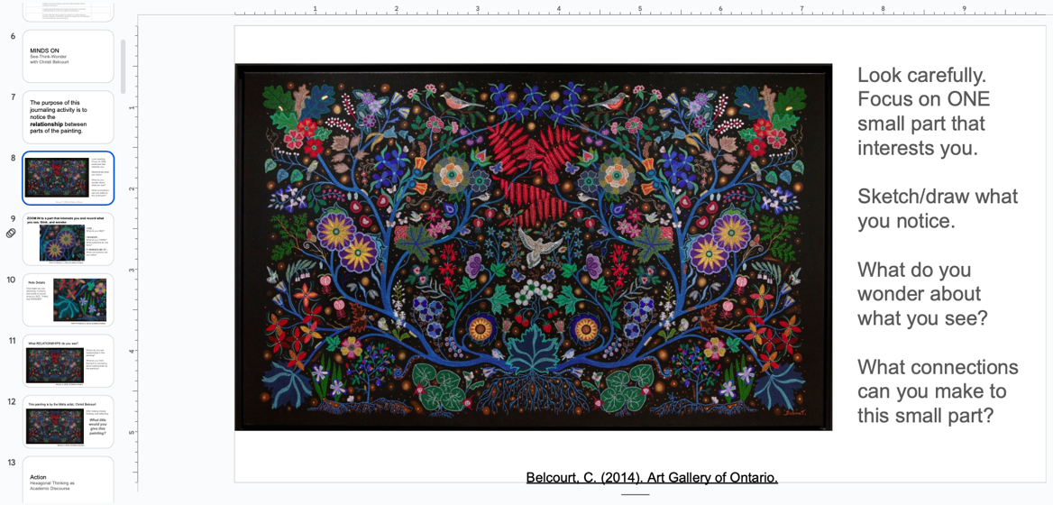](https://docs.google.com/presentation/d/1OV5cplhy3Jb6l3qNA6kUiXKeSznpqIv0Orf2dJ42dwc/edit#slide=id.g27fae0ab8a1_1_0)

Slide 8 of the lesson slide deck introduces the visual of the painting by Christi Belcourt and offers prompts for see, think, and wonder.

1. Invite students to see, think, and wonder (slides 8, 9 and 10). Use prompts, such as
   1. *Look carefully at the painting as a whole.*
   2. *Focus on one specific part that interests you.*
   3. *Sketch what you see/notice.*
   4. *Use pictures, words, and numbers to note details.*
   5. *Include what you wonder and what it reminds you of.*

[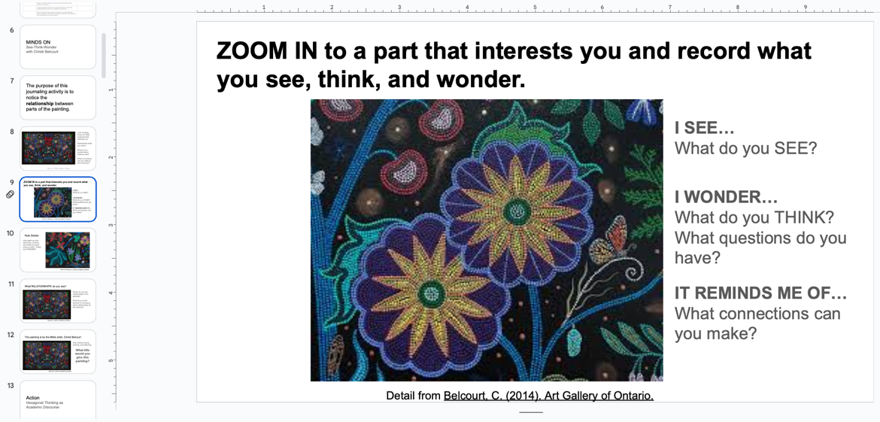](https://docs.google.com/presentation/d/1OV5cplhy3Jb6l3qNA6kUiXKeSznpqIv0Orf2dJ42dwc/edit#slide=id.g2f1e90f90e6_1_63)

Slide 9 of the lesson slide deck shows an example of a closeup section of the painting and offers prompts for see, think, and wonder.

1. Once students have had time to see, think, and wonder, ask them to discuss: *Where do you see relationships in this painting? What is being communicated about relationships by this painting?* (slide 11)
2. Listen carefully to student conversation and guide students with questions that allow knowledge building scaffolds to emerge. For example:
   1. *What is the relationship between different things/elements in this painting?*
   2. *What do you think? How do you know that? Where did you learn…?*
3. Ask students: *What title would you give this painting?* (slide 12) Provide a few minutes for students to respond in writing.

## Action

### Building ideas about relationships

1. Share the title of the painting: “The Wisdom of the Universe”.
2. Show students the [artist’s statement (external resource)](https://ago.ca/agoinsider/artists-statement-christi-belcourt-wisdom-universe) (slide 15).

[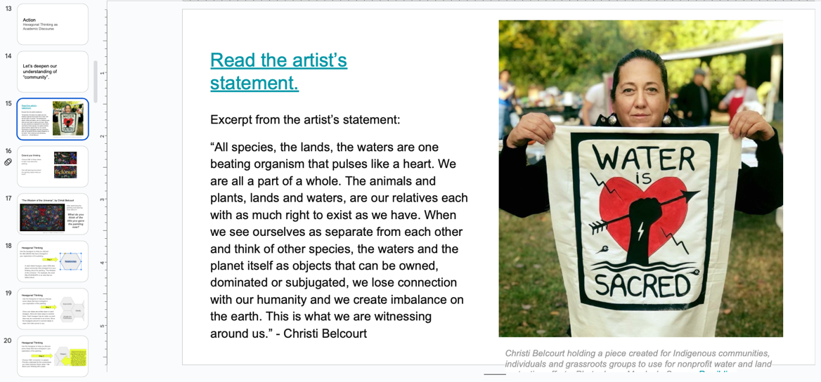](https://docs.google.com/presentation/d/1OV5cplhy3Jb6l3qNA6kUiXKeSznpqIv0Orf2dJ42dwc/edit#slide=id.g2ef3359d110_0_18)

Slide 15 of the lesson slide deck includes an excerpt of Belcourt’s artist statement.

1. Show students either of the two videos provided on slide 16 about Belcourt’s “The Wisdom of the Universe”.
   1. [“Multisensory Moments” video (YouTube)](https://www.youtube.com/watch?v=WRKO_mlolu4&t=1s) (16 minutes) - multisensory video by the AGO that explains the significance of the painting’s details (Art Gallery of Ontario, 2022).
   2. [“The Wisdom of the Universe” video (YouTube)](https://www.youtube.com/watch?v=Gktriwbs2x4) (11 minutes) - introductory information about the painting and artist (TVO Docs, 2024).
2. After watching the video, invite students to revisit the title they gave the painting (slide 17).
3. Ask students the following questions and document their thinking in response to the third and fourthon the board or chart paper:
   1. How do the different titles for this painting compare?
   2. What rationale would you provide for your title? Did seeing the video influence what you think the title should be?
   3. Why might Christi Belcourt call her painting “The Wisdom of the Universe”?
   4. What does this painting tell us about relationships and community?

### Finding connections

1. Prepare students for a **Hexagonal Thinking** activity by providing them with blank hexagons, either digitally (see slides 21 and 22) or paper cut outs (see Blank Hexagonal Thinking handout (Appendix B)). Explain that the hexagons are tools to help extend their thinking about the painting and about what makes a strong community. (For more on hexagonal thinking, see the blog post [Hexagonal Thinking: A Colorful Tool for Discussion (external resource)](https://www.cultofpedagogy.com/hexagonal-thinking/) (Potash, 2020).
2. Invite students to write down one word or phrase per hexagon that relates to what makes a strong community (e.g., cooperation, taking responsibility, respecting others) (slide 18). Students may do this independently, in pairs, or small groups.

[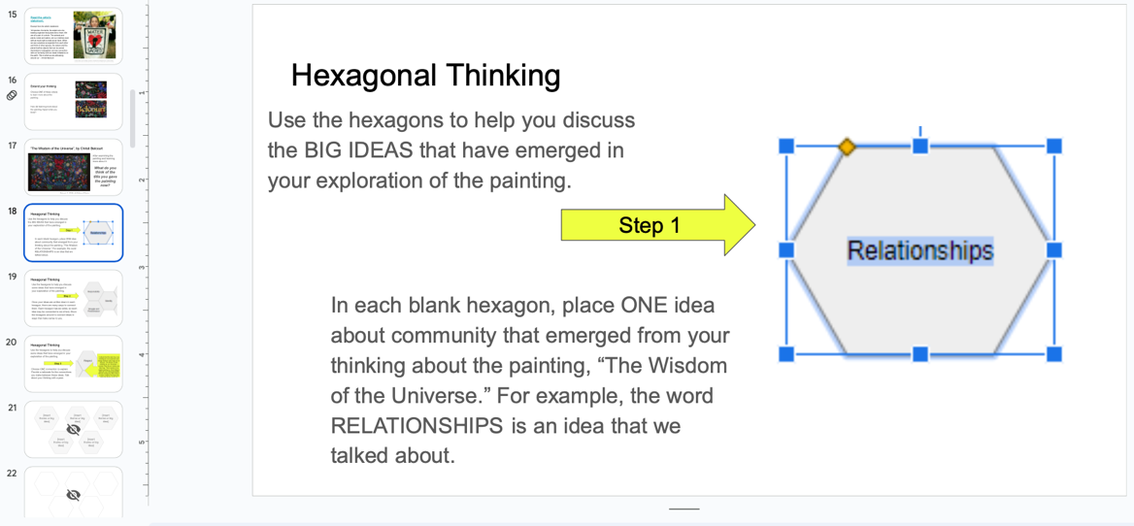](https://docs.google.com/presentation/d/1OV5cplhy3Jb6l3qNA6kUiXKeSznpqIv0Orf2dJ42dwc/edit#slide=id.g2f1e90f90e6_1_93)

Slide 18 of the lesson slide deck explains step 1 of the hexagonal thinking activity.

1. Once students have recorded thoughts on their hexagons, invite them to move the hexagons around and connect the terms based on what they think makes a strong community (slide 19). There are endless ways to connect the various terms. Encourage diversity of thinking and the intentional movement of the hexagons. Guiding questions might be: *How are these terms related when it comes to building a strong community? How else?*
2. Invite students to compare and discuss their hexagonal thinking (slides 20, 24).
3. Have students identify *one* particular connection they have made and offer a written or oral rationale for this connection (slide 25). Student rationales should address the following questions:
   1. What relationship do these terms have to one another?
   2. How does this connection relate to building a strong community?
   3. Are there any tensions you are grappling with as you think about this connection?

#### **Assessment opportunity**

Using observations and conversations, assess students’ response as an assessment *for* learning opportunity. Use additional prompts to guide students’ thinking as needed.

### Nature journaling

1. Tell students that they will be building upon their thinking in response to Christi Belcourt’s painting, “The Wisdom of the Universe” (slides 26 and 27).
2. Introduce students to the concept of **Nature Journaling:** an outdoor activity that allows them to build their capacity to observe, learn, and collaborate outside of the traditional classroom setting. (See [What is Nature Journaling? (external resource)](https://www.wildwonder.org/what-is-nature-journaling) (Wild Wonder Foundation, n.d.) for more information.) If needed to build background knowledge, show the short video on slide 28.
3. Explain the purpose of the nature journaling activity: to **notice where they see relationships outdoors in nature** (slide 29). To notice the relationship between two or more natural elements, they might look for (slide 30):
   * Cause and effect
   * Parts of a whole
   * Systems made up of individuals
   * Change and stability: what causes change?

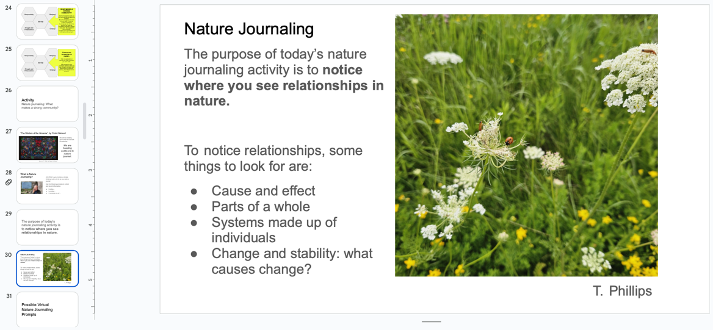

Slide 30 of the lesson slide deck provides instructions for the Nature Journaling activity.

Because they will be invited to find a place to work outdoors, clear limits must be set on how far students may go as well as how long they will have to find a spot and do their journaling. (Apply your school’s policies in terms of whether students may take a short walk near the school or must remain on school premises.) A small patch of nature, including a tuft of grass growing out of a bit of pavement can work. As an **alternative to nature journaling outdoors**, this activity may be done indoors using photographs of nature. (See slides 31 to 35.)

[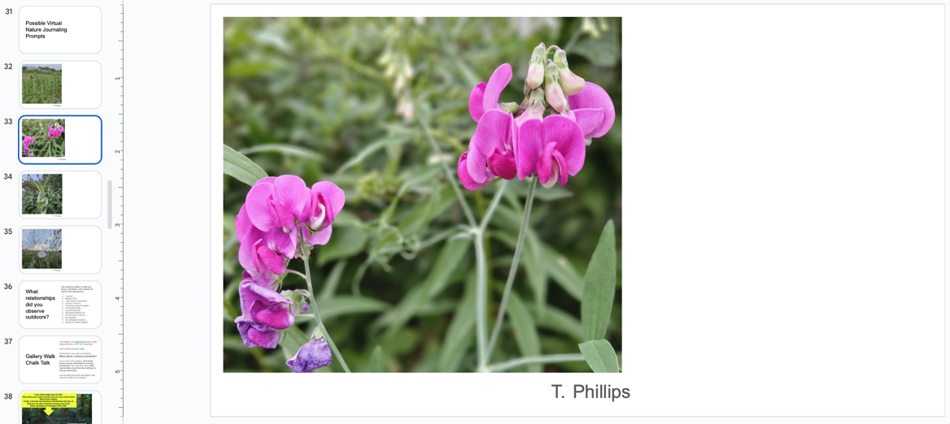](https://docs.google.com/presentation/d/1OV5cplhy3Jb6l3qNA6kUiXKeSznpqIv0Orf2dJ42dwc/edit#slide=id.g27fb6e3ee1b_0_11)

Slide 33 of the lesson slide deck is one of several nature photographs for virtual Nature Journaling activity.

Accompany students outdoors to engage in nature journaling. Students may need encouragement to sketch detail and label their sketches. Circulate and offer prompts/reminders.

When students are finished nature journaling, head back inside to engage in whole-class discussion.

Invite students to use their nature journal entry as an anchor to engage in knowledge building discourse. Remind students that the purpose of discussion is to share their observations and wonderings about what makes a strong relationship.

Start with the prompt: What relationships did you notice outdoors? (slide 36)

Document student thinking in a digital or paper document, on chart paper, or on sticky notes. Ideally, this documentation can be posted in the classroom for students to refer to later.

Listen carefully for big ideas that emerge that reveal what students know and understand about what makes a strong community, based on their own lived experiences.

Guide discourse based on concepts that are relevant to the themes of community and relationships, using questions such as:

* + *What makes a strong relationship?*
  + *What makes a strong community?*
  + *What does it mean to be a part of a whole or an individual in a relationship?*
  + *What is needed for the individual to thrive?*
  + *What is the purpose of relationships? Do all individuals in the relationship share common goals? What happens when they don’t?*
  + *What is the impact of time and place on relationships?*
  + *How is conflict negotiated in a relationship?*

Invite students to look at the documentation of discourse and to add to their nature journal any new thoughts. Encourage them to add words/phrases that further reveal what makes a strong relationship and what it means to live in a community.

### Engaging in a gallery walk

Prepare students to engage in a digital Gallery Walk by explaining the instructions on slides 37 and 38.

Share the [Gallery Walk Chalk Talk slide deck (Google slides)](https://docs.google.com/presentation/d/1a0PZePgDugO_k-Wjk62wiyzCaswHPE_XCamwNUpQSIE/edit?usp=sharing) with students by making one or more copies of the slide deck, then sharing it with permission to Edit with the class or with smaller groups of students. Alternatively, simply show slides 39 - 47 to the class and have students record words and phrases in their nature journals.

[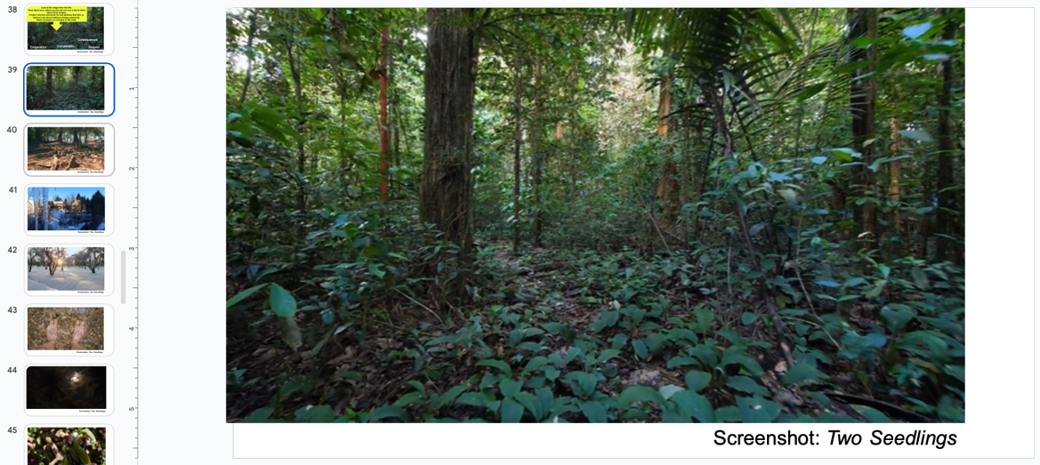](https://docs.google.com/presentation/d/1OV5cplhy3Jb6l3qNA6kUiXKeSznpqIv0Orf2dJ42dwc/edit#slide=id.g27fb6e3ee1b_0_30)

Slide 39 of the lesson slide deck shows one of several images found in the slide deck from the film Two Seedlings.

Invite students to text code the gallery by recording words and phrases on the slides or in their journals.

Provide the following prompts: *Look carefully at the image.*

* + What do you **notice?** Make lots of observations.
  + What do you **think** about this image?
  + What **connections** can you make to this image?
  + How might this photograph be connected to what you know about what makes a **strong community?**

Give students time to discuss what they see, think, and wonder with an elbow partner. Possibly discuss connections they can make to the Minds On activities regarding what makes a strong community (slide 48).

### Exploring digital stories

Let students know that the photographs are parts of a digital story (slide 49). Provide a definition of a digital story to students (slide 50). Let students know that they will be viewing a digital story and responding to it in a following activity (slide 51).

Remind students that a digital story combines audio, images, and video clips to tell a story or present an idea in two-to-four minutes. You may wish to review the film stills to remind students that many different types of photography and imagery, in addition to audio, are used to tell a personal story in this short film (slides 52 - 55).

Prepare students for viewing the digital story:

Invite them to pay close attention to the audio, video, and imagery that make up this digital story.

Review the guiding question: *What makes a strong community?*

Ask students to consider: *What does Vijay Saravanamuthu’s digital story add to what we think about community?*

Show students the digital story by Vijay Saravanamuthu titled “Two Seedlings” for the first time with nothing in hand; simply watch and enjoy (slide 56).

Invite students to engage in “draft” viewing the film (slide 57). View the digital story again, applying the following process:

* 1. Watch and notice the audio, images, and video without anything in hand.
  2. Sketchnote as you watch. Notice the characters, settings (places and times), and big ideas (themes) that emerge.
  3. Add to your sketchnote. What message is being conveyed about the individual in a community?

### Creating a concept circle

After viewing, provide students with a **Concept Circle** handout. There are two options available

* 1. A Concept Circle handout with terms provided (Appendix C) for students to discuss.
  2. A blank 4-segment Concept Circle handout (Appendix D) or blank 8-segment Concept Circle handout (Appendix E) where students must populate terms to discuss based on their viewing. If using the blank handout, give students time to write their concepts into the inner circle of the handout.

1. Explain instructions for completing the Concept Circle (slides 58 — 60). Prompt students to engage in small group conversation about each term and add their discussion notes to the outer segments of the Concept Circle. After engaging in discussion, invite students to consider and come to consensus on one unifying idea/term that should be inserted in the centre of the Concept Circle. Invite students to share their ideas: *What did you decide and why?*

[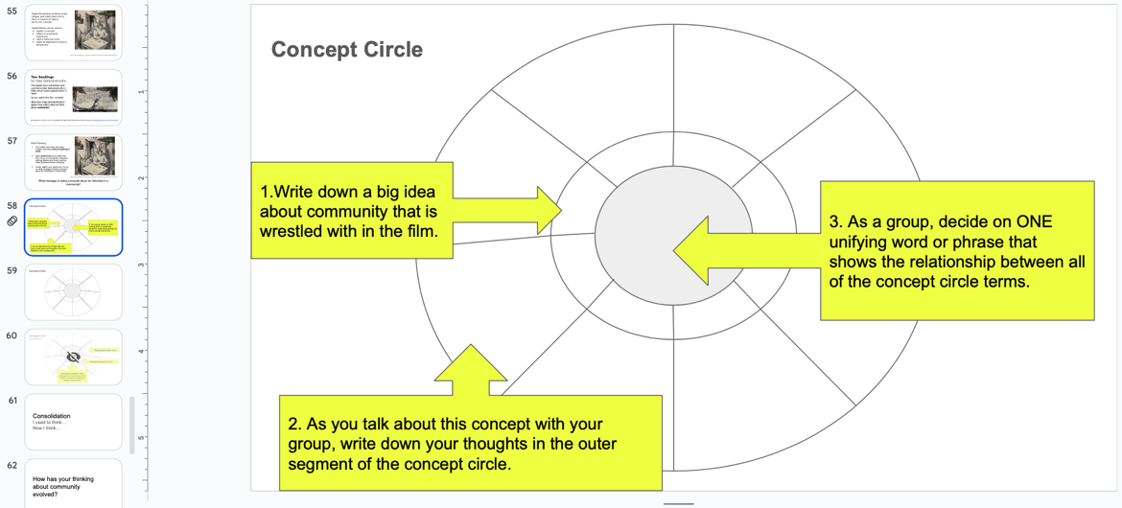](https://docs.google.com/presentation/d/1OV5cplhy3Jb6l3qNA6kUiXKeSznpqIv0Orf2dJ42dwc/edit#slide=id.g2ef3359d110_0_627)

Slide 58 of the lesson slide deck includes a visualization and instructions for the concept circle activity.

#### Assessment opportunity

Using observation of small group discussions and of the creation of the concept circles, assess students’ understanding of the relationships they are capturing in the graphic organizer. Prompt student to keep the big idea about community in mind as they are representing the relationships between ideas.

1. Debrief the Concept Circle handout with students:
   1. *What do you think about the concept of community now?*
   2. *How does this film complicate or enhance our notions of community and the individual in a community?*
   3. *What is the relationship between what you have written at the centre of your Concept Circle and your ideas about community?*

## Consolidation

### Reflection

Invite students to complete an “I used to think… Now I think…” exit pass. Look over the documentation of learning thus far and remind students of:

* 1. “The Wonder of the Universe”
  2. Nature Journaling
  3. Hexagonal Thinking Discussion
  4. Gallery Walk
  5. Digital Story
  6. Concept Circle Discussion

1. Ask students to consider how engaging in thinking, reflecting, and discourse has impacted their understanding of community and then complete the Exit Pass.

## Possible extensions

### Personal storytelling

This extensive exploration of community may provide students with the opportunity to express what they think by telling their own story. The following prompts may support students in telling their own stories which have the power to help us think, reflect, remember, and grapple.

* Why was it important for Vijay Saravanamuthu to tell this story?
* What is significant about the title “Two Seedlings”?
* What does this film add to your thinking about being a part of a whole or an individual in a community?
* You have done a lot of thinking about being a PART of a WHOLE and the meaning of **community**. What in your life tells a story about you as part of a **community**?
* What story would you want to tell that helps you to **grapple** with being a part of a **community**? (Slide 64)

### Morphology using Hexagonal Thinking or Concept Circles

These graphic organizers can also be used creatively to think about morphology and the way that words are constructed to make meaning. For example, if you provide hexagons populated with prefixes, how might students play with language to think about the smallest parts of words that offer meaning? (Slides 65 – 67)

[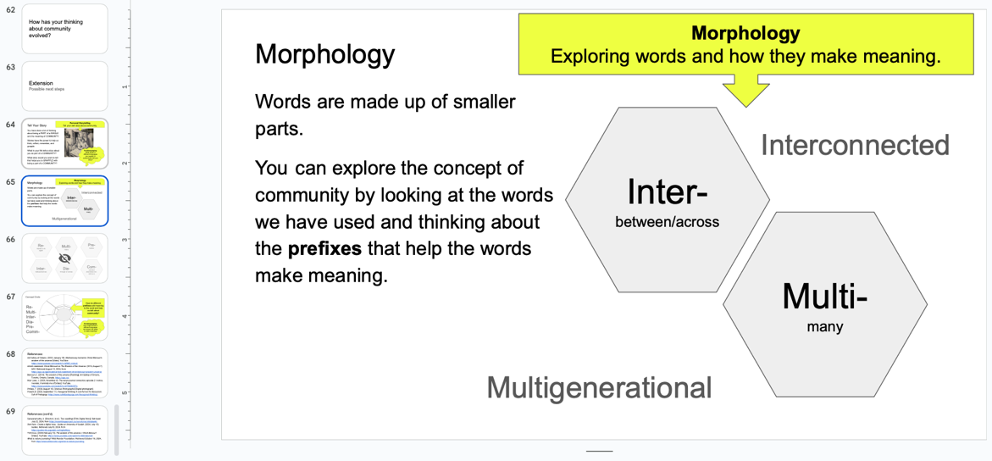](https://docs.google.com/presentation/d/1OV5cplhy3Jb6l3qNA6kUiXKeSznpqIv0Orf2dJ42dwc/edit#slide=id.g2f1e90f90e6_1_390)

Slide 65 of lesson the slide deck shows the role of prefixes in a hexagonal thinking morphology activity.

# Appendix A

## Hexagonal Thinking handout with terms

Hexagons with example “Community” terminology pre-set:

* Responsibility
* Beauty
* Respect
* Struggle and Perseverance
* Identity
* Change

Six hexagons each with one of the following terms: Responsibility, Beauty, Respect, Struggle and Perseverance, Identity, Change.


# Appendix B

## Blank Hexagonal Thinking handout

Blank hexagons for students to generate the terms on their own.

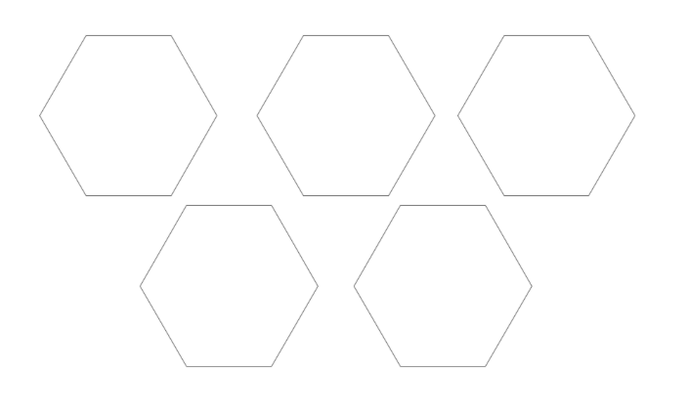

# Appendix C

## Concept Circle with terms provided

Terminology for discussion:

* Memories
* Generations
* Time and place
* Understanding

A circular diagram divided into 4 quarters with two layers, and a hole in the middle, . The inner layer contains the terms: Memories, Generations, Time and place, Understanding. The outer layer of each quadrant is blank. 


# Appendix D

## Blank 4-segment concept circle

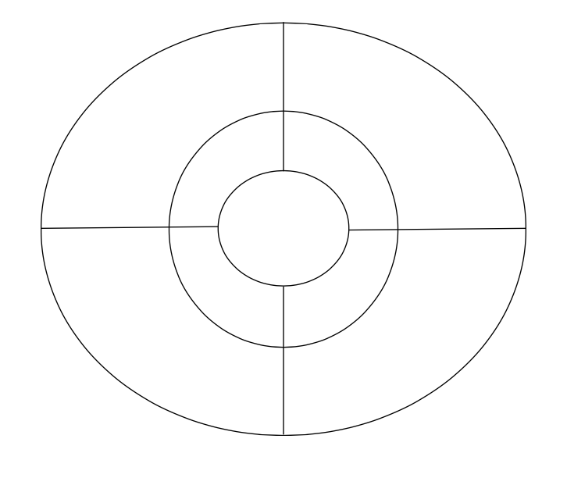

# Appendix E

## Blank 8-segment concept circle

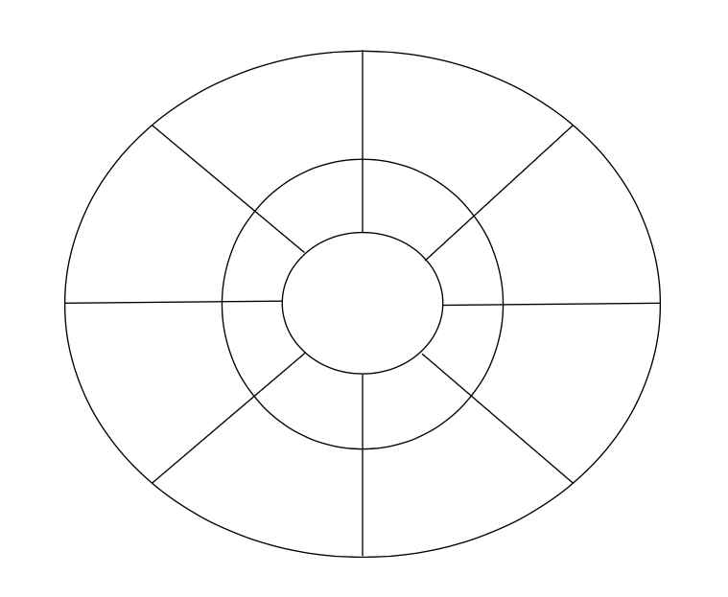

# Appendix F

## Curriculum expectations

### A3. Applications, Connections, and Contributions

apply language and literacy skills in cross-curricular and integrated learning, and demonstrate an understanding of, and make connections to, diverse voices, experiences, perspectives, histories, and contributions, including those of First Nations, Métis, and Inuit individuals, communities, groups, and nations

#### A3.2. Identity and Community

demonstrate an understanding of the historical contexts, contributions, lived experiences, and perspectives of a diversity of individuals and communities, including those in Canada, by exploring and analyzing the concepts of identity, self, and sense of belonging in a variety of culturally responsive and relevant texts

### C1. Knowledge about Texts

apply foundational knowledge and skills to understand a variety of texts, including digital and media texts, by creators with diverse identities, perspectives, and experience, and demonstrate an understanding of the patterns, features, and elements of style associated with various text forms and genres

#### C1.4. Visual Elements of Texts

evaluate how images, graphics, and visual design create, communicate, and contribute to meaning in a variety of texts

#### C1.7. Indigenous Context of Various Text Forms

read, listen to, and view a wide variety of text forms by diverse First Nations, Métis, and Inuit creators to make meaning through Indigenous Storywork about First Nations, Métis, and Inuit histories, cultures, relationships, communities, groups, nations, and lived experiences

### C2. Comprehension Strategies

apply comprehension strategies before, during, and after reading, listening to, and viewing a variety of texts, including digital and media texts, by creators with diverse identities, perspectives, and experience, in order to understand and clarify the meaning of texts

#### C2.1. Prereading: Activating Prior Knowledge

identify and explain prior knowledge from various sources, including personal experiences and learning in other subject areas, that they can use to make connections and understand new texts

#### C2.5. Monitoring of Understanding: Making Connections

connect, compare, and contrast the ideas expressed in texts and their knowledges and lived experiences, the ideas in other texts, and the world around them

#### C2.6. Summarizing: Identifying Relevant information and Drawing Conclusions

summarize and synthesize the important ideas and supporting details in complex texts, and draw effective conclusions

#### C2.7. Reflecting on Learning

explain andcompare how various strategies, such as visualizing, making predictions, summarizing, and connecting to their experiences, have helped them comprehend various texts, and set goals for future improvement

# References

Art Gallery of Ontario. (2022, January 18). *Multisensory moments: Christi Belcourt’s wisdom of the universe* [Video]. YouTube. <https://www.youtube.com/watch?v=WRKO_mlolu4>

*Artist's statement: Christi Belcourt on The Wisdom of the Universe*. (2014, August 7). AGO. Retrieved August 12, 2024, from <https://ago.ca/agoinsider/artists-statement-christi-belcourt-wisdom-universe>

Belcourt, C. (2014). *The wisdom of the universe* [Painting]. Art Gallery of Ontario, Toronto, Ontario, Canada. <https://ago.ca/>

Muir Laws, J. (2020, November 4). *The nature journal connection, episode 2: I notice, I wonder, it reminds me of* [Video]. YouTube. <https://www.youtube.com/watch?v=v079W4lZ0TU>

Phillips, T. (2024, August 16). [Various Photographs] [Digital photograph].

Potash, B. (2020, September 11). *Hexagonal thinking: A colorful tool for discussion*. Cult of Pedagogy. <https://www.cultofpedagogy.com/hexagonal-thinking/>

Saravanamuthu, V. (Director). (n.d.). *Two seedlings* [Film; Digital Story]. Retrieved July 22, 2024, from <https://resemblageproject.ca/our-stories/storybank/>

*Start here - Create a digital story - Guides at University of Guelph*. (2024, July 10). Guides. Retrieved July 30, 2024, from <https://guides.lib.uoguelph.ca/DigitalStory>

TVO Docs. (2024, February 15). *The wisdom of the universe / Christi Belcourt* [Video]. YouTube. <https://www.youtube.com/watch?v=Gktriwbs2x4>

*What is nature journaling?* Wild Wonder Foundation. Retrieved October 18, 2024, from <https://www.wildwonder.org/what-is-nature-journaling>

# Attribution license

This lesson plan is published under a [CC BY-NC-SA](https://creativecommons.org/licenses/by-nc-sa/4.0/) license. Third-party resources are subject to their own copyright.



This license enables reusers to distribute, remix, adapt, and build upon the material in any medium or format for noncommercial purposes only, and only so long as attribution is given to the creator. If you remix, adapt, or build upon the material, you must license the modified material under identical terms. CC BY-NC-SA includes the following elements:

  BY: credit must be given to the creator.  
  NC: Only noncommercial uses of the work are permitted.  
  SA: Adaptations must be shared under the same terms.

# Updates

When updates are made to this document, they are tracked below with date and description of update.

* February 2025: initial release