

Developing Fluency Through Poetry

This lesson promotes [fluency (Glossary)](https://docs.google.com/document/d/112IyTd4r4Wy3Z3prrSetIYpK8AkUp9ckL7xX1c9cNWg/edit#bookmark=id.cjin81zd28vj) development through [choral reading (Glossary)](https://docs.google.com/document/d/112IyTd4r4Wy3Z3prrSetIYpK8AkUp9ckL7xX1c9cNWg/edit#bookmark=id.ibakyntscami) of a short poem with attention to accuracy, rate, and expression. Students also learn related decoding strategies such as syllabication and morphological awareness.

Grade

9

Curriculum expectations

A1, A1.1, B1, B1.1, B2, B2.2, B2.3, B3, B3.2, B3.3 (see Appendix F for full descriptions)

Strands

A. Literacy Connections and Applications

B. Foundations of Language

# Contents

Grade 1

Curriculum expectations 1

Strands 1

Contents 2

Learning goals 5

Success criteria 5

Lesson path 6

Time 6

Materials and resources 6

Minds on 7

Exploring prosody 7

Working with word parts 8

Engaging in choral reading 8

Action 9

Analysing language 9

Experimenting with prosody and meaning 10

Possible support actions 12

Additional challenges 13

Finding interpretations through expression 13

Consolidation 14

Reflection 14

Possible extensions 14

Write and read aloud a cinquain poem 14

Create an expressive reading 15

Provide more opportunities for fluency practice 15

Appendix A: 16

Reading Fluency Reflection (Entry / Exit Ticket) 16

Entry ticket reflection statements 17

Exit ticket 3-2-1 reflection questions 18

Appendix B: 19

Where is the stress? Part 1 19

Appendix C 20

Where is the stress? Part 2 20

Appendix D 21

Snow 21

Appendix E 21

Cinquains 21

Niagara Seen on a Night in November 21

November Night 22

Cinquains written during a tropical storm 22

The sky 22

Sample cinquain 22

Appendix F 23

Curriculum expectations 23

A1. Transferable Skills 23

B1. Oral and Non-Verbal Communication 24

B2. Language Foundations for Reading and Writing 24

B3. Language Conventions for Reading and Writing 25

Glossary 25

References 27

Attribution license 29

Updates 29

# Learning goals



We are learning …

* read fluently with appropriate accuracy, rate, and expression.

# Success criteria



I can …

* use syllables (Glossary) or morphemes (Glossary) to help me decode new words.
* use punctuation and phrasing to read with appropriate expression.
* read fluently (Glossary) as demonstrated by my accuracy, rate, and expression.
* use listening skills to hear fluency and prosody.
* make choices about expression and prosody when reading texts.

# Lesson path



## Time

140 minutes

This is a suggested amount of time. This lesson may be implemented over a series of days. Educators will make the best judgement on how to implement.

## Materials and resources

* [Lesson slide deck (Google slides)](https://docs.google.com/presentation/d/1hNeOcqp3DVUqzfvtcpNxFpYwBS3IXXpRRs5z-IQHsYc/edit?usp=sharing)
* Reading Fluency Reflection (Entry / Exit Ticket)(Appendix A)
* Where is the stress? Part 1 (Appendix B) (Sentences copied and cut into strips for group task.)
* Where is the stress? Part 2 (Appendix C) (Sentences copied and cut into strips for group task.)
* Printed copies of the poem “Snow” by Adelaide Crapsey (Appendix D).
* Examples of Cinquains (Appendix E)

## Minds on

### Exploring prosody

**Distribute** Reading Fluency Reflection (Entry / Exit Ticket) (Appendix A) (also on slides 5 – 6) and invite students to reflect on their current skills by placing a circle on the continuum in the first section. (Students will reassess their skills and complete the remainder of the ticket at the end of the lesson.)

**Collect** the entry tickets or ask students to put them away for later use.

**Prepare students** for Prosody practice (Glossary) by arranging students into small groups (random, self-selected, or teacher-selected). Using Where is the stress? Part 1 (Appendix B) sentences (printed and cut into strips), distribute a different sentence to each person in the group (slide 7).

**Invite students** to:

Read the sentence to themselves (whispered or quietly).

Read the sentences to each other, putting stress on the bolded word and paying attention to the punctuation.

#### Assessment opportunity

**Circulate** while students read sentences to offer feedback and make observations.

1. **Conduct** a short class discussion (slide 10). Note that the stressed word and the punctuation change how we read and understand the sentence. This is set up on slide 11 (optional).

### Working with word parts

**Prepare** **students** for **Word Work** by writing the word BLEAKEN on the board and / or showing slide 12. Ask students to break this word into syllables (Glossary).

**Hint:** every syllable must have a vowel and circulate to offer feedback and make observations.

**Accessibility and participation considerations:** Include different modalities and formats. For example, write on a whiteboard, piece of paper, or other surface, or offer digital approaches such a keyboard or voice to text.

Once students have tried this independently, **review** the steps and answers together (slide 13).

**Ask** students to identify the root word (Glossary) and suffix (Glossary) of the word (slide 14).

**Then ask** if they know the meaning of the root word or suffix. Gather student responses, confirming correct meanings. (The suffix *-en* means *to become or to cause.* When we add *-en* to an adjective, the word often becomes a verb.)

**Optional Extension:** Brainstorm a list of words that use the suffix -*en*. Discuss and note the common meaning and identify any outliers. Note how adding a suffix (Glossary) to a word can change the part of speech. Examples: golden, waxen, woolen, deepen, darken.

### Engaging in choral reading

If possible, **invite** students to stand up and gather in a huddle in an available space in the classroom (no need to move any furniture). Prepare students to explore the poem “Snow” by Adelaide Crapsey (Appendix D) by providing some context. (E.g., *The poem we are about to read is about the shift from* autumn *to winter. As I read the poem, pay attention to the rhythm. Ask yourself: What are some adverbs or adjectives that describe this shift?*) (slide 15).

**Distribute** copies of the poem (one copy per pair), then read the poem aloud to the class while students follow along (slide 16).

**Invite** students to participate in a choral reading (Glossary) of the poem, that is, to read the poem aloud in unison. Repeat to improve familiarity and unity.

**Pause** to look at the poem. Point out the line breaks, punctuation, etc., and discuss how they might influence how the poem is read.

**Repeat** the choral reading paying attention to line breaks and punctuation.

## Action

### Analysing language

**Create** groupings of two or three students to engage in a close reading of the poem.

**Present** the following sets of questions and have groups engage in a think-pair-share (slides 18 and 19).

* + What features do you notice in the poem?
  + What types of language are used?
  + How many lines are in the poem?
  + Is there rhythm to the poem? If so how is it achieved?
  + Divide each line into syllables? How many syllables does each line have?

[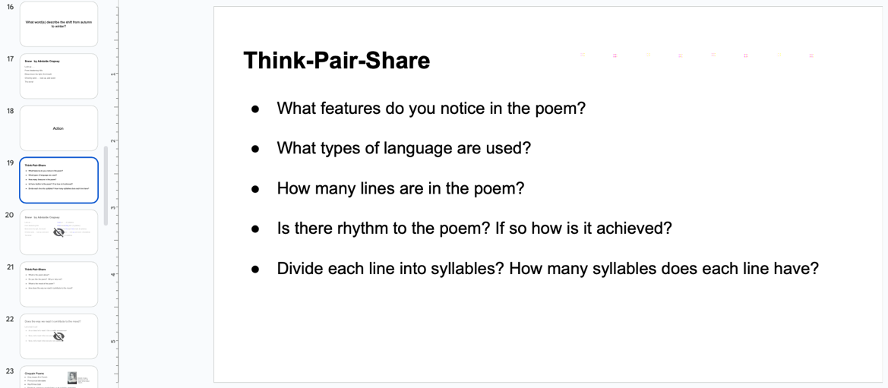](https://docs.google.com/presentation/d/1hNeOcqp3DVUqzfvtcpNxFpYwBS3IXXpRRs5z-IQHsYc/edit#slide=id.g27896d05c77_0_46)

Slide 19 of the lesson slide deck has the five Think-Pair-Share questions for students to review.

**Pause** to examine the syllables of each line (slide 20). Note that the syllable pattern contributes to the rhythm, expression, and rate at which we read the poem.

**Present** the questions on slide 21 and have groups engage in another think-pair-share: a) What is the poem about?; b) Do you like the poem? Why or why not?; c) What is the mood of the poem?; d) How does the way we read it contribute to the mood?

If students need **further practice** to understand how fluency (Glossary) and prosody (Glossary) contribute to mood, do the activity on slide 22.

**Explain** the key features and structural form of the cinquain poem (slides 23 and 24).

1. If students need to review the parts of speech, share slide 25.

### Experimenting with prosody and meaning

**Prepare** students for Prosody (Glossary) **practice** by arranging students into small groups (random, self-selected, or teacher-selected). Using Where is the stress? Part 2 (Appendix C) sentences (printed and cut into strips), distribute a different sentence to each person in the group (slides 8 and 9).

**Invite students** to:

Read the sentence to themselves (whispered or quietly).

Read the sentences to each other, putting stress on the bolded word and paying attention to the punctuation.

**Circulate** to offer feedback and make observations.

**Conduct** a short class discussion (slide 10). Note that the stressed word and the punctuation change how we read and understand the sentence. You may wish to show and discuss slide 11 (optional).

If some **Word Work is needed**, select one or more key words from the poems students will read later and use the same routine followed earlier in the lesson to explore root words (Glossary) and affixes (Glossary).

**Ask students** to recall the features of a cinquain poem. Note their responses and create a list on the board or refer to slides 23 and 24.

**Ask** **students** to recall what they learned about choral reading (Glossary). Note their responses on the board, chart paper, or screen.

1. **Form groups** of three based on your observations of the students’ fluency, prosody, and vocabulary knowledge.
2. **Provide** an appropriate cinquain poem to each group. Each student in the group should receive a copy of the poem. Use student interests and background knowledge to help select which poem to provide each group of students. (Some examples are provided in Appendix E at varying levels of complexity. Alternatively, find other poems with an online search).
3. **Explain** the consolidation instructions on slides 26 – 30.
4. **Invite students** to engage in the process of exploring their cinquain poem, one slide at a time.

[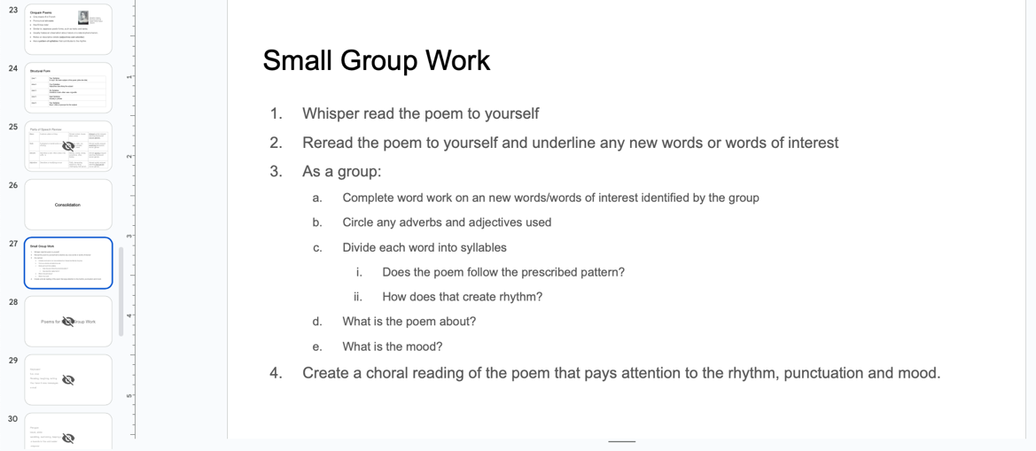](https://docs.google.com/presentation/d/1hNeOcqp3DVUqzfvtcpNxFpYwBS3IXXpRRs5z-IQHsYc/edit#slide=id.g27896d05c77_0_80)

Slide 27 of the lesson slide deck outlines the process for small group work.

#### Assessment opportunity

Through observations and conversations, gauge how students are experimenting with different aspects of prosody, and prompt students to share rationales for their choices as they relate to meaning and interpretation.

### **Possible support actions**

* **Read** the poem to the students the first time or offer the use of assistive technology such as text-to-speech technology.
* **Review** the syllabication strategy with small group:
  + Model dividing the first line into syllables.
  + With the group, divide the second line into syllables.
  + Ask them to divide the remaining lines into syllables.
* **Review** parts of speech with small group:
  + Give them a word bank of adverbs and adjectives to help them find others.
* **Offer** a change of poem to one of greater interest.
* **Invite** students to highlight punctuation and underline words they want to place emphasis on to aid in their choral reading.
* **Encourage** students to answer the questions orally instead of in writing.

### **Additional challenges**

* **Ask** students to look up the etymology of words from the poem to learn their origins. Sites such as [etymonline.com](https://www.etymonline.com/) (external resource) are helpful.
* **Invite** students to create a list of synonyms and antonyms for key vocabulary. Using that list, have them substitute words to see how it changes the meaning, mood, subject, or rhythm of the poem.
* **Have students** search for another poem on the same topic (in any form) to compare the descriptive language. How does word choice create tone and mood?
* **Offer** a change of poem to one of greater challenge.

### Finding interpretations through expression

**Prepare** **students** to perform their choral reading for one other group in the class by creating partner groups.

1. **Have each group** perform their choral reading to the partner group. Listeners will offer feedback on accuracy, pace, emotion/expression, stress, and rhythm (slide 31). Listeners may use the sentence starters (slide 32) to help with this process.

#### Assessment opportunity

**Circulate** listening to the groups and gathering observations about accuracy, rate, and emotion/expression.

## Consolidation

### Reflection

**Have students revisit** the Reading Fluency Reflection (Entry / Exit Ticket) (Appendix A) they began at the outset (slides 5 – 6). Have students self-assess their skills at this moment by placing an X on the continuum. (This allows them to reflect on how the lesson supported their growth as a reader.) Additionally, have them complete the 3-2-1 reflection section (Appendix A).

1. **Collect** these reflections to make assessment observations and use for planning purposes.

#### Assessment opportunity

Invite students to make a voice recording of their choral reading. This reading should apply the feedback given by their peers.

Students may use this recording for self-assessment (assessment *as* learning), and the teacher may use observations to help plan future lessons, small group work, or to review concepts.

## Possible extensions

### **Write and read aloud a cinquain poem**

Students can use their knowledge of syllables, punctuation, and the parts of speech to write their own poem in the same format (slides 24 and 35). Once they have written a poem, they may read it aloud to a peer, small group, or to the teacher.

Suggestions for differentiating this task include:

* Allow students to work collaboratively or independently.
* Provide a word bank of adverbs and adjectives for those who need help building their descriptive vocabulary.
* Provide a selection of images as inspiration.
* Have students use appropriate online resources to look up synonyms and antonyms to help them select the best words for their poem.
* Have students record their reading of the poem or perform a live reading to a small group or just the teacher.

### **Create an expressive reading**

Students can use their knowledge of vocabulary, punctuation, descriptive language, and the parts of speech to find a poem that interests them, then use it to create an expressive [multimodal](https://docs.google.com/document/d/112IyTd4r4Wy3Z3prrSetIYpK8AkUp9ckL7xX1c9cNWg/edit#bookmark=kix.e6ehcsk9t9uq) (Glossary) reading of the poem that integrates multiple modes of expression such as audio and visual elements (slide 36).

Suggestions for differentiating this task include:

* Allow students to work collaboratively or independently.
* Provide a small bank of preselected poems.
* Have students write their own poem.
* Provide a bank of images and sounds.

### **Provide more opportunities for fluency practice**

Fluency practice can be done with other poems, with children’s literature, and with other texts studied in the course. Listening to, viewing, repeated reading, partner reading, and choral reading are all effective ways to add fluency practice to a lesson.

# Appendix A:

## Reading Fluency Reflection (Entry / Exit Ticket)

Use the statements below to prompt students to reflect on their confidence for each skill. The statements may be presented as entry/exit tickets, asking them to mark their confidence on a continuum.

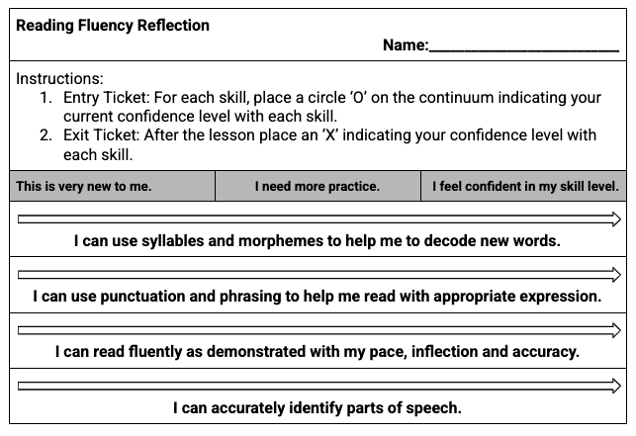

Example Entry ticket for learners who prefer paper format.

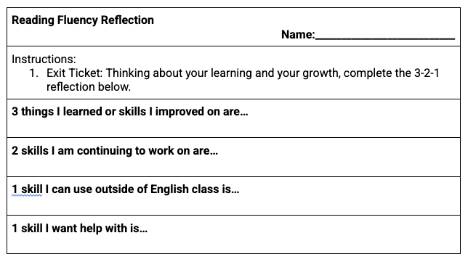

Example Exit ticket for learners who prefer paper format.

**Note:** If you choose to create digital Entry / Exit tickets, the layout of the responses may need to be adjusted to meet accessibility needs.

### Entry ticket reflection statements

Before and after the lesson, indicate your confidence level with each skill:

1. I can use syllables and morphemes to help me to decode new words.

This is very new to me.

I need more practice.

I feel confident in my skill level.

I can use punctuation and phrasing to help me read with appropriate expression.

This is very new to me.

I need more practice.

I feel confident in my skill level.

I can read fluently as demonstrated with my pace, inflection and accuracy.

This is very new to me.

I need more practice.

I feel confident in my skill level.

I can accurately identify parts of speech.

This is very new to me.

I need more practice.

I feel confident in my skill level.

### Exit ticket 3-2-1 reflection questions

Thinking about your learning and your growth, complete the 3-2-1 reflection below.

* 3 things I learned or skills I improvised on are:
* 2 skills I am continuing to work on are:
* 1 skill I can use outside of English class is:
* 1 skill I want help with is:

# Appendix B:

## Where is the stress? Part 1

Read each sentence out loud stressing the bolded word and paying attention to punctuation. Think about how the change of stressed word affects the meaning of the sentence or how the statement would be received.

**He** took my pencil.

He took **my** pencil.

He **took** my pencil!

He took my **pencil?**

# Appendix C

## Where is the stress? Part 2

Read each sentence out loud stressing the bolded word and paying attention to punctuation. Think about how the change of stressed word affects the meaning of the sentence or how the statement would be received.

**Yeah,** that was a great book.

Yeah, that was a **great** book!

**Where** are you?

Where are **you?**

Where **are** you?

# Appendix D

## Snow

By Adelaide Crapsey

Look up . . .

From bleakening hills

Blows down the light, first breath

Of wintry wind . . . look up, and scent

The snow!

# Appendix E

## Cinquains

### **Niagara Seen on a Night in November**

By Adelaide Crapsey

How frail

Above the bulk

Of crashing water hangs

Autumnal, evanescent, wan

The moon.

### **November Night**

By Adelaide Crapsey

Listen. .

With faint dry sound,

Like steps of passing ghosts,

The leaves, frost-crisp'd, break from the trees

And fall.

### **Cinquains written during a tropical storm**

By Urayón Noel

to live

now is to speak

the language of the tree

toppled along the expressway

at night

### The sky

By Maria Herron

The sky

Grows light and pink

As the sun rises and

Warms the sleepy mountains with a

Soft kiss

### Sample cinquain

dessert

cold, creamy

eating, giggling, licking

cone with three scoops

ice cream

Source: [Sample Cinquains (external PDF resource)](https://www.readwritethink.org/sites/default/files/resources/lesson_images/lesson43/RWT016-1.PDF)

# Appendix F

## Curriculum expectations

### A1. Transferable Skills

demonstrate an understanding of how the seven transferable skills (critical thinking and problem solving; innovation, creativity, and entrepreneurship; self-directed learning; **collaboration**; communication; global citizenship and sustainability; and digital literacy) are used in various language and literacy contexts

#### A1.1. Receptive and Expressive Communication

analyze and explain how transferable skills can be used to support communication in various cultural, social, linguistic, and domain-specific contexts, and apply them when reading, listening to, viewing, and creating texts of various forms

### B1. Oral and Non-Verbal Communication

apply listening, speaking, and non-verbal communication skills and strategies to understand and communicate meaning in formal and informal contexts and for various purposes and audiences

#### B1.1. Effective Listening Skills

evaluate and use various effective listening skills to enhance comprehension, including paraphrasing, asking open-ended questions, making relevant responses in group discussions, and reflecting on what has been said, and use these skills in formal and informal contexts and for various purposes

### B2. Language Foundations for Reading and Writing

demonstrate an understanding of foundational language knowledge and skills, and apply this understanding when reading and writing

#### B2.2. Vocabulary

demonstrate an understanding of a wide variety of words, acquire and use explicitly taught vocabulary flexibly in various contexts, including other subject areas, and use consolidated morphological knowledge to analyze and understand new words in context

#### B2.3. Reading Fluency: Accuracy, Rate & Prosody

read a variety of complex texts fluently, with accuracy and appropriate pacing to support comprehension, and when reading aloud, adjust expression and intonation according to the purpose of reading

### B3. Language Conventions for Reading and Writing

demonstrate an understanding of sentence structure, grammar, cohesive ties, and capitalization and punctuation, and apply this knowledge when reading and writing sentences, paragraphs, and a variety of texts

#### B3.2 Grammar

demonstrate an understanding of the functions of parts of speech in sentences, consolidate and refine their understanding of grammar, and use this knowledge to support comprehension and communicate meaning clearly and precisely

#### B3.3 Capitalization and Punctuation

use and refine their understanding of the meaning and function of capitalization and punctuation to communicate meaning clearly and coherently, when reading and writing

# Glossary

**Affix:** A morpheme attached to the beginning or end of a base to modify its meaning. Affixes are bound morphemes; they cannot stand alone. Prefixes and suffixes are both affixes. ([ENL1W Curriculum Glossary (external resource)](https://www.dcp.edu.gov.on.ca/en/curriculum/secondary-english/courses/enl1w/glossary#a))

**Blending:** An aspect of phonemic awareness that involves the ability to combine individual phonemes (sounds) to form words.” ([ENL1W Curriculum Glossary (external resource)](https://www.dcp.edu.gov.on.ca/en/curriculum/secondary-english/courses/enl1w/glossary#a))

**Choral Reading:** Choral reading is reading aloud in unison with a whole class or group of students. Choral reading helps build students’ fluency, self-confidence, and motivation. Because students are reading aloud together, students who may ordinarily feel self-conscious or nervous about reading aloud have built-in support ([Reading Rockets](https://www.readingrockets.org/classroom/classroom-strategies/choral-reading)).

**Digraphs:** A combination of two letters representing one sound (e.g., consonant digraphs: ph, sh, ch, etc., and vowel digraphs: ar, ea, ir, er, oa, ue, etc.) ([ENL1W Curriculum Glossary (external resource)](https://www.dcp.edu.gov.on.ca/en/curriculum/secondary-english/courses/enl1w/glossary#a))

**Fluency:** The ability to identify words accurately and to read text quickly with ease, pace, automaticity, and expression. As they develop fluency, students read expressively, with proper phrasing and punctuation, and gain more meaning from the text. ([ENL1W Curriculum Glossary (external resource)](https://www.dcp.edu.gov.on.ca/en/curriculum/secondary-english/courses/enl1w/glossary#a))

**Morpheme:** The smallest unit of meaning within words. A morpheme can be either a prefix, a suffix, or a base. Words are made up of one or more morphemes. ([ENL1W Curriculum Glossary (external resource)](https://www.dcp.edu.gov.on.ca/en/curriculum/secondary-english/courses/enl1w/glossary#a)). The study of these is known as **morphology.**

**Multimodal:** A multimodal text is one that “uses more than one mode to communicate meaning (e.g., children’s picture book; graphic novel; film; video; website; speech with visual aids). Most media texts are multimodal ([ENL1W Curriculum Glossary (external resource)](https://www.dcp.edu.gov.on.ca/en/curriculum/secondary-english/courses/enl1w/glossary#a)).

**Prefix:** A morpheme that precedes a base to form a different word (e.g., trans- before form or act) ([ENL1W Curriculum Glossary (external resource)](https://www.dcp.edu.gov.on.ca/en/curriculum/secondary-english/courses/enl1w/glossary#a))

**Prosody practice:** Reading aloud or speaking expression, which is determined by phrasing, pause structures, stress, intonation, and general expressiveness. ([ENL1W Curriculum Glossary (external resource)](https://www.dcp.edu.gov.on.ca/en/curriculum/secondary-english/courses/enl1w/glossary#a))

**Root word:** Root words hold the most basic meaning of a word. [(Reading Rockets)](https://www.readingrockets.org/topics/spelling-and-word-study/articles/root-words-suffixes-and-prefixes).

**Suffix:** A morpheme that is added to the end of a base to create a different word. ([ENL1W Curriculum Glossary (external resource)](https://www.dcp.edu.gov.on.ca/en/curriculum/secondary-english/courses/enl1w/glossary#a))

**Syllable:** The smallest segment of a word that includes one vowel sound, which may have an accompanying consonant, for example, family has three syllables: fam-i-ly. ([ENL1W Curriculum Glossary (external resource)](https://www.dcp.edu.gov.on.ca/en/curriculum/secondary-english/courses/enl1w/glossary#a))

# References

*Adelaide Crapsey*. (2023, October 9). In *Wikipedia*. <https://en.wikipedia.org/wiki/Adelaide_Crapsey>

Betts, J. (2021, January 4). *Cinquain Examples and Poem Format*. Your Dictionary. Retrieved July 31, 2024, from <https://www.yourdictionary.com/articles/cinquain-poems>

Crapsey, A. (n.d.). *Niagara* [poem]. Poetry Foundation. Retrieved August 15, 2024, from <https://www.poetryfoundation.org/poems/46258/niagara-56d226153edc6>

Crapsey, A. (n.d.). *Snow* [poem]. All Poetry. Retrieved July 31, 2024, from <https://allpoetry.com/poem/8543797-Snow-by-Adelaide-Crapsey>

Crapsey, A. (n.d.). *November night* [poem]. Poetry Foundation. Retrieved August 15, 2024, from <https://www.poetryfoundation.org/poems/46253/november-night>

Herron, M. (n.d.). *The sky* [poem]. Mom Junction. Retrieved October 22, 2024, from <https://www.momjunction.com/articles/how-to-write-cinquains-poems-for-kids-examples_00732853/#10-examples-of-cinquain-poems-for-kids>

McEwan, E. K. (2024). *Root Words, Suffixes, and Prefixes*. Reading Rockets. Retrieved July 31, 2024, from <https://www.readingrockets.org/topics/spelling-and-word-study/articles/root-words-suffixes-and-prefixes>

Noel, U. (2023, January 2). *Cinquains written during a tropical storm* [poem]. Poets.org. Retrieved on October 22, 2024 from <https://poets.org/poem/cinquains-written-during-tropical-storm>

Ontario Ministry of Education. (2023). *The Ontario curriculum: Grades 9-12 English.* Toronto: Author.

Reading Rockets. (2024). *Choral Reading*. Reading Rockets. Retrieved July 31, 2024, from <https://www.readingrockets.org/classroom/classroom-strategies/choral-reading>

*Sample Cinquains*. (n.d.). Read Write Think. Retrieved August 15, 2024, from <https://www.readwritethink.org/sites/default/files/resources/lesson_images/lesson43/RWT016-1.PDF>

# Attribution license

This lesson plan is published under a [CC BY-NC-SA](https://creativecommons.org/licenses/by-nc-sa/4.0/) license. Third-party resources are subject to their own copyright.



This license enables reusers to distribute, remix, adapt, and build upon the material in any medium or format for noncommercial purposes only, and only so long as attribution is given to the creator. If you remix, adapt, or build upon the material, you must license the modified material under identical terms. CC BY-NC-SA includes the following elements:

  BY: credit must be given to the creator.  
  NC: Only noncommercial uses of the work are permitted.  
  SA: Adaptations must be shared under the same terms.

# Updates

When updates are made to this document, they are tracked below with date and description of update.

* February 2025: initial release