

Short, Manageable and Engaging Daily Vocabulary Routines

This lesson, structured as a series of mini-lessons delivered over a number of days, establishes vocabulary routines based on 3–5 Tier 2 vocabulary “Words of the Week” pulled from class texts. This routine gives students morphological background, repeated exposure to and active engagement with words resulting in the building of students’ vocabulary banks and ever-increasing depth, breadth, and flexibility of word knowledge. This lesson plan uses the transcription of The Next Chapter CBC Radio Interview [Zoey Roy’s visual album Zoetry uses poetry and performance art to bear witness (external resource)](https://www.cbc.ca/radio/thenextchapter/full-episode-sept-03-2022-1.6412444/zoey-roy-s-visual-album-zoetry-uses-poetry-and-performance-art-to-bear-witness-1.6412468) (2022) to demonstrate this vocabulary work.

Grade

9

Curriculum expectations

B2, B2.1, B2.2, C1, C1.1 (see Appendix E for full descriptions)

Strands

B. Foundations of Language,

C. Comprehension: Understanding and Responding to Texts

# Contents

Grade 1

Curriculum expectations 1

Strands 1

Contents 2

Learning goals 4

Success criteria 4

Lesson path 5

Time 5

Materials and resources 5

Minds on 6

Encoding challenge (mini-lesson 1) 6

Action 8

Applying morphology (mini-lesson 2) 8

Unpacking new words (mini-lesson 3) 9

Expanding word knowledge (mini-lesson 4) 10

Self-assessing vocabulary understanding 10

Sentence challenge 11

Consolidation 12

Building vocabulary accuracy and flexibility (mini-lesson 5) 12

Possible extensions 13

Appendix A 14

Scheduling vocabulary routine mini-lessons 14

Sample “Words of the Week” 5-day schedule 14

Sample “Words of the Week” 3-day schedule 17

Appendix B 19

“Words of the Week” vocabulary routines lesson preparation 19

Appendix C 23

Frayer Model Vocabulary Log Graphic Organizer 23

Appendix D 24

Vocabulary instruction background information 24

Explicit vocabulary instruction 24

Which words should I teach explicitly? 24

Appendix E 26

Curriculum expectations 26

B2. Language Foundations for Reading and Writing 26

C1. Knowledge about Texts 27

References 27

Attribution license 29

Updates 29

# Learning goals



We are learning (to)…

* Acquire and use new vocabulary flexibly in different contexts through repeated exposures and active engagement with the words.

# Success criteria



I can …

* Use my phonics and morphological knowledge to spell and read new words.
* Use and apply my morphological knowledge to understand new words.
* Build my own personal word bank.
* Use new words flexibly in different contexts.

# Lesson path



## Time

75 Minutes (time distributed over a series of mini-lessons)

This is a suggested amount of time. This lesson is implemented over a series of days. Educators will make the best judgement on how to implement.

## Materials and resources

* Teacher-selected core text that corresponds to the vocabulary under study. This lesson uses, as an example, thetranscription of the CBC *The Next Chapter* interview: [Zoey Roy’s visual album Zoetry uses poetry and performance art to bear witness (external resource)](https://www.cbc.ca/radio/thenextchapter/full-episode-sept-03-2022-1.6412444/zoey-roy-s-visual-album-zoetry-uses-poetry-and-performance-art-to-bear-witness-1.6412468).
* [Lesson slide deck (Google slides)](https://docs.google.com/presentation/d/1PtleM_G0m7VRIRUpIJUt18gdUJKjIy4y-GUZLYOlD24/edit?usp=sharing) Slides include vocabulary taken from sample core text. Teachers are encouraged to use these slides as a template when introducing 3-5 vocabulary words from the core text they have selected.
* Mini whiteboards, erasable markers and erasers (class set)
* Scheduling Vocabulary Routine Mini-lessons (Appendix A)
* “Words of the Week” Vocabulary Routines Preparation (Appendix B)
* Vocabulary Log Frayer Model (Appendix C) ([Vocabulary Log Entry Frayer Model Template (Google slide)](https://docs.google.com/presentation/d/1XQ1NSKsbBUG4kyX_WoLXmg0xXYNxWRBtgKWOs4fO-u8/copy))A vocabulary log (e.g., a duotang with log entry sheets, a blank notebook, a section of a student’s binder) is a great way for students to track their vocabulary learning over the course of a semester. Choosing a format for class vocabulary log entries and providing students with a vocabulary log at the beginning of the semester allows for the students to continue to track their learning each week.  In this lesson, the Frayer Model (Appendix C) will be used as a Vocabulary Log entry sheet. Teachers can photocopy this for students or they can have the students draw the Frayer Model template themselves. For a different vocabulary log template, consider this [Alternative Vocabulary Log Entry Sheet (Google doc)](https://docs.google.com/document/d/1lA6quJjB6y_ZS0GExZustFH3d2EHrduhXjvQ7aIPtSU/copy).
* Appendix D: Vocabulary Instruction Background Information

## Minds on

### Encoding challenge (mini-lesson 1)

**Note:** if the students are familiar with syllabication and morphology, they may be ready to skip ahead to Self-Assessing Word Knowledge following step 7.

Based on words selected from a text that will be their ‘Words of the Week’ – words that will be studied concurrently with other lesson texts (See Appendix B for information about preparation) – explain that students will do an encoding challenge. For example, for this lesson, students will be working with Tier 2 words from the CBC *The Next Chapter* interview transcription [Zoey Roy’s Visual album Zoetry uses Poetry and Performance Art to Bear Witness (external resource)](https://www.cbc.ca/radio/thenextchapter/full-episode-sept-03-2022-1.6412444/zoey-roy-s-visual-album-zoetry-uses-poetry-and-performance-art-to-bear-witness-1.6412468).

Invite students to use a mini white board, marker and eraser (or paper and pencil). Giving students the option of doing the challenge in pairs provides opportunity for collaboration and co-generating understanding.

Explain that a list of words will be read aloud, and that students should try to write these words in syllables (word parts) on their white boards (or paper). Remind students that every syllable has at least one vowel (a, e, i, o, u and sometimes y).

Read the following list of words out loud to the students:

* + resurgence
  + resilience
  + implication

As students are writing, circulate and provide immediate feedback (e.g., Great work, you spelled each of the syllables correctly but this last one… in the word “construction,” the last syllable is spelled “tion” not “sion”).

Have the students hold up their whiteboards to show their answers.

Show students potential ways to break up the syllables (slide 5). The key is that each syllable needs to have at least one vowel, for example,

re - sur - gence

re - si - li - ence

im - pli - ca- tion

#### Assessment opportunity

Say each word and have the students self-assess their extent of word knowledge about each word by indicating (codifying) their level of familiarity and understanding of each word, for example by pointing to a set of colours or symbols at their desks (e.g., as shown on slide 6) or by standing at various locations in the classroom.

Note that codifying can add a barrier to intended meaning for some students. For example, holding up a particular number of fingers to represent levels of understanding may be too many steps to express intended meaning. On the other hand, neurodivergent individuals often prefer one step, that is clear and has direct meaning. Ultimately, this may be an opportunity to co-designing ways to demonstrate their understanding.

This ends this vocabulary mini-lesson. Continue on with your concurrent lesson plan or continue on to mini-lesson 2.

## Action

### Applying morphology (mini-lesson 2)

1. Explain to students that the encoding challenge (from the Minds On) involved breaking words into syllables and that there is a more precise way of understanding how to break apart and understand words. Show an example of a morphological analysis (slide 8), and have students turn to their elbow partners to describe what morphology or morphological analysis is.
2. If this is the first time the class is discussing morphology, use slide 8 to provide more explicit instruction, for example,
   1. unbreakable
   2. un-break-able
   3. prefix (un), root (break), suffix (able)
   4. un = not
   5. break = to cause something to separate into pieces or break apart
   6. able= able to
   7. Added together, the morphemes in this word mean something that others are not able to separate or break apart.
3. Explain that morphemes have both a spelling pattern and meaning. They are the smallest chunks of meaning in a word and the more morphological knowledge we have, the easier it is to figure out new words–especially academic words in school.
4. Have partners discuss any spelling or morphological patterns that they see in the “Words of the Week,” e.g., resurgence, resilience, implication (re, ence, tion). Explain that the class will be coming back to these patterns as we unpack these “Words of the Week.”

### Unpacking new words (mini-lesson 3)

1. Distribute and preview the Frayer Model Vocabulary Logs (Appendix C or by using Frayer Model Vocabulary Log Template (Appendix C), also on slide 13) for each new “Words of the Week.”
2. Remind students that the words are from the text they are studying (e.g., [Zoey Roy’s Visual album Zoetry uses Poetry and Performance Art to Bear Witness (external resource)](https://www.cbc.ca/radio/thenextchapter/full-episode-sept-03-2022-1.6412444/zoey-roy-s-visual-album-zoetry-uses-poetry-and-performance-art-to-bear-witness-1.6412468)).
3. For each new “Word of the Week,”:
   1. Unpack the morphology of the word (e.g., as shown on slide 14-15).
   2. Describe the meaning of the word in student-friendly language using the morphology to support this meaning if it aligns well with the modern day meaning of the word.
   3. Show and explain visual representation(s) for each word (e.g., as shown on slide 16-17).
   4. Have students write a sentence in pairs on their mini whiteboards using sentence stems (e.g., as shown on slide 18-19).
   5. Have students describe the meaning of the word orally to a partner in their own words (e.g., as shown on slide 20-21).
4. Review the template and explain they will be completing the top section of the Frayer Model. Explain that the class will be doing the bottom section (the Examples and Non-Examples) at a later time. Have students complete the top portion of their Frayer Model Vocabulary Log entry form (Word, Definition, Visual).
5. This ends this vocabulary mini-lesson.

#### Assessment opportunity

Monitor and assess student completion of the top portion of the template. Provide feedback, as needed.

### Expanding word knowledge (mini-lesson 4)

1. Explain to students that doing something quick with the “Words of the Week” every day will help deepen their understanding of each word and move the knowledge into long term memories.
2. Prepare students to continue their vocabulary knowledge on the Frayer Model Vocabulary Log (started in mini-lesson 3) by making the logs available.
3. For each “Word of the Week”:
   1. Model creating an example/non-example for one or more of the words (see slide 24-25)
   2. Have the students create their own example/non-example OR write down your example on the bottom of their Frayer Model Vocabulary Log for each word.
   3. If students are struggling to create their own examples and non-examples, they can use the teacher’s examples as well.
4. Point out to students that creating examples and non-examples is a great way to really understand a word’s meaning and start getting good at using it flexibly.

### Self-assessing vocabulary understanding

1. Tell students that they will be self-assessing their vocabulary understanding by doing an activity called “Thumbs Up, Thumbs down.” Explain that the students will be listening to a series of sentences that use the “Words of the Week.”
2. Read a series of sentences, such as the examples below, and have students put their thumbs up for sentences where the word is used correctly or thumbs down when the use is not correct.
   1. The cake’s **resilience** made it taste incredibly sweet. (thumbs down)
3. After years of decline, there has been a **resurgence** of interest in crafts and handmade goods. (thumbs up)
4. Despite many setbacks, her **resilience** allowed her to overcome every obstacle and achieve her goals. (thumbs up)
5. She decided to **resurgence** her homework before going to bed. (thumbs down)

### Sentence challenge

1. Prepare students to participate in a sentence challenge with the “Words of the Week”; that is, they will try to create a sentence, either a statement or question, that includes some or all of the “Words of the Week”.
2. Model a sample sentence. (*e.g.,* *There are many implications to the resurgence of resilience among young people*).
3. Divide the students into groups of 2-3 and have them create and share their sentences.

#### Assessment opportunity

Circulate through the classroom while students are composing the sentences to support sentence creation and accurate use of the words.

1. As a possible extension, use some of the created statements or questions to prompt small group or whole class discussions. (*e.g.,* *What are the implications of declining resilience on human well-being?*)
2. This ends this vocabulary mini-lesson.

## Consolidation

### Building vocabulary accuracy and flexibility (mini-lesson 5)

1. Use all “Words of the Week” in a written or oral response (e.g., quick write, journal response, analysis paragraph, infographic, recorded reflection, oral discussion) related to original class text or current class focus. This can be related to the core text the words were originally drawn from or could be about a greater course theme. The key is for students to use the “words of the week”  flexibly and accurately in this new context.

#### Assessment opportunity

Put up the “Extent of Knowledge about a Word” slide again (slide 27). Indicate that students will self-assess themselves to see if they have increased the extent of their word knowledge for any of the words. Say each word to the students (e.g., resurgence, resilience) and have them rate the extent of word knowledge by holding up the number of fingers that represent their understanding of that word.

1. Have students explain to a partner which word they made the biggest leap in understanding with and why they thought this was the case (slide 28).
2. Celebrate the joy and benefits of increasing word knowledge with your students. Reinforce the fact that this vocabulary work they’re doing supports them in decoding and comprehending the texts they read along with helping them express their amazing thoughts about themselves and the world around them.

## Possible extensions

The active engagement activities suggested in this lesson can be replaced with other active engagement activities over the course of the semester. Additional vocabulary active engagement activities, adapted from Beck, McKeown and Kucan’s book, Bringing Words to Life, include:

* **Word Continuum:** Put “Words of the Week” on a continuum (e.g., drowsy *to* fatigued *to* sleepy *to* tired *to* exhausted).
* **Which Word Doesn’t Belong?** Create a “which word doesn’t belong?” for each “Word of the Week” (e.g., strength, endurance, flexibility, resilience, fragility).
* **Analogies:** Have the students create analogies with the words (e.g., Resurgence is like a phoenix rising after death because it represents rising again after difficult times or a period of inactivity).
* **Celebrating Authentic Word Use:** Challenge students to use new vocabulary words throughout the week and track it (e.g., write the “Words of the Week” on the board and celebrate and keep a tally for each time the words are used successfully in or outside of class).
* **Word Webs:** Create a word web with “Words of the Week” and other vocabulary related to the course content.
* **Word Sorts:** Include the “Words of the Week” in a word sort.

# Appendix A

## Scheduling vocabulary routine mini-lessons

Research shows that multiple exposures to words in varied contexts is critical for new vocabulary acquisition (Honig et al, 2018, pp. 416-417). With this in mind, the daily vocabulary routine as a series of mini-lessons provides brief, regular, engaging activities meant to be done with an active pace.

The sample schedules below show these mini-lessons at the beginning of class with other content lessons (e.g., working with texts that include the vocabulary) following. Teachers are invited to resist the urge to do full class lesson deep dives with vocabulary, but rather aim for spaced practice in short sessions over the course of a week.

### Sample “Words of the Week” 5-day schedule

#### Monday

##### Vocabulary routine

Mini-lesson 1. Minds on: Encoding challenge. Vocabulary pre self-assessment

**Time:** 20 Min

##### Daily lesson

Continued Lessons/Activities Related to Class Text(s) with intentional integration of vocabulary words into authentic contexts

**Time:** 55 min

#### Tuesday

##### Vocabulary routine

Mini-lesson 2. Action: Applying morphology.

**Time:** 10 min

##### Daily lesson

Continued Lessons/Activities Related to Class Text(s) with intentional integration of vocabulary words into authentic contexts

**Time:** 65 min

#### Wednesday

##### Vocabulary routine

Mini-lesson 3. Action: Unpacking new words

**Time:** 10 min

##### Daily lesson

Continued Lessons/Activities Related to Class Text(s) with intentional integration of vocabulary words into authentic contexts

**Time:** 65 min

#### Thursday

##### Vocabulary routine

Mini-lesson 4. Action: Expanding word knowledge. Sentence Challenge.

**Time:** 10-15 min

##### Daily lesson

Continued Lessons/Activities Related to Class Text(s) with intentional integration of vocabulary words into authentic contexts

**Time:** 60-65 min

#### Friday

##### Vocabulary routine

Mini-lesson 5 Consolidation: Building vocabulary accuracy and flexibility

Vocabulary post self-assessment

**Time:** 20 min

##### Daily lesson

Continued Lessons/Activities Related to Class Text(s) with intentional integration of vocabulary words into authentic contexts

**Time:** 55 min

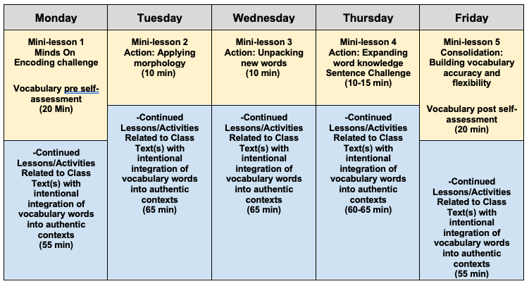

Example of “Words of the Week” 5-Day Schedule

### Sample “Words of the Week” 3-day schedule

Tuesday and Thursday do not include a vocabulary routine. On these days, continue Lessons/Activities Related to Class Text(s) with intentional integration of vocabulary words into authentic contexts. Each daily lesson is 75 minutes.

#### Monday

##### Vocabulary routine

Mini-lesson 1. Minds On: Encoding challenge. Vocabulary pre self-assessment.

Mini-lesson 2. Action: Applying morphology

**Time:** 30 min

##### Daily lesson

Continued Lessons/Activities Related to Class Text(s) with intentional integration of vocabulary words into authentic contexts

**Time:** 45 min

#### Wednesday

##### Vocabulary routine

Mini-lesson 3. Action: Unpacking new words

**Time:** 10 min

##### Daily lesson

Continued Lessons/Activities Related to Class Text(s) with intentional integration of vocabulary words into authentic contexts

**Time:** 65 min

#### Friday

##### Vocabulary routine

Mini-lesson 4. Action: Expanding word knowledge. Sentence Challenge

Mini-lesson 5 Consolidation: Building vocabulary accuracy and flexibility. Vocabulary post self-assessment

**Time:** 30 min

##### Daily lesson

Continued Lessons/Activities Related to Class Text(s) with intentional integration of vocabulary words into authentic contexts

**Time:** 45 min

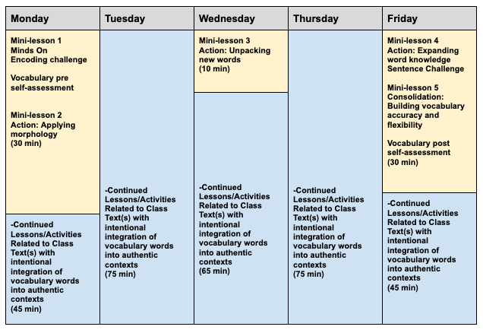

Example of “Words of the Week” 5-Day Schedule

# Appendix B

## “Words of the Week” vocabulary routines lesson preparation

1. Select the core text with which the class will be working

The Tier 2 vocabulary words the class unpacks can be from any core class text a teacher will be using, such as a short story, poem, essay, song lyrics, novel, meme, infographic, etc. For this sample lesson,  the CBC *The Next Chapter* interview transcription [Zoey Roy’s Visual album Zoetry uses Poetry and Performance Art to Bear Witness](https://www.cbc.ca/radio/thenextchapter/full-episode-sept-03-2022-1.6412444/zoey-roy-s-visual-album-zoetry-uses-poetry-and-performance-art-to-bear-witness-1.6412468) will be used as a core text.

Depending on the core text chosen, curriculum expectations from Strands A and C can be addressed alongside those for this daily vocabulary routines lesson. For example, if students create and discuss a question using their new vocabulary words that allows them to dig deeper into the text themes and content such as “What are the **implications** of Zoey Roy’s **resilience** on her art?” OR “How is Zoey Roy’s **resilience impacting** a **resurgence** in and celebration of Indigenous ways of being?”, additional expectations may be addressed.

1. Highlight potential Tier 2 words from the article

E.g., The Roy interview is rich with potential Tier 2 words to teach such as: resilience, resurgence, reflecting, disarm, encourage, compassion, conscious, fragmented, judgmental, construction, implications, emulates. Please see the Appendix D: Vocabulary Instruction Background Information section for more information about choosing Tier 2 words to teach explicitly.

1. Choose 3-5 Tier 2 “Words of the Week”

Use the following Tier 2 word questions from The Teaching Reading Sourcebook as a guide

1. Is it a word whose meaning students are unlikely to know?
2. Is it a word that is generally useful…that students are likely to encounter across a wide variety of domains?
3. Can the meaning of the word be explained in everyday language, using words and concepts that are familiar to students?
4. What is the word’s instructional potential? Is its meaning necessary for comprehension of the text being read (Honig et al., 2018, p. 422).

**Tier 2 word selection rationale example:** The words resilience and resurgence were chosen because they are key concepts that will support further class discussions about this and future texts. In addition, these words share common morphological prefixes and suffixes allowing for an exploration of these morphemes. The word implication was chosen because it has strong cross-curricular potential and it would be helpful in discussions around the Roy interview. It also contains the high frequency suffix “tion” which all students need to know how to spell and recognize.

1. Preparation tips

#### Mini-lesson 1

##### **Create morphological analysis slide (for each word)**

**NOTE:** Not all Tier 2 vocabulary words contain more than one morpheme. For example, the Tier 2 word “ponder” is one morpheme (one unit of meaning by itself). It does not contain a prefix or suffix.

#### Mini-lesson 3

##### **Create a student-friendly definition for each word**

**For support** with creating a student friendly definition, teachers can use the prompt “describe [vocabulary word] at a grade 5 level” with their AI tool of choice. A description of the word at a lower grade level often results in a student-friendly definition of the word appropriate to the grade. **Note:** consult Board policies for AI tools approved for educator and/or student use.

##### **Create sentence prompt slide (for each word)**

Ensure that the sentence prompt requires the students to understand the word in order to fill out the prompt accurately. Adding a “because” clause can be helpful for this.

##### **Use a vocabulary log slide (for each word)**

**For support** with the morphological analysis, teachers can use the prompt “Give the meaning of the prefix, root and suffix” of the Tier 2 word and an etymology online tool, such as [Etymonline](https://www.etymonline.com/).

#### Mini-lesson 5

##### Create examples and non-examples

Create a sample example and non-example slide for your chosen Tier 2 “Words of the Week”.

**For support** with creating examples and non-examples for the correct and incorrect use of the words, teachers can use the prompt *“Write a sentence that accurately uses the word [vocabulary word]”* and *“Write a sentence that inaccurately uses the [vocabulary word] incorrectly”* in their AI tool of choice.

##### Create sentences and definitions

Create 5-10 sentences and/or definitions that correctly and incorrectly use your chosen words.

##### Create sample sentences and questions

Create a sample sentence and/or question that combines all or some of your vocabulary words to provide as an example to the students.

**For support** with an example of a sentence or question that uses all of the words “Words of the Week,” teachers can use the prompts: *“Write a sentence that accurately uses the words [vocabulary word 1], [vocabulary word 2] and [vocabulary word 3]”* or *“Write a question that accurately uses the words [vocabulary word 1], [vocabulary word 2] and [vocabulary word 3]”* in their AI tool of choice.

1. Morphological analysis sites

When choosing new words to explicitly unpack with students, online tools can be helpful in both supporting teachers with quick morphological word analysis information and the production of sample activities such as examples and non-examples for the daily active engagement activities. An example of an analysis site is [Etymonline (external resource)](https://www.etymonline.com/).

# Appendix C

## Frayer Model Vocabulary Log Graphic Organizer

Word:

* Definition:
* Visual, Facts and/or Characteristics
* Examples
* Non-examples

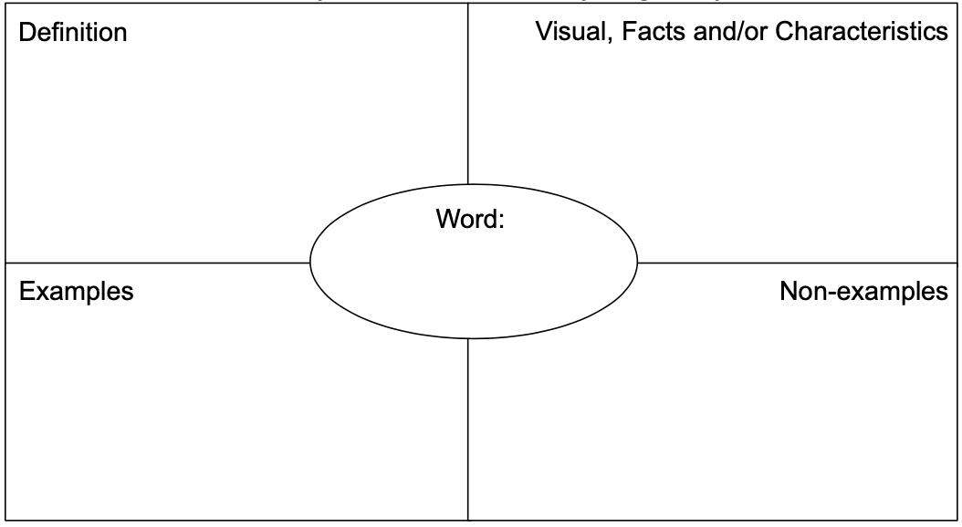

This example of a Frayer Model vocabulary log is for someone who prefers paper format. Note: If you choose to create a digital vocabulary log, the layout may need to be adjusted to meet accessibility needs.

# Appendix D

## Vocabulary instruction background information

### Explicit vocabulary instruction

Vocabulary is the knowledge of words and word meanings. Vocabulary and reading comprehension are intrinsically linked. Vocabulary is acquired both implicitly through indirect exposure to words and intentionally through explicit instruction. (Honig et al, 2018, p. 407).  Although much vocabulary is learned without formal teaching, research has shown that explicitly teaching vocabulary can result in measurable gains in reading comprehension (Shanahan, n.d., 5 Key Principles for Effective Vocabulary Instruction).

### Which words should I teach explicitly?

Beck, McKeown, & Omason (1987) suggested a Tier framework to consider vocabulary words for instruction with:

* **Tier 1 words** being common words used in oral language that seldom require explicit instruction (e.g., house, car, help)
* **Tier 2 words** containing high utility academic words used across disciplines (e.g., industrious, benevolent, acquired, curtail)
* **Tier 3 words** which are used infrequently and are often limited to specific disciplines and domains (e.g., photosynthesis, autocratic, carburetor)

Focusing explicit instructional attention on Tier 2 words supports the continued development of a student’s language knowledge and reading comprehension.

**NOTE:** Choosing which words to teach explicitly can be overwhelming. As stated by Beck, McKeown and Kucan in Bringing Words to Life, “there is no formula for selecting age-appropriate vocabulary words…As long as the word can be explained in known words and can apply to what students might talk or write about, it is an appropriate word to teach” (2002, p.39). The key is to start making explicit vocabulary instruction a core part of instructional practice so that students can consciously build their vocabulary and apply morphological knowledge built through this instruction to decode and comprehend new words encountered in context.

To dig deeper into **Explicit Vocabulary Instruction and Tiered Vocabulary Study,** consider the following sites:

* [Choosing Words to Teach (Reading Rockets, external resource)](https://www.readingrockets.org/topics/vocabulary/articles/choosing-words-teach)
* [Five Key Principles to Reading Instruction (Reading Rockets, external resource)](https://www.readingrockets.org/topics/vocabulary/articles/five-key-principles-effective-vocabulary-instruction)
* [Explicit Vocabulary Instruction Demonstration (ONlit, external resource)](https://onlit.org/resource/27689/)*
* [Three Tiers of Vocabulary-Teacher Information (curriculum.learnalberta.ca, external resource)](https://drive.google.com/file/d/1wZMK00Ng2R7H5YHzr2Jt1ryf8scZWoII/view?usp=sharing)
* [Tiered Vocabulary-Narrowing Your Instructional Focus (Columbia.edu, external resource)](https://cpet.tc.columbia.edu/news-press/tiered-vocabulary-narrowing-your-instructional-focus)
* [Bringing Words to Life (free copy through ONlit, external resource)](https://onlit.org/resource/bringing-words-to-life-robust-vocabulary-instruction/)*

To dig deeper into **Morphology instruction,** consider the following sites:

* [Morphology Matters: Building Vocabulary Through Word Parts (ONlit, external resource)](https://onlit.org/resource/morphology-matters-building-vocabulary-through-word-parts/)*
* [Morphological Awareness: One Piece of the Literacy Pie (ONlit, external resource)](https://onlit.org/resource/morphological-awareness-one-piece-of-the-literacy-pie/)*
* [English Decoded: Layers of the English Language (ONlit, external resource)](https://onlit.org/resource/english-decoded-layers-of-the-english-language/)*

**\*** Users must create a free account in order to access ONlit materials.

# Appendix E

## Curriculum expectations

### B2. Language Foundations for Reading and Writing

demonstrate an understanding of foundational language knowledge and skills, and apply this understanding when reading and writing.

#### B2.1 Word-Level Reading and Spelling: Using Morphological Knowledge

use consolidated knowledge of the meanings of words and morphemes (i.e. bases, prefixes and suffixes) to read and spell complex words with accuracy and automaticity

#### B2.2 Vocabulary

demonstrate an understanding of a wide variety of words, acquire and use explicitly taught vocabulary flexibly in various contexts, including other subject areas.

### C1. Knowledge about Texts

apply foundational knowledge and skills to understand a variety of texts, including digital and media texts, by creators with diverse identities, perspectives, and experience, and demonstrate an understanding of the patterns, features, and elements of style associated with various text forms and genres

#### C1.1 Using Foundational Knowledge and Skills to Comprehend Texts

read and comprehend various complex texts, using knowledge of words, grammar, cohesive ties, sentence structures, and background knowledge

# References

Beck, I. L., McKeown, M. G., & Omanson, R. C. (1987). The effects and uses of diverse

vocabulary instructional techniques. In M. G. McKeown & M. E. Curtis (eds.), *The nature of vocabulary acquisition* (pp. 147-163). Hillsdale, NJ: Erlbaum.

Beck, I.L, M. G. McKeown, and L. Kucan. (2002). *Bringing words to life: Robust vocabulary instruction.* New York: Guilford.

CBC Radio. (2022, April 8). *Zoey Roy’s visual album Zoetry uses poetry and performance art to bear witness*. The Next Chapter Interview. <https://www.cbc.ca/radio/thenextchapter/full-episode-sept-03-2022-1.6412444/zoe>

Honig, B., Diamond, L., & Gutlohn, L. (2018). *Teaching reading sourcebook*. CORE ; Arena Press.

Shanahan, T. (n.d.). *Five key principles for effective vocabulary instruction*. Reading Rockets. <https://www.readingrockets.org/topics/vocabulary/articles/five-key-principles-effective-vocabulary-instruction>

# Attribution license

This lesson plan is published under a [CC BY-NC-SA](https://creativecommons.org/licenses/by-nc-sa/4.0/) license. Third-party resources are subject to their own copyright.



This license enables reusers to distribute, remix, adapt, and build upon the material in any medium or format for noncommercial purposes only, and only so long as attribution is given to the creator. If you remix, adapt, or build upon the material, you must license the modified material under identical terms. CC BY-NC-SA includes the following elements:

  BY: credit must be given to the creator.  
  NC: Only noncommercial uses of the work are permitted.  
  SA: Adaptations must be shared under the same terms.

# Updates

When updates are made to this document, they are tracked below with date and description of update.

* February 2025: initial release