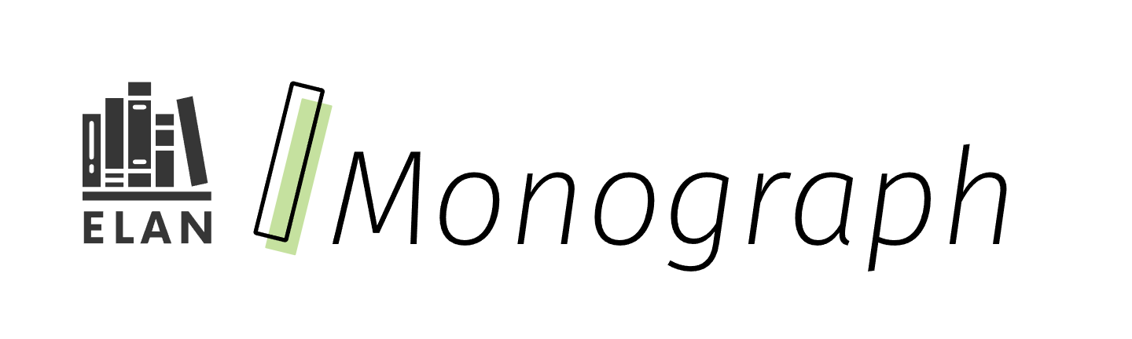

Dynamic Morphology

Building the Foundations of Language in Junior and Intermediate Grades

Curriculum connections

* Foundations of language
* Morphological knowledge
* Explicit instruction
* Reading
* Writing

# Contents

Curriculum connections 1

Contents 2

What it is 3

Why it matters 3

How it works 4

Finding time for word work 4

Sample Weekly Schedule 5

What might explicit whole-class instruction look like? 6

Building opportunities for morphology 8

Collaborative learning 8

Games for purposeful practice 10

Cross-curricular integration 11

Inquiry activities 12

Additional considerations 12

Resources 14

References 14

Attribution license 15

Updates 16

# What it is



After students master basic phonics and decoding skills, research suggests that **morphological awareness (i.e., the ability to think about the smallest units of meaning in language) is essential and becomes a better predictor of reading ability by age 10** (Mann & Singson, 2003). Morphology instruction enhances decoding, spelling, and vocabulary (Reading League of Wisconsin, 2023), as well as reading comprehension and writing ability (Bowers et al., 2010). However, traditional worksheets — with repetitive activities or fill-in-the-blank questions — are an ineffective method for consolidating this learning (Kohn, 2006).

Dynamic morphology, on the other hand, engages students in language learning (specifically morphology) through active learning and social interaction. It treats opportunities for morphological awareness, and other language learning, as ongoing and iterative (i.e., building from simple to complex word knowledge over time) and infused with a sense of play. All of which mirrors how we naturally acquire new language.

# Why it matters



By moving away from pre-made worksheets, teachers can tailor the learning to the topics and the students they are teaching. They are free to use more diverse texts and real-world examples, which can validate student identities and foster greater engagement. Teachers can also spark student interest by selecting inquiry-driven learning activities with multiple entry points.

The 2023 Ontario Language, Grades 1–8 and English Grade 9 curriculum includes specific expectations in Strand B: Foundations of Language that supports students to use morphological knowledge. Since teachers are already engaging students’ reading and writing skills through a variety of texts with their rich and diverse vocabulary (in Language, English and across subject areas), they can authentically provide opportunities for students to apply and develop their morphology skills. Doing this work in context of texts and tasks that students are already working with helps them make deeper connections with the meaning of ideas within the texts and expand their understanding of how language works. Further, in classrooms that emphasize the importance of translanguaging, learners can see connections across languages by, for example, making connections between morphemes and cognates.

# How it works



## Finding time for word work

Morphology instruction time should be adapted to fit into each particular classroom situation; however, students are likely to benefit greatly by working with words, and their parts, on a regular and routine basis. For example, one way to incorporate more of this instruction into a class would be to explicitly highlight one morpheme per week (e.g., Morpheme Monday), preferably by working with words that are connected to texts or topics already studied, with a variety of follow-up activities planned for the other four days.

### Sample Weekly Schedule

|  |  |  |  |  |
| --- | --- | --- | --- | --- |
| **Monday** | **Tuesday\*** | **Wednesday** | **Thursday\*** | **Friday\*** |
| Explicit class instruction | Small-group activity | Text-specific work | Review game | Reflection |
| Focus on one or more relevant words and their parts | Involve students in collaborative word work  (E.g., try word sorts or look at variations of a word in its noun, verb, adjective, or adverb forms; identify word bases and affixes) | Have students investigate how words are used in texts already under study or in other relevant, cross-curricular texts. Practice using them in writing and speech | Create a game or challenge that allows students to review both new and previously studied words | Prompt students to reflect on their vocabulary knowledge and how it may help them in their reading, writing, and speaking |

* activities can be assigned to small groups during learning rotations

### What might explicit whole-class instruction look like?

This structured approach helps ensure that students not only learn about morphemes but also apply their knowledge in various contexts, reinforcing their understanding and usage.

| **Step** | **Activity** | **Teacher action** | **Student action** |
| --- | --- | --- | --- |
| **1** | Introduce the morpheme | Present the prefix, suffix, or base that will be the focus of the lesson. (E.g., “this week, we’re highlighting the morpheme graph which means ‘written’”). Depending on the group and the focus morpheme, this portion could also include etymology of the morpheme | Students add information to the reference book that helps reinforce their understanding and its application in different contexts. (E.g., the morpheme graph means “written” or “recorded.” Origin: Greek) |
| **2** | Model word analysis | Demonstrate how to break down words into their morphemes and how to analyze and interpret the meaning of complex words. (E.g., autograph: auto (self) + graph (written) = written with one’s own hand) | With partners, have students work to break down and analyze related words (e.g., biography, calligraphy, paragraph) |
| **3** | Provide examples and non-examples | Present words that include the morpheme. Include a brief explanation of why certain words are non-examples of the morpheme when applicable | Have students share examples or ask for clarification on possible examples. (E.g., “what about ‘graffiti’?” Does it have the root graph?). Designate a spot in the classroom for students to record possible examples that they encounter in independent reading |
| **4** | Display learning | Create an anchor chart that students can reference for future activities | Encourage students to be on the lookout for more examples throughout the week and have them add to the list as words come up  Discuss how they used morphology to understand the meaning |

## Building opportunities for morphology

The following activities can be used to help foster more active engagement in your classroom.

Note: Dynamic, interactive, playful instruction, and practice need not be limited to morphology. Consider using some of the tools and strategies highlighted in this document in your syntax and grammar lessons.

### Collaborative learning

Engage students in cooperative activities where they analyze and break down complex words into their morphemes and discuss their meaning.

* **Morphology Tree:** Present a morpheme as a tree truck or root. Break the class into small groups and challenge each group to come up with all the words they can that grow on the morphology tree. Display each chart and invite other groups to examine them. Challenge any words that they consider to be non-examples and explain why.

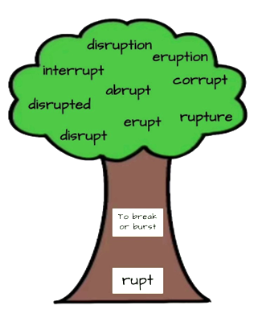

Example of a morpheme tree. The morpheme and definition are in the base of the tree and words that ‘grow’ from the morpheme are listed above in the foliage.

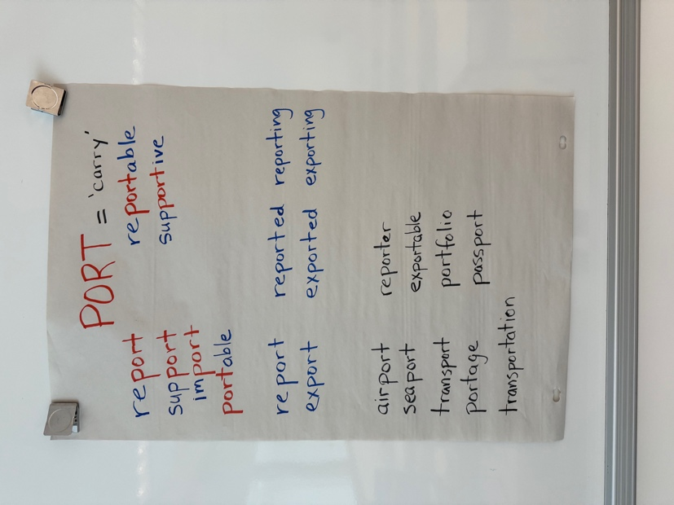

Example of a morpheme chart for PORT = ‘carry’. Note. A chart for the morpheme PORT, like the one portrayed here, could be created with the class in a single session or over time as students discover new, related words.

#### Images with solid fillDescriptive summary of Morpheme chart for PORT = ‘carry’

##### Section 1: Root examples

Re**port**, sup**port**, im**port**, **port**able, re**port**able, sup**port**ive

##### Section 2: Verb tenses

Report, reported, reporting

Export, exported, exporting

##### Section 3: Student generated

Airport, seaport, transport, portage, transportation, reporter, exportable, portfolio, passport

* **Classroom Lexicographer:** Rotating through the class, give a student the job of looking up words and reporting back to the class when questions arise. (E.g., does “Portugal” come from the same root as “portable” and “import”?)
* **Word Sorts:** Conduct word sorts where students categorize words based on their morphemes (e.g., words that contain the prefix pre- versus re-, or words that double the final letter when a suffix is added versus those that do not).

### Games for purposeful practice

Simple word-focus games can promote social interaction and student engagement.

* **Matching Game:** Also known as “Memory,” players aim to find partner cards (i.e., a morpheme card and a meaning card) in a matrix of facedown cards. The goal is to match all pairs (e.g., hydro and “water”) and accumulate the most matches or points.
* **I Have, Who Has:** Each player gets a card containing two parts: a morpheme and a question. Player 1 reads their card aloud (e.g., “I have struct. Who has the base that means ‘to carry’?”) and then student with the linking card then reads that card aloud. (E.g., “I have port. Who has the base that means ‘to write’?”) Play continues until we are back at Player 1.
* **Headbands:** Players wear a headband with a card on it that displays a unique morpheme. The objective is to ask yes/no questions (e.g., “Is it a prefix?”) to correctly guess the morpheme on their cards before time runs out.
* **Drama Games:** Have students act out words and their parts (i.e., bases, prefixes, and suffixes) in fun scenarios. This helps them see how these word parts come together to form meanings and understand word structure better.

### Cross-curricular integration

Be intentional about bringing morphology discussions into other subject areas. It can be helpful to use a list like Lane and Allan’s *Sophisticated Words Related to Specific Content Areas* (2010) to identify the most relevant word parts to study with your class.

* **Vocabulary Support:** When students misunderstand words in a text, they are far less likely to understand the overall concept being taught. By highlighting key words and explaining how to use morphology to deconstruct their meaning, we can lighten their cognitive load.
* **Contextual Practice:** Incorporate morphological instruction into reading and writing tasks in the content areas. (E.g., “in your math journal, break down the words ‘numerator’ and ‘denominator’ into their morphemes. How might it help your understanding of fractions to break down these words?”)

### Inquiry activities

As students become more familiar with morphemes, they can let their curiosity for words fuel independent learning.

* **Word Investigation Project:** Invite students to explore the etymology and morphological structure of academic or subject-specific vocabulary such as examining how scientific terms are constructed.
* **Structured Word Inquiry:** Adapt Pete Bower’s methods by having students use word matrices and word sums to investigate and discuss word formation (2008; also see Resources).

### Additional considerations

* **Ease Your Load with AI:** Consider using AI tools to generate short readings and dynamic word lists that focus on specific morphological concepts. Create or modify stories and texts to highlight these concepts and enable students to explore and apply morphology in engaging ways. (E.g., write two paragraphs on the topic of cricket as your favourite sport using a variety of sentence types. Include different uses of the prefixes en- and em-.)
* **Consider the Learning Cycle:** Keep in mind that the emphasis on morphology can vary at different stages of a learning cycle. For instance, when starting a science unit, a teacher might prioritize teaching vocabulary by focusing on morphology and specific morphemes before delving into the subject matter. Alternatively, for a novel study, choose to highlight morphological elements orally as new words appear. Morphology instruction will not look the same in all classrooms, nor will it look the same at all points of the year.

# Resources

[ONlit (external link)](https://onlit.org/) includes slide decks adapted from The Morphology Project

[Online Etymology Dictionary (external link)](https://www.etymonline.com/) offers information about words’ origins and history

[The Six Shifts (external link)](https://thesixshifts.com/downloads/) offers a lesson planning template for morphology instruction

[Structured Word Inquiry (external link)](https://www.wordworkskingston.com/WordWorks/Structured_Word_Inquiry.html) provides evidence-based strategies for structured word inquiry

# References

Bowers, P. (2008). *Structured word inquiry: Instruction for building literacy & critical thinking for learners of all ages and abilities.* Word Works Literacy Centre. [https://www.wordworkskingston.com/WordWorks/Structured_Word_Inquiry.html](https://www.wordworkskingston.com/WordWorks/Structured_Word_Inquiry.html%20%20)

Bowers, P. N., Kirby, J. R., & Deacon, S. H. (2010). The effects of morphological instruction on literacy skills: A systematic review of the literature. *Review of Educational Research, 80*(2), 144–179. <https://doi.org/10.3102/0034654309359353>

Kohn, A. (2006). The homework myth: Why our kids get too much of a bad thing (1st Da Capo Press ed). Da Capo Life Long.

Lane, H. B., & Allen, S. A. (2010). The vocabulary-rich classroom: Modeling sophisticated word use to promote word consciousness and vocabulary growth. *The Reading Teacher, 63*(5), 362–370. <http://dx.doi.org/10.1598/RT.63.5.2>

Mann, V., & Singson, M. (2003). Linking morphological knowledge to English decoding ability: Large effects of little suffixes. In E. Assink & D. Sandra (Eds.), *Reading Complex Words: Cross-Language Studies* (pp. 1–25). Kluwer Academic/Plenum Publishers.

Reading League of Wisconsin. (2023, January 10). *Morphology: 60 years of reflection with Marcia Henry* [Video]. YouTube. <https://www.youtube.com/watch?v=9ymnQmIRRb4>

Rohrer, D., Dedrick, R. F., & Stershic, S. (2015). Interleaved practice improves mathematics learning. *Journal of Educational Psychology, 107*(3), 900–908. <http://dx.doi.org/10.1037/edu0000001>

# Attribution license

This monograph is published under a [CC BY-NC-SA](https://creativecommons.org/licenses/by-nc-sa/4.0/) license. Third-party resources are subject to their own copyright.



This license enables reusers to distribute, remix, adapt, and build upon the material in any medium or format for noncommercial purposes only, and only so long as attribution is given to the creator. If you remix, adapt, or build upon the material, you must license the modified material under identical terms. CC BY-NC-SA includes the following elements:

  BY: credit must be given to the creator.  
  NC: Only noncommercial uses of the work are permitted.  
  SA: Adaptations must be shared under the same terms.

# Updates

When updates are made to this document, they are tracked below with date and description of update.

* February 2025: initial release