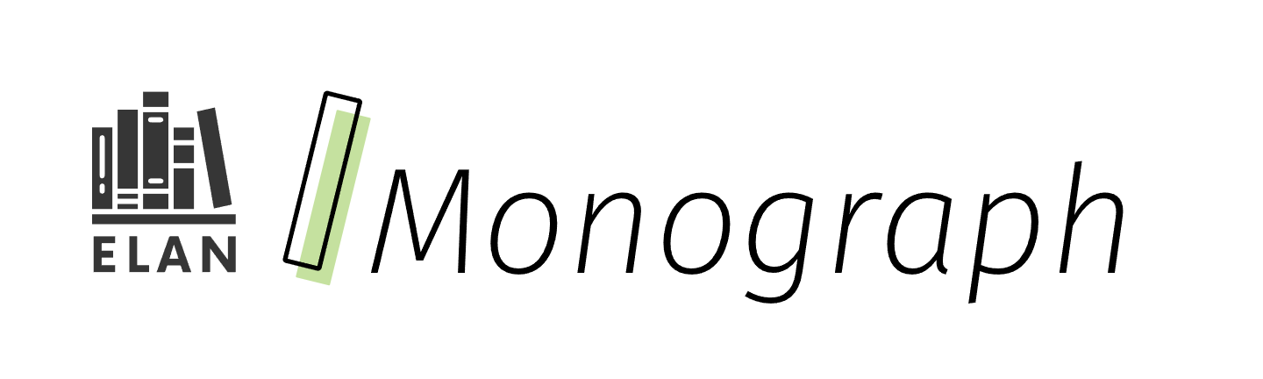

Universal Design for Learning

Using UDL for firm goals, flexible means

Curriculum connections

* Universal Design for Learning
* Differentiation
* Assessment
* Culturally responsive and relevant pedagogy

# Contents

Curriculum connections 1

Contents 2

What it is 3

Why it matters 5

How it works 6

About “Firm Goals, Flexible Means” 6

Applying “Firm Goals, Flexible Means” (case study example) 7

Firm curriculum goal 7

Flexible means for achieving goal 8

Quick tips 11

Resources 12

References 13

Attribution license 15

Updates 15

# What it is



Students come to us with a wonderfully diverse set of interests, identities, and abilities. One-size-fits-all instruction, therefore, falls short of meeting the needs of all students. So how can educators begin to imagine responsive programming for all students in a manageable way? The answer: begin with firm learning goals rooted in curriculum, then devise flexible, research-based means of empowering students to understand and reach the goals.

**The phrase “Firm Goals, Flexible Means” (Novak, 2023) is a succinct way to describe how educators are meant to implement Universal Design for Learning (UDL).** “Firm Goals” refer to the learning outcomes, described in Ontario curriculum or other sources, which are clear to both students and teachers as the focus of learning. “Flexible Means” “refers to the options and choices we provide to our students as they work toward achieving our well-defined goals” (Novak, 2023). In other words, while *what* students will learn remains firm, *how* students will learn and demonstrate their learning should be flexible in response to particular needs or preferences.

“Firm Goals, Flexible Means” is the foundation for responsive programming for all learners that maintains high expectations rooted in the curriculum. Various means to meet these expectations are often *necessary for some students, but good for all.*

**UDL, along with** **Differentiated Instruction (DI), is included in the recommended approaches to teaching and learning described in the front matter of the Ontario Language, Grades 1–8 curriculum and English, Grade 9 (ENL1W) curriculum (2023).** UDL and DI are both approaches that aim to reach diverse learners, and utilize a wide variety of tools, scaffolding techniques, and technologies. The main difference is that UDL happens *ahead* of learning in the design phase, while DI tends to happen *during* learning as a response to individual needs.

The flexibility UDL promotes makes it a strong companion for culturally responsive and relevant pedagogy (CRRP).

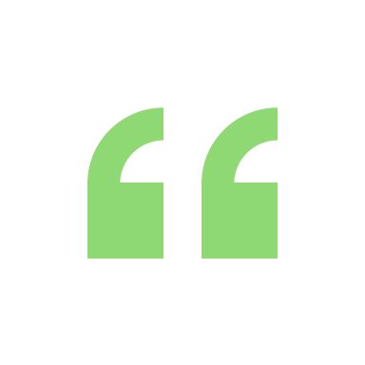Students who do not see themselves reflected in what they are learning, in their classrooms, and in their schools become disengaged and do not experience as great a sense of well-being or as high a level of academic achievement as those who do.” ([*Ontario Ministry of Education, 2024*](https://www.dcp.edu.gov.on.ca/en/program-planning/considerations-for-program-planning/human-rights-equity-and-inclusive-education))

“To support sustained effort and persistence, it is essential for learners to be clear on the goal and to have space to explore how the goal is meaningful to their own lives and communities. Further, it is important the meaning and purpose of the goal is clearly and consistently reinforced and apparent to learners throughout the learning process.” ([CAST, 2024](https://udlguidelines.cast.org/engagement/effort-persistence/meaning-purpose-goals/))

# Why it matters



When students and teachers share a clear understanding of learning goals and success criteria (“Firm Goals”), their energies can be more focused on developing and demonstrating evidence of their learning. While the goal is to help all students attain the provincial standard (Level 3), those learners who are not yet there may reach at least a “limited” or Level 1 achievement of the learning goals. Clear learning goals and success criteria make progress-monitoring, self-assessment, and flexible ideas for learning easier to achieve. (Estrada & Warren, 2014)

“Flexible Means” engage students as well as teachers in some decision-making about how the learning will take place, thereby promoting student autonomy and independence. When students have a role to play in the learning process, they are more likely to engage and share the responsibility with their teachers.

Further, once students are clear about goals and criteria, learning can be student-led (e.g., inquiry-driven, project-based, land-based), using a variety of responsive and relevant learning materials (CRRP). These approaches provide opportunities for meaningful learning as students make connections to their lived experiences, and find relevance and purpose in their work.

Rather than focus on preparing students for future English courses, teachers can focus on the skills, content, and knowledge in the curriculum at hand. Emphasizing the learning process and welcoming flexibility in how students build and express their knowledge and skills, as well as offering a freedom to explore, can improve opportunities for feedback that supports progress towards specific and overall curriculum goals for diverse learners. Teachers can feel confident they are supporting students to achieve high curriculum standards, and both teachers and students can enjoy the flexibility of imagining different ways to access and express the learning.

# How it works

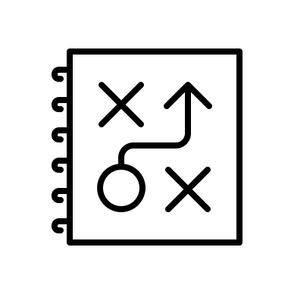

UDL is structured around the concept of “multiple means” at various moments in the learning cycle.

## About “Firm Goals, Flexible Means”

Students can access various ways of engaging with, expressing, and representing their learning.

1. Firm goals

* Establishing clear learning goals, derived from curriculum in student-friendly language.

1. Flexible means

* **Multiple means of engagement:** outlining and modeling what success entails and different ways to get there.
* **Multiple means of expression:** determining which forms of evidence are an acceptable demonstration of the learning goal.
* **Multiple means of representation:** Practicing with a variety of learning materials, progress-monitoring and self-assessment. Scaffolding (e.g., simple to complex) guidance and feedback to meet students’ needs.

## Applying “Firm Goals, Flexible Means” (case study example)

So, how do educators put “Firm Goals, Flexible Means” into classroom practice? A good place to start is the [UDL Guidelines by CAST (external website)](https://udlguidelines.cast.org/).

For an idea of how this might look in an English/Language Arts classroom, consider the case of a teacher in search of support for diverse learners with word-level reading and spelling. When developing a “Firm goal, flexible means” framework keep UDL guidelines and student needs and preferences top of mind to support developing inclusive approaches.

Once teachers get to know their students’ interests, backgrounds, and experiences, they can predict both potential barriers to curriculum learning, and strategies that will minimize those barriers. Cultivating the habit of thinking about flexible means for learning and demonstrating firm goals can only enhance the learning that occurs in English/Language Arts classrooms.

The following example offers an array of possible strategies or “means” for meeting the learning goal, inspired by the UDL guidelines.

### Firm curriculum goal

**Word-Level Reading and Spelling: Using Morphological Knowledge [Grade 7]:** B2.1 use generalized knowledge of the meanings of words and morphemes (i.e., bases, prefixes, and suffixes) to read and spell complex words with accuracy and automaticity

### Flexible means for achieving goal

Multiple Means of Engagement:

* Think of examples for the concept in any language students know (e.g., brainstorm prefixes we find in French, Korean, or Anishinaabe).
* Vary categories of morphemes based on student interests (e.g., use examples with sports or gaming vocabulary).
* Make clear the curriculum learning goal (e.g., in student-friendly language, visible on the board, digitally accessible), and check for understanding before proceeding. Then provide different models of what successful achievement of the learning goal can look like (e.g., identifying prefixes can happen through annotation, direct instruction and discussion with words on a board, or by sorting base words with and without prefixes).
* In small groups, complete a scavenger hunt in a paragraph. Have students determine the topic of their text.
* Promote collaboration by having students discuss their thinking (e.g., What was similar about our ideas, and what was different?)

Multiple Means of Representation:

* Ask a search engine, like Google, where a word comes from, or watch a video about root words.
* Connect new vocabulary to students’ own lived experiences and other contexts (e.g., what other subject areas might use the base word “angle” or “theme”?)
* Generate examples in random groups on a vertical surface so everyone can see (e.g., brainstorm words with the prefix “re”).
* Use manipulatives to sort morphemes or words into categories (e.g., hexagonal thinking, paper tiles).
* Use scaffolding and gradual release (e.g., provide verbal feedback with less complex words, then increase complexity at differentiated rates depending on student needs).
* Use a graphic organizer to demonstrate knowledge of how affixes change the meaning of base words.
* Use multiple entry points with options for word length and complexity.

Multiple Means of Action & Expression:

**Students can:**

* Use speech or text, digital or non-digital means, or physical manipulatives to show their learning.
* Complete a graphic organizer.
* Create a mini-lesson for the class in small groups.
* Draw lines to connect words with the same root or base.
* Create a mind-map or word matrix to show how prefixes and suffixes change the meaning of a root word.
* Create a sorting game for younger students using tiles.
* Create their own anchor charts to display and reference.

**Teachers can:**

* Decide what forms of evidence would be an acceptable demonstration of the learning goal (e.g., co-create success criteria based on a model the teacher has provided).
* Decide when assessment data can be gathered through observations, conversations, and products.

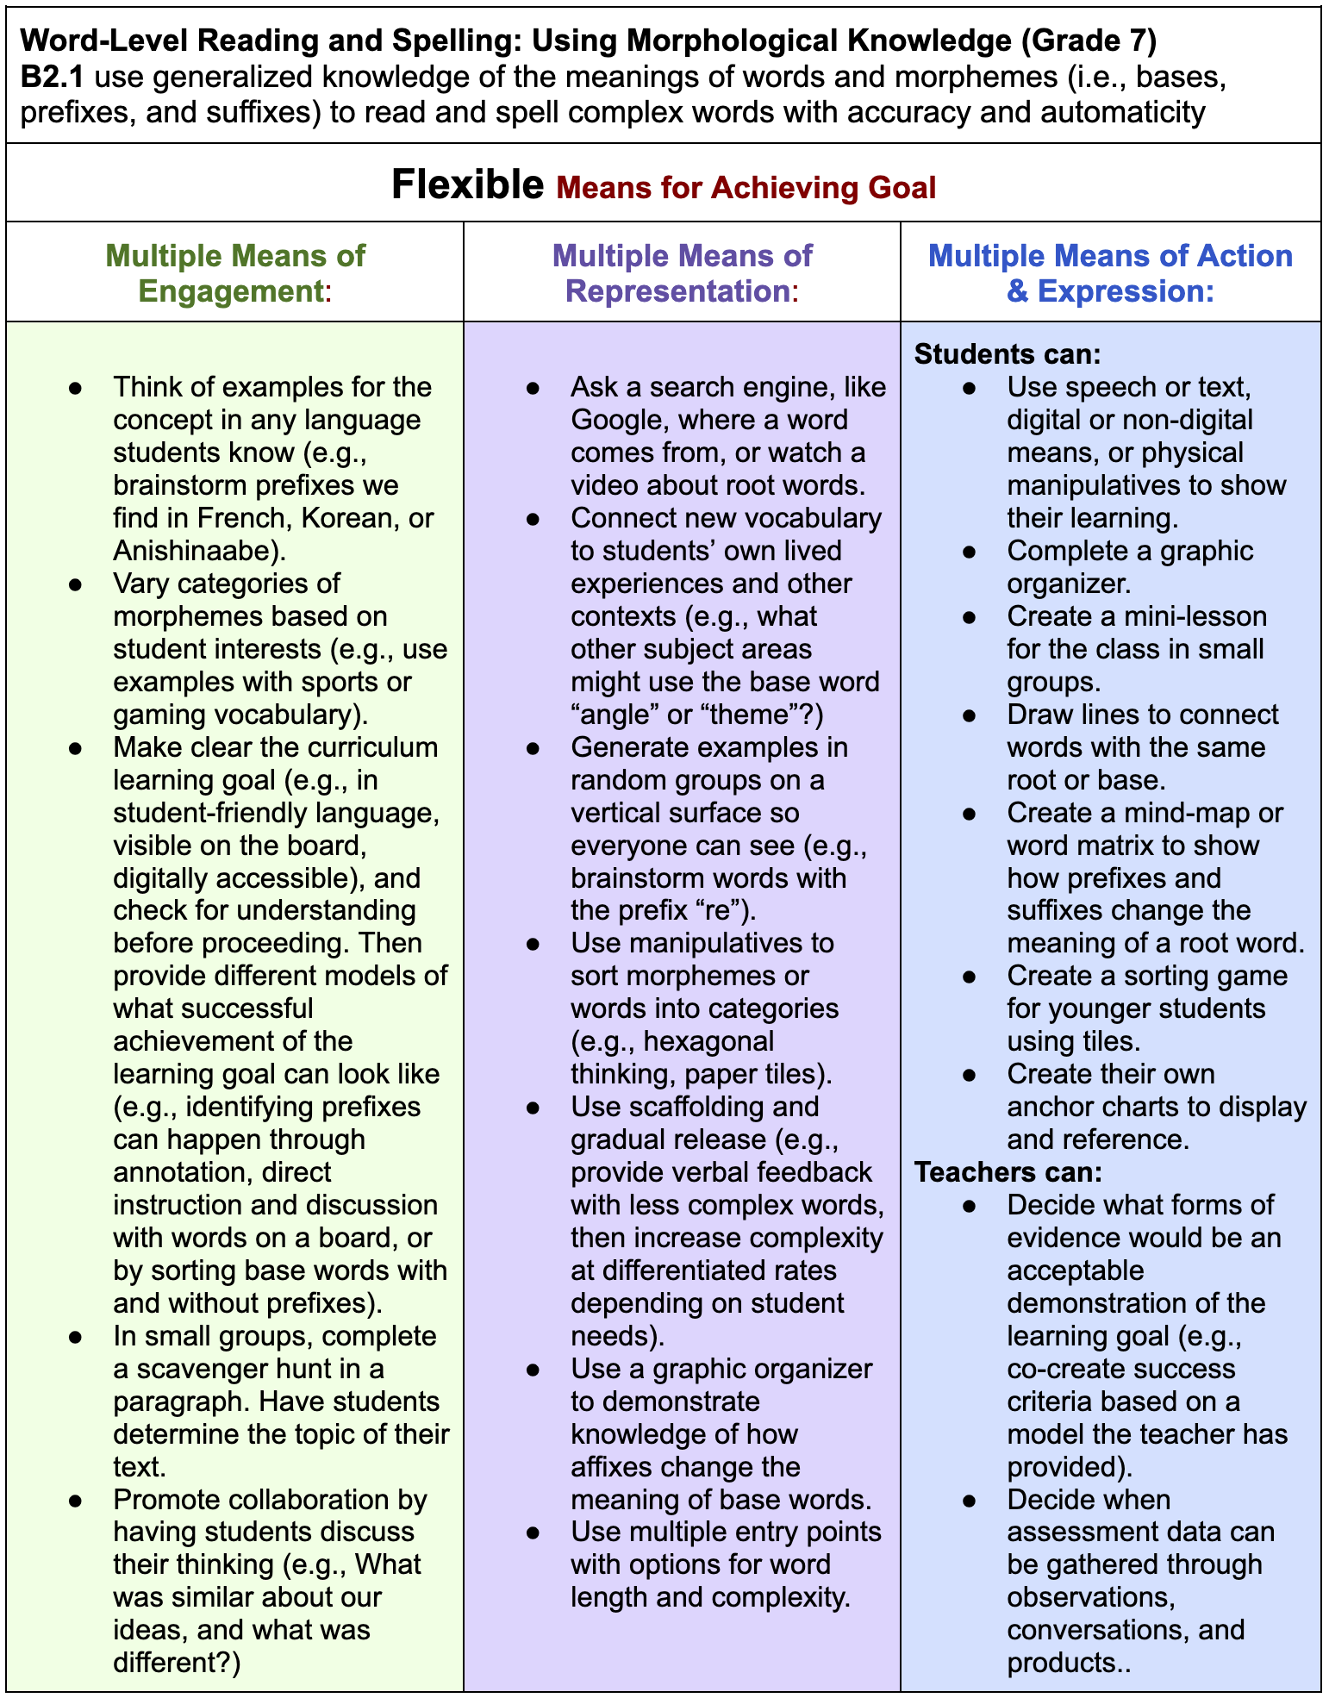

This image shows the case study example content in a chart format inspired further by CAST’s UDL organizational approach.

## Quick tips

* Work at a pace that works for you and your students. For example, try a “Firm Goals, Flexible Means” approach one day a week, for one curriculum expectation, or for one assignment.
* Get your students involved! They can give ideas and feedback on how they like to learn, and give feedback about learning resources.
* Create a network of support and collaboration with other educators in your building, in other schools, or central support.

| **Possible risks of not applying Firm Goals, Flexible Means** | **Anticipated benefits of applying Firm Goals, Flexible Means** |
| --- | --- |
| Disengagement (which can sometimes manifest in negative behaviours) | Increased engagement, relevance, and participation |
| Less inclusive classroom culture | Stronger classroom culture and partnership between teacher and students, and among students |
| Diminished autonomy, competence, and relevance of the learning, or basic learner needs (Ryan & Deci, 2000) | Increased student efficacy, independence, responsibility, and achievement |
| Diminished clarity of learning goals, accuracy of assessments, and consistency across schools and boards | Increased confidence that all learning is connected to curriculum standards, along with increased clarity and less pressure to follow outdated practices |

# Resources

[Firm Goals, Flexible Means: Connecting Curriculum to UDL Guidelines (YouTube video)](https://youtu.be/PdLD10m6hc8): This four minute video walks through the layout of the UDL Guidelines, and provides examples, using Ontario curriculum expectations.

[Learner Variability Navigator (LVN) (external resource)](https://lvp.digitalpromiseglobal.org/content-area/literacy-7-12/factors): This online tool presents a wide scope of factors to consider when designing literacy lessons for diverse students. By clicking on the *Strategies* tab, teachers can access various suggested means to address the unique set of strengths and needs they identify in their students.

[Student-Centred Learning: Building Agency and Engagement (YouTube video)](https://www.youtube.com/watch?v=bXS5FnaWyDk): This video, published by Edutopia, presents some insights and examples of how a student-centred approach can look and feel in an English class and in a science class.

[UDL Guidelines (external resource)](https://udlguidelines.cast.org/):This set of guidelines, developed by CAST, works with a curriculum-driven approach. The firm goals build a solid foundation for exploring multiple means of learning based on what teachers know about their students, and what students know about themselves as learners.

# References

CAST (2024). The UDL Guidelines 3.0. <https://udlguidelines.cast.org>

Estrada, B., & Warren, S. (2014). Increasing the writing performance of urban seniors placed at-risk through goal-setting in a culturally responsive and creativity-centered classroom. *Journal of urban learning, teaching, and research, 10*, 50-63. <https://files.eric.ed.gov/fulltext/EJ1044204.pdf>

Novak, K. (2023, September 17). The what and how of firm goals, flexible means: UDL in the classroom. Novak Education. <https://www.novakeducation.com/blog/firmgoalsflexiblemeans#:~:text=%E2%80%9CFirm%20goals%20and%20flexible%20means,both%20teachers%20and%20students%20alike>

Ontario Ministry of Education. (2024, June). Considerations for program planning. Ontario curriculum and resources. <https://www.dcp.edu.gov.on.ca/en/program-planning/considerations-for-program-planning/human-rights-equity-and-inclusive-education>

Ryan, R. M., & Deci, E. L. (2000). Self-determination theory and the facilitation of intrinsic motivation, social development, and well-being. *American Psychologist, 55*(1), 68–78. [https://doi.org/10.1037/0003-066X.55.1.68](https://psycnet.apa.org/doi/10.1037/0003-066X.55.1.68)

# Attribution license

This monograph is published under a [CC BY-NC-SA](https://creativecommons.org/licenses/by-nc-sa/4.0/) license. Third-party resources are subject to their own copyright.

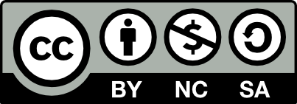

This license enables reusers to distribute, remix, adapt, and build upon the material in any medium or format for noncommercial purposes only, and only so long as attribution is given to the creator. If you remix, adapt, or build upon the material, you must license the modified material under identical terms. CC BY-NC-SA includes the following elements:

  BY: credit must be given to the creator.  
  NC: Only noncommercial uses of the work are permitted.  
  SA: Adaptations must be shared under the same terms.

# Updates

When updates are made to this document, they are tracked below with date and description of update.

* February 2025: initial release